FIRST AID FOR THE OUTDOORS http://www.pitt.edu/~kconover
Teaching Outline
Keith Conover, M.D., FACEP, NSS 12893
Assistant Medical Advisor, Eastern Region, National Cave Rescue Commission
Medical Director for Pennsylvania, Appalachian Search and Rescue Conference
Past Chair, Appalachian Region, Mountain Rescue Association
Version 3.0 -- April 4, 2002
Motivate:
In most outdoor rescue situations, you initially have little to work with: no or few bandages and splints, no IV's, no oxygen, no hotpacks. You DO have your mind and your hands and senses, which are invaluable medical and first aid tools. The purpose of this half-hour of lecture and 45 minutes of practice is to show you how to use minimal equipment for initial management of the injured caver. The American Heart Association touts the “Universal Algorithm” for CPR and ACLS -- however it needs to be expanded to include other problems to be a truly “Universal Algorithm” and this is it.
I. FIRST AID
A. STEP ZERO: ASSESS AND MANAGE HAZARDS. “The first principle in management of the injured caver: take care of HAZARDS. Start first aid only after ensuring safety (the victim’s AND yours) from hazards, such as falling, rockfall, severe cold exposure, or flooding.”
(“A dead rescuer never did anyone any good.”)
B. STEP 1: PRIMARY SURVEY. Do a PRIMARY SURVEY, looking for life-threatening conditions; correct them as you find them. There are only a few absolute rules in first aid, but one of them is: always check airway, breathing, and circulation, in that order. Of course, if you ask a victim ‘Are you alright?’ and get a ‘No, dammit, I think I’ve broken my ankle’ then you can guess that airway and breathing are OK.
1. STEP A: AIRWAY.
a. STEP A-1: CHECK FOR AIR MOVEMENT. Tell students that if patient is NOT talking, to look, listen, feel for air movement.
b. STEP A-2: OPEN AIRWAY. If none, initiate neck hyperextension or jaw thrust (demonstrate). Tell students to take a CPR course to learn care of the obstructed airway.
c. Mention need for maintaining neck in neutral position if suspicion of neck injury, e.g. after a fall; demonstrate use of jaw thrust/neck stabilization.
d. Explain that care of airway is important after primary survey as well: use coma/recovery position (left lateral decubitus) to protect airway and lungs of unconscious caver (explain why: danger of aspiration of secretions or vomit); stabilize neck if necessary. Explain the use of padding to support head.
2. STEP B: BREATHING.
a. STEP B-1: ARTIFICIAL RESPIRATION. Tell students to take a CPR course to learn artificial respiration.
b. STEP B-2: PLUG SUCKING CHEST WOUND. Explain what a sucking chest wound is, and that it should be plugged up with whatever is handy. Someone will ask ‘What if a tension pneumothorax develops?’ Answer: unplug it for a minute, then plug it up again.
c. STEP B-3: SPLINT MAJOR FLAIL CHEST. Explain what a flail chest is, and how to stabilize it with a cave pack or other splint; and, that stabilizing it with the one lung collapsed will decrease the work of breathing and decrease bleeding and pain.
3. STEP C: CIRCULATION.
a. STEP C-1: CARDIAC RESUSCITATION. Check pulse; tell students to take a CPR course to learn external cardiac compression.
b. STEP C-2: CONTROL SEVERE BLEEDING. Check for SEVERE bleeding: use direct pressure and elevation to stop it.
Explain that tourniquet is sacrifice of limb to save life, and that tourniquets must be wide, tight, and are not to be removed, except on order of physician.
Explain that pressure points are rarely useful.
c. STEP C-3: DETECT AND TREAT SEVERE SHOCK. Check pulse for life-threatening shock:
i. weak, thready rapid pulse in an anxious, thirsty victim = shock.
ii. treat: elevate legs, keep warm, reassure.
C. STEP 2: MANAGE. “Stand back—Look—Think—MANAGE! Once the immediately life-threatening situations are under control, hold back and figure out what else needs to be done. If you get too deeply involved in first aid, you may lose track of other things that need to be done: (e.g. waiting 2 hours to send someone for help—it’s happened!) Partition up the work to be done; find something for everyone to do.”
(“Don’t just do something, stand there!”)
D. STEP 3: FOCUSED H & P. Do a FOCUSED H & P for additional injuries. Start at head and work down, feeling for deformity or tenderness, looking for bruising or other injury.
1. HEAD/NEUROLOGICAL EXAM
a. The major problem with a head injury is that pressure from bleeding or bruising can build up inside the skull, ‘squishing’ parts of the brain; there are 3 main ways of telling whether or not this is happening:
When the brain is being squished more and more, the LEVEL OF CONSCIOUSNESS goes down: the person becomes more and more lethargic, and less responsive to voice or pain.
ii. When the nerve to the eye is being compressed, it may cause one of the pupils to respond to light less well, and may end up completely dilated (a big, black pupil that does not respond to light.)
iii. Pressure on certain parts of the brain may cause weakness or numbness of certain parts of the face or body, or even seizures starting in certain parts of the body. This information may may help the neurosurgeon decide where the injury is.
b. There’s little that can be done in the field for a head injury; poor breathing can make it worse, and mild hyperventilation is sometimes used to help; keeping the head level or higher than the feet is also a good idea.
c. If there is a decreasing level of consciousness, possibly coupled with a ‘blown’ pupil, paralysis, or seizures, then the pressure inside the skull is increasing and the caver must be evacuated to a hospital NOW or he will probably die.
2. NECK
a. check sensation, movement (response to and movement from pain if unconscious) in all extremities; if OK, means probably no damage to spinal cord, BUT bony spine may still have fractures that may sever cord on movement.
b. feel the spine for deformity, tenderness (note that C7 has a prominent spine, which is normal)
c. even if both a. and b. are normal, but victim sustained a fall with a blow to the head, or for some other reason you suspect possible spine injury, treat as one: don’t transport without good immobilization of spine. Remember, the spinal cord has the consistency of a ripe banana.
d. The general principle is NOT to move a stable caver with a suspected spine injury until a properly-designed backboard is available; however, if the caver has some other problem that needs URGENT treatment (severe shock, decreasing level of consciousness), then you must use improvised spinal immobilization.
e. improvised neck splints (demonstrate each):
i. Ensolite pad section
ii. blanket rolls
iii. wire splint with Ace wrap and padding
3. CHEST
a. (Sucking chest wounds and flail chest were discussed under Primary Survey.)
b. Explain: collarbones are splinted by splinting the arm to the body; fractured ribs don’t need to be splinted unless flail chest is present.
4. ABDOMEN AND PELVIS
a. Explain and demonstrate evaluation of the abdomen:
i. LOOK for wounds, bruising, or distension;
ii. LISTEN for bowel sounds (absence is relatively bad).
iii. FEEL for guarding (involuntary rigidity of muscles)
b. Explain that internal bleeding alone may cause shock; cannot control bleeding, but can treat early for shock.
c. Explain and demonstrate examination of the bony pelvis (press on symphysis, in on iliac crests, and out on iliac crests); pain or abnormal motion indicates a fracture—fracture may cause death due to internal blood loss.
5. EXTREMITIES
a. Principles of splinting:
1. Long bone fractures: immobilize the joint above and joint below.
2. Fractures and dislocations around a joint: immobilize the bone above and the bone below.
3. Check pulse/capillary refill and movement/sensation BEFORE and AFTER splinting.
4. In general, splint it as it lies; under axial traction, a long bone may be gently straightened, if there’s no great amount of pain or resistance.
5. Thigh fractures should wait for a traction splint, if other injuries allow.
6. Keep checking circulation to make sure the swelling hasn’t made the splint too tight.
b. (Improvised splinting will be practiced later.)
6. BACK
a. use a log roll (demonstrate) to roll the patient as a unit if you suspect a spinal injury, but check the back for wounds, bruises, deformity.

CONCLUSION: Review important points, using student outline
FIRST AID FOR THE OUTDOORS
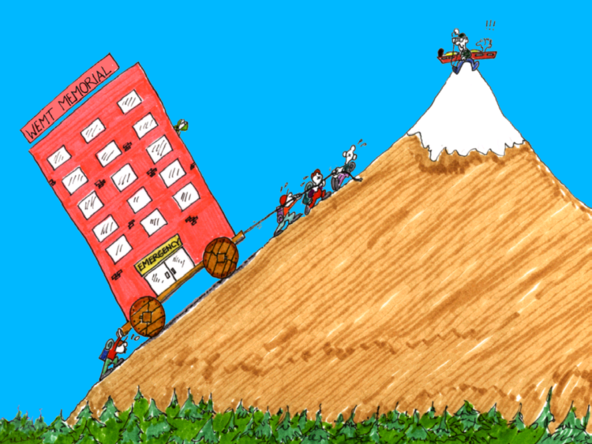
Keith Conover, M.D., FACEP, NSS 12893
Assistant Medical Advisor, Eastern Region, National Cave Rescue Commission
Medical Director for Pennsylvania, Appalachian Search and Rescue Conference
Past Chair, Appalachian Region, Mountain Rescue Association
Version 3.0 -- April 4, 2002 http://www.pitt.edu/~kconover

STEP ZERO: ASSESS AND MANAGE HAZARDS.
The patient AND you. ("A dead rescuer never did anyone any good.")
Student Outline
STEP 1: PRIMARY SURVEY.

STEP A: AIRWAY.

STEP A-1: CHECK FOR AIR MOVEMENT.

STEP A-2: OPEN AIRWAY. (BUT CAREFUL FOR BROKEN NECK!)

STEP B: BREATHING.

STEP B-1: ARTIFICIAL RESPIRATION.

STEP B-2: PLUG SUCKING CHEST WOUND.

STEP B-3: SPLINT MAJOR FLAIL CHEST.

STEP C: CIRCULATION.

STEP C-1: CARDIAC RESUSCITATION.

STEP C-2: CONTROL SEVERE BLEEDING.

STEP C-3: DETECT AND TREAT SEVERE SHOCK.

STEP 2: MANAGE.
("Don't just do something, stand there!")

STEP 3: FOCUSED H & P:
Ask, Look, Listen, Feel

VITAL SIGNS

HEAD/NEUROLOGICAL EXAMINATION

NECK

CHEST

ABDOMEN AND PELVIS

EXTREMITIES
- "Immobilize the joint above and below the broken bone, or the bone above and below the broken joint."
- "Check circulation and innervation BEFORE and AFTER splinting."
- "Splint it as it lies." (but straightening a fracture or cervical spine may be OK)
- "Use a traction splint on thigh fractures if you can."
- "Keep an eye out for swelling cutting off circulation."

BACK 

