Global health and science are Multinational. Why not Multilingual?
11/20/18
Serageldin Multilingual Science team of the Library of Alexandra
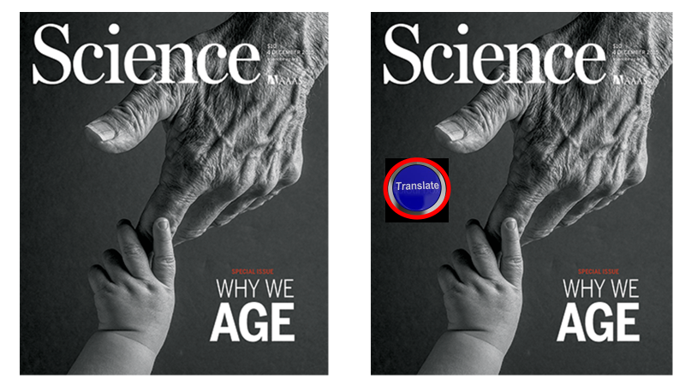
It is a simple concept, and now feasible. This is the result of the remarkable improvement of Google Translate. When Google Translate began in 2006 it often yielded gibberish. Five years ago translation improved although understandable but missed some subtle nuances. When we examined it again; we were highly impressed. We did a series of forward and back translation of scientific materials, as well having native language scientists examine the translation. The translations were very good, many not needing any “touching up”. Here is a simple example from Dr. Serageldin Creed translated into Urdu. As can be seen the back translation is very good. We believe it is time for Teaching, Libraries and Science to all become multilingual so that science has no language boundaries.
Back translation of Serageldin from Urdu to English
The world is my home. Humanity is my family. Non-violence is my creed. Peace, justice, equality and dignity for all is my purpose. Engagement, rationality, tolerance, dialogue, learning and understanding are my means. With outstretched hands we welcome all who share these beliefs. Because of the improved quality of translation, we now consider broad-scale usage across science.

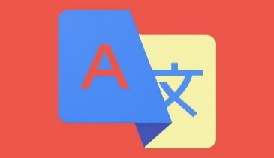
Original Supercourse
Translate
English Version
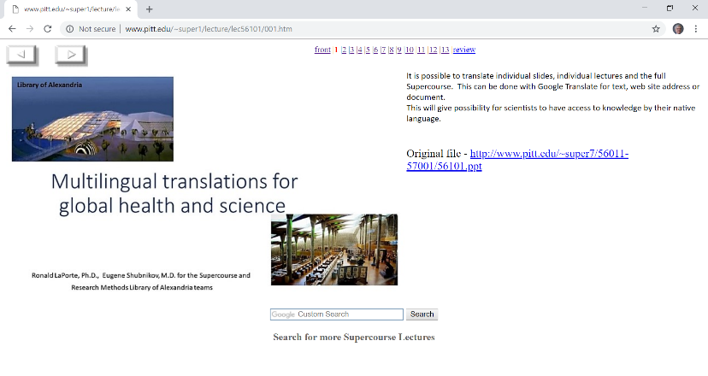
Multilingual Supercourse We were one of the first groups to put PowerPoint on the Web with the collection of 6000 scientific lectures in the Supercourse. In addition, we had native speakers translate 1000 lectures into one or more languages. Multilingual translation of Supercourse and the Serageldin Research Methods Library of Alexandria virtual materials would greatly improve training. Statistics is a difficult topic to learn, and made doubly difficult learning it in a second language. With translation, students could review the topic “Variance” not only in English, but also in Farsi, or Malay. In the last month we have spent considerable time learning how to translate lectures in the Supercourse. We able to develop a simple system with the Supercourse and RMLA potentially being translated into 100 languages. We created a short lecture describing our approach. http://www.pitt.edu/~super1/lecture/lec56101/index.htm The approach is still a little cumbersome but definitely feasible with very understandable slides and notes. This will provide teaching and statistical materials to learn from different languages.
Arabic Translation

Multilingual Library of Alexandria and global Libraries:
Many are interested in Egyptian, Arab, and Muslim history. The BA has an enormous collection of Arabic materials. But many scientists can only understand English, French or Russian. This led to the concept that all virtual materials in the BA and Libraries world wide should be multilingual. We examined the BA and some materials are translated, but not all. Making the BA a multilanguage virtual library model would set the stage for all libraries to be multilingual.

Egypt History in Arabic from BA
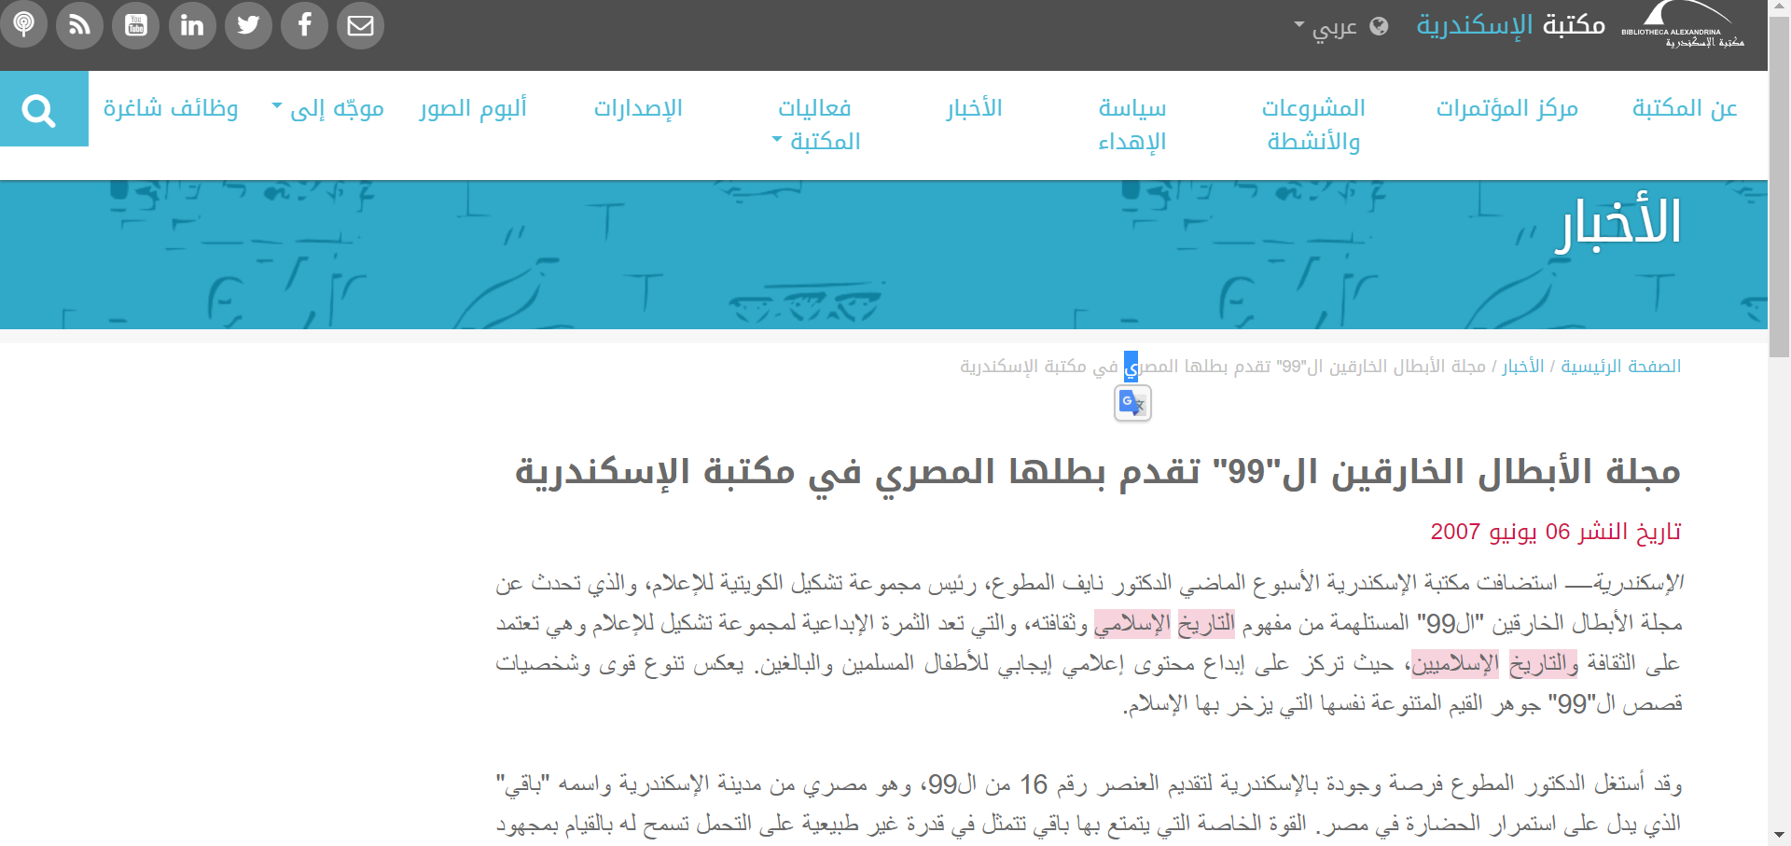
Egypt History translated from Arabic BA
“99 superheroes magazine presents its Egyptian hero at the Bibliotheca Alexandrina Posted on June 06,
Alexandria - The BA hosted last week Dr. Nayef Al Mutawa, President of the Kuwaiti Media Group, which talked about the 99th superhero magazine inspired by the concept of Islamic history and culture, which is the creative fruit of the Tshkool Group of Media and is based on Islamic culture and history. Creating positive media content for Muslim and adult children. The diversity of the powers and personalities of the "99" stories reflects the essence of the diverse values ​​of Islam.”

Multilingual Global health and science: We have been thinking about taking this a step further. Why cannot all journals in global health and science have a translation button on their site? This would broaden science to non-english speakers and developing countries. Science would not have to be funneled through the English Language.
If the BA took the lead, would could start a multilingual wave across training, libraries, and science
Serageldin Nature article first part translated into Arabic

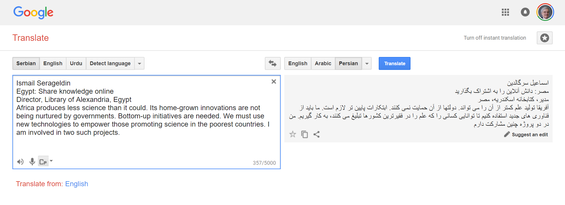

Conclusions: The BA can start the wave by becoming truly multilingual with all virtual materials available in 100 languages. Within a year much of the virtual materials of PowerPoint lectures and slide can be used to teach students in many different languages. All scientific journals will have a translate button.

