Installation Guide of Statistical Packages for Excel in STAT 1100

As of request of the College of Business Administration, this course uses Excel as the statistical package with which we will be solving statistics problems.
There are three steps towards installing all the statistical tools that we will be using in this class:
STEP 1: You need to install Microsoft Excel 2007 or 2010 on your computer. If you don't own Microsoft Office yet (of which Excel is a part), then you can get the software free of charge at Pitt's Software Services located at Bellefield Hall. The Microsoft Office Installation is very straightforward. Simply put in the CD into your drive and follow the on-screen instructions. Make sure you include Excel into your installation (it usually is by default).
Important note: If you use Windows 7 and install Office 2010, you will be asked whether you want to install the 32 bit or 64 bit version of Microsoft Office. Choose the 32 bit version because the Add-In software that comes with your textbook ("Data Analysis Plus 5.1") will not work otherwise!
STEP 2: Once you have Excel installed, you will need to activate a statistical package of Excel called "Analysis ToolPak".
Step 2.1: To activate it, click on the big round button in the top left corner, then on Excel Options:
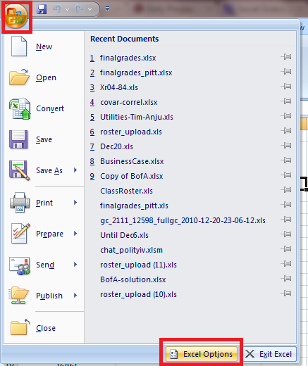
Step 2.2: Next, click on "Add-Ins" and click on "Analysis ToolPak" (this will be on your computer likely under "Inactive Application Add-Ins". Then click the Ok-Button.
(If on your computer "Analysis ToolPak" is not listed at all, choose in the dropbox at the bottom manage "Excel Add-Ins" and click the Go-Button. In the window that then appears, make a checkmark next to "Analysis ToolPak" -- if it is again not listed, click the Browse-Button and locate the file on the Office installation CD or your hard drive. It is unlikely that you'll get here. Instead you should see the next message.)
If you see a message that tells you that the Analysis ToolPak is currently not installed on your computer, click Yes to install it. (It will then ask you to put the Microsoft Office installation CD into your CD drive.)
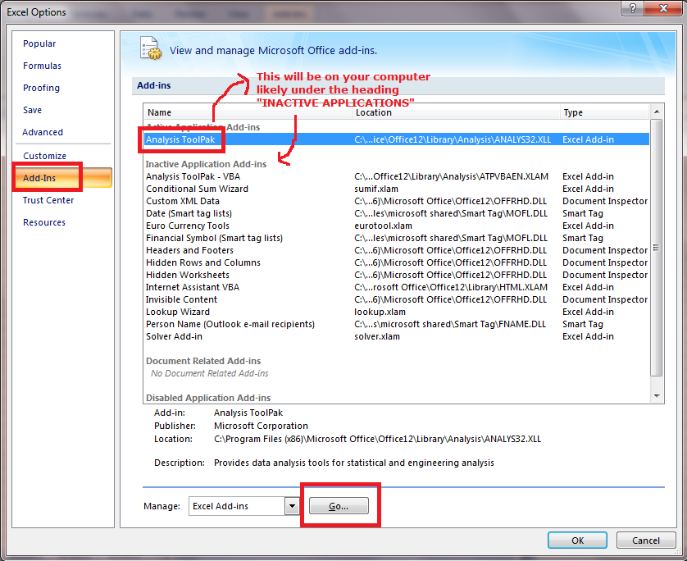

Step 2.3: Verify that the installation was successful. If the "Analysis ToolPak" has been successfully installed, then you should find it under the menu item "Data" an entry called "Data Analysis" (see next screenshot). If that entry is missing then the Analysis TookPak has not yet been successfully installed.
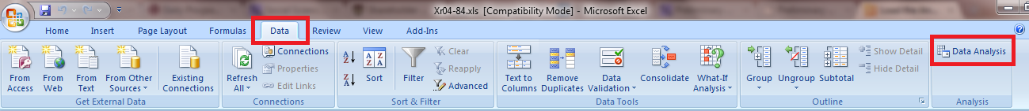

STEP 3: Finally, you need to install the "Data Analysis Plus 5.1" Add-In that comes with your textbook CD.
Step 3.1: To install it, first close Excel if it is open. Then insert the textbook CD into your CD drive. The following screen should automatically appear. (If not, go to the Windows Explorer and double-click "Start.exe" that is located in the root directory of your CD.) Choose "Data Analysis 5.1" and follow the instructions on the screen.
Note: your screen may look a bit differently if you bought the 9th edition of the textbook.
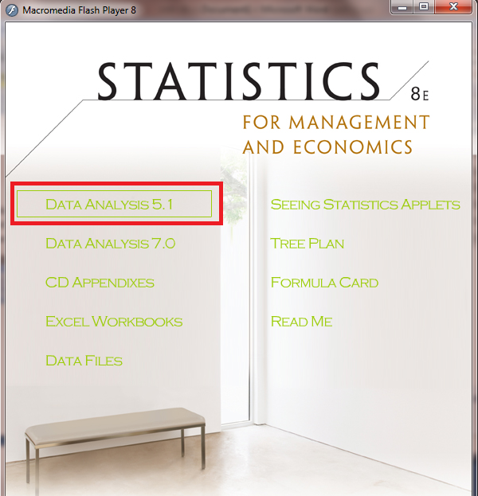
Step 3.2: To verify that "Data Analysis Plus 5.1" has been correctly installed, open Excel and see if you have a new menu item called "Add-Ins" under which you will find the entry "Data Analysis Plus 5.1". If it is there, click it and you should see a listbox (see below) appear -- if the menu item or entry is not there or clicking on "Data Analysis Plus" does not appear, the installation was not successful. Try again from above. If it still doesn't work out, let me know and I'll help you.
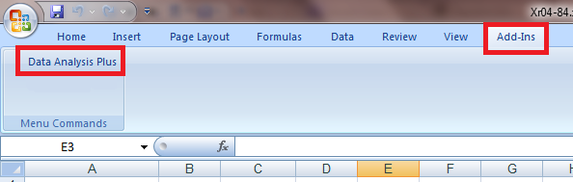

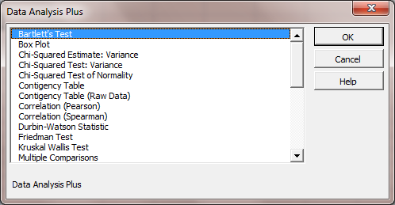
Note: If you receive an error during installation, you might be using Microsoft Excel 64 bit. The software will not work with the 64 bit version. You will need to deinstall Microsoft Office and reinstall the 32 bit edition of it.

TROUBLE-SHOOTING:
Q: How do I find out if I have Microsoft Office 32 bit or 64 bit installed?
First, you can only have the 64-bit edition of Microsoft Office installed if and only if you use Windows 7. If you do not use Windows 7, then you have Office 32 bit installed. If you however have Windows 7, then check where your Microsoft Office is installed on your hard drive. If it is installed in the folder "C:\Program Files (x86)\Microsoft Office" then you have the 32bit version installed. If it is installed however in "C:\Program Files\Microsoft Office", then you have the 64 bit version installed. Data Analysis Plus 5.1 won't work with the 64 bit version of Office.

Q: I installed Data Analysis Plus 5.1 but no Add-Ins menu item appears in Excel. Or, I installed Data Analysis Plus 5.1 and although an Add-Ins menu item appears, it is empty. What do I do?
A: All the installation program for Data Analysis Plus 5.1 does is to copy one file called "stats.xls" into a folder called "XLSTART" in your Microsoft Excel installation. Sometimes, however, Microsoft Office may have several of these "XLSTART" folders and the installation program copies it into the wrong folder. As a result, Microsoft Office will not find the Add-In and will not list it. To solve this problem, go to the folder into which you installed Microsoft Office (typically, this is C:\Program Files (x86)\Microsoft Office). If you have several OFFICExx folders (where xx stands for a number, typically 11, 12 or 14), then go into each of those folders and look if there is a "XLSTART" folder. If yes, copy stats.xls (located on the textbook CD in the folder manual_install Data Analysis Plus 5.1) into each of those XLSTART folders. Now it should work.

Q: I installed Data Analysis Plus 5.1 and it works. However, I have 2 menu item entries called "Data Analysis Plus" under the menu "Add-Ins" and not just one. Both seem to work. What do I do?
A: Simply ignore the 2nd button. Or, find out how to get rid of it and let me know.

More information at: http://www.technology.pitt.edu/software/for-students-software.html.

