Installation Guide of Software for STAT 1100 on a Macintosh OS

PART 1/3: Install Microsoft Office for Macintosh
If you don't have it, you can get it for free from Software Services. Simply put Office CD into your CD drive and follow the on-screen instructions.

PART 2/3: Installing the Data Analysis ToolPak

Note: Microsoft Office 2008 for Macintosh does not come with the Data Analysis ToolPak. Instead you need to download a 3rd-party software that is called StatPlus Mac LE. The light edition of that 3rd party software includes (i believe) all the functionality that we need and is free of charge. The software may prompt you sometimes to update the light edition to the professional edition (which costs money). I would recommend not to upgrade the software as you won't need it for this course.

To install StatPlus Mac LE:
Step 1: Go to www.analystsoft.com/en/products/statplusmacle/download.phtml
Step 2: Click the Download button to download the software.
Step 3: Unzip the file that you downloaded.
Step 4: Once you have unzipped it, there should be a file called SPM_580.dmg. Double-click it and follow the on-screen instructions to install the program. (You need to drag and drop the StatPlus Icon onto the Applications icon -- but the on-screen instructions will tell you to do so.) Done!

To use StatPlus Mac LE:
Step 1: Start Excel and type up or load the data with which you'd like to use StatPlus.
Step 2: Click in the dock (where all the programs are listed) the StatPlus icon. (If Excel is not yet started, it should open automatically).
Step 3: StatPlus shows a new menu on the top of the screen with all the functions (see screenshot). Click whatever function you'd like to use from the menu-entry "Statistics" and follow on-screen
instructions.
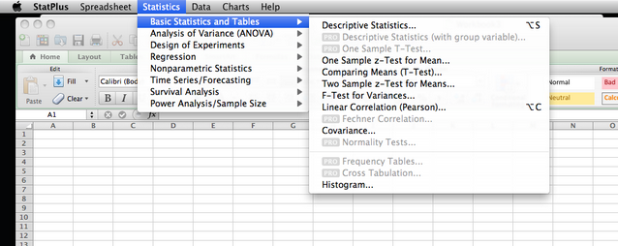

PART 3/3: Installing the Textbook Add-In "Data Analysis Plus 5.1"

To install Data Analysis Plus 5.1:
Step 1: Insert the textbook CD into your CD drive.
Step 2: Right-click stats.xls which is located on the CD in the folder manual_install Data Analysis Plus 5.1 and choose the "Copy" option from the menu.
Step 3: Go to the folder Application -> Microsoft Office 2011 Office Startup Excel, right-click into it and choose the "Paste" option from the menu so that stat.xls is copied into this folder.

Done!

To use Data Analysis Plus 5.1 :
Step 1: Open Excel.
Step 2: Click in menu on "Tools""Data Analysis Plus" and choose the function that you'd like to use.

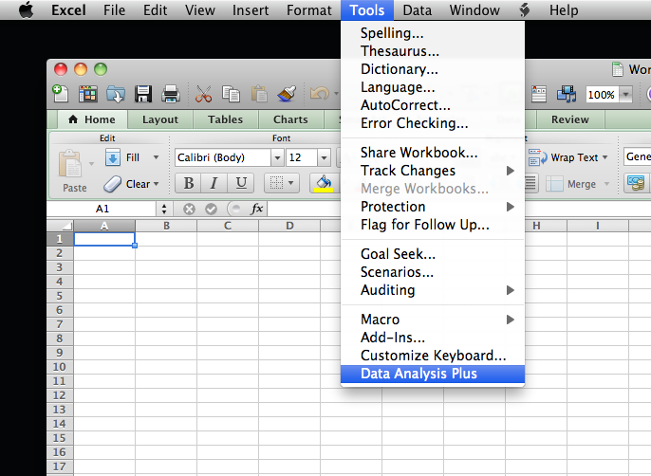

An alternative to this procedure is to have a software called "Boot Camp" installed on your Macintosh. Boot Camp simulates a complete Windows computer within the Macintosh operating system. (Cool, eh?) If you have it installed (don't ask me how that works but Pitt's technology people may help with this), then you can install Microsoft Office for Windows within Boot Camp and follow the previously uploaded Installation Guide for Windows instead of this one.

