A 2500 YEAR LAKE SEDIMENT RECORD OF DROUGHT AND HUMAN ACTIVITY FROM SOUTHWESTERN CHINA
Aubrey Leigh Hillman, M.S.
University of Pittsburgh, 2011

The delivery of precipitation to southwestern China is largely through monsoon circulations that have evolved with changing insolation forcing during the Holocene. Additionally, monsoon strength and timing will likely change in response to changes in greenhouse gas concentration, affecting roughly two billion people who depend on this water source for agriculture, drinking water, and energy. This region of China has a long history of human activity including mining, metallurgy, agriculture, and consequent pollution. Here, high-resolution sampling (0.5 cm intervals) of a sediment core from the Yunnan Province at Xing Yun Hu (24°10’N, 102°46’E), a drought sensitive lake that behaves as a closed basin, provides a sub-decadal record of changing climate and human activity in the late Holocene. Specifically, we use bulk sediment carbonate δ¹⁸O and δ¹³C values to document the timing, direction, and magnitude of moisture changes associated with variations in monsoon strength.
On the basis of accelerator mass spectrometer radiocarbon ¹⁴C dates and ²¹⁰Pb and ¹³⁷Cs dating, the core spans the period from 2500 years BP to present. δ¹⁸O measurements of authigenic carbonate indicate a wet period persisting from 400 BC to 400 AD. The Medieval Climate Anomaly (MCA), defined as the period from 1000-1250 AD, is expressed as a time of increased monsoon activity. Thereafter, values indicate a rapid transition to a substantially drier climate that took place over 50 years and persisted from 1300-1880 AD as an expression of the Little Ice Age (LIA). δ¹⁸O values return to a slightly wetter climate that continues to present day. Xing Yun’s δ¹⁸O record matches other climate reconstructions from both speleothems and lacustrine sediments.
δ¹³C covaries with δ¹⁸O supporting the interpretation that Xing Yun is a hydrologically closed system until 1600 AD. δ¹³C values then show rapid flux toward a more negative trend into present day. As 1600 AD is the time frame in which many Han immigrants from the north settled and worked land in the Yunnan Province, this record has the potential to illuminate the extent of human activity. Combined with other proxies, the goal is to develop a better understanding of the human and climate interactions in Chinese history.

TABLE OF CONTENTS
List of tables viii
List of figures ix
preface xii
1.0 Introduction 1
1.1 THE ASIAN MONSOON SYSTEM 1
1.2 SETTING 4
2.0 A 2500 YEAR HISTORY OF DROUGHT IN SOUTHWESTERN CHINA 9
2.1 INTRODUCTION 9
2.2 METHODS 12
2.2.1 Chronology 12
2.2.2 Sampling 15
2.3 RESULTS 17
2.4 DISCUSSION 25
2.4.1 Isotopes 25
2.4.2 Covariance 28
2.4.3 Other Climate Comparisons 30
2.5 CONcLUSION 34
3.0 A 2500 YEAR HISTORY OF HUMAN ACTIVITY IN SOUTHWESTERN CHINA 36
3.1 INTRODUCTION 36
3.2 METHODS 46
3.2.1 Chronology 46
3.2.2 Sampling 49
3.3 RESULTS 51
3.4 DISCUSSION 54
3.5 CONCLUSION 59
4.0 THE INTERACTION BETWEEN HUMAN activity AND LANDSCAPE DEVELOPMENT 61
APPENDIX A 64
TABLE OF DATA FOR DRIVE 1 64
APPENDIX b 71
TABLE OF DATA FOR DRIVE 2 71
APPENDIX C 76
TABLE OF DATA FOR DRIVE 3 76
APPENDIX D 80
TABLE OF TRACE METAL DATA 80
APPENDIX E 92
TABLE OF Carbon to nitrogen ratio DATA 92
bibliography 96
List of tables
Table 2-1- Radiocarbon dates. 14
Table 2-2- Xing Yun A09 samples measured with XRD. 15
Table 3-1- Estimates of silver taxation from the Yunnan Province during the Ming dynasty from Yang (2009). 41
Table 3-2- Estimates of yearly copper production in Yunnan from Yang (2009). 1 jin is equivalent to 2 kg. 43
Table 3-3- Radiocarbon dates. 48
Table 3-4- Measured elements and detection limits. 49

List of figures
Figure 1-1- Oxygen isotopes from Xing Yun compared to summer insolation at 20°N. Image adapted from Hodell et al. (1999). 2
Figure 1-2- Map of Yunnan Province adapted from ESRI 2010 with Chinese border highlighted for emphasis. 4
Figure 1-3- Map of Xing Yun lake and watershed adapted from ESRI 2010. Areas of low relief are light in color and represent the boundaries of the watershed. 5
Figure 1-4- Bathymetry of Xing Yun Lake showing cross section in Figure 1-5. 6
Figure 1-5- Hypsographic profile of Xing Yun from A to B in Figure 1-4. 7
Figure 2-1- Age depth model for Xing Yun A09. Circles denote ¹⁴C dates, squares denote ¹³⁷Cs dates, and triangles denote ²¹⁰Pb dates. 14
Figure 2-2 – Selected X-ray diffraction peaks for Drive 1. Calcite peaks are marked with a C, quartz peaks are marked with a Q. 18
Figure 2-3- X-ray diffraction peaks for Drive 2. Calcite peaks are marked with a C, quartz peaks are marked with a Q. 19
Figure 2-4- X-ray diffraction peaks for Drive 3. Calcite peaks are marked with a C, quartz peaks are marked with a Q. 20
Figure 2-5- Euhedral calcite from Xing Yun A09 D1 4 cm. 21
Figure 2-6- Subhedral calcite from Xing Yun A09 D1 130 cm. 22
Figure 2-7- % organic matter in dashed line, % carbonate in solid line, % residual mineral matter in dotted line, stable isotopes, and magnetic susceptibility of Xing Yun A09. 23
Figure 2-8- Calculated Δδ¹⁸O values compared with Xing Yun δ¹⁸O record. 25
Figure 2-9- Covariance for Xing Yun A09 grouped into 4 time periods. 1- 400 BC to 1360 AD. 2- 1360 to 1880 AD. 3- 1880 to 1970 AD. 4- 1970 AD to present. 29
Figure 2-10- Xing Yun compared to Dongge and Wanxiang Cave records. Highlighted areas are potential periods of agreement. 31
Figure 2-11- Cook et al (2010) PDSI reconstruction compared to Xing Yun. Highlighted areas indicate potential periods of agreement. 33
Figure 2-12- Braganza et al. (2009) ENSO reconstruction compared to Xing Yun. Highlighted areas are potential periods of anti-correlation. 34
Figure 3-1- Map of archaeological sites of interest in the Yunnan Province adapted from ESRI 2010. All sites are from the Dian culture mentioned in Higham (1996). 37
Figure 3-2- Map of pre-20th century copper mines in the Yunnan province adapted from Golas (1999). The square is the approximate location of Xing Yun. 39
Figure 3-3- Map of pre-20th century silver mines in the Yunnan province adapted from Golas (1999). The square is the approximate location of Xing Yun. 40
Figure 3-4- Map of pre-20th century tin and lead mines in the Yunnan province adapted from Golas (1999). The square is the approximate location of Xing Yun. 41
Figure 3-5- Cupellation of argentiferous lead in the Yunnna province from Needham and Gwei-djen (1974). 42
Figure 3-6- Age depth model for Xing Yun A09. Circles denote ¹⁴C dates, squares denote ¹³⁷Cs dates, and triangles denote ²¹⁰Pb dates. 48
Figure 3-7- Calculated metal flux for selected elements. 52
Figure 3-8- Biplot of PCA loadings for 41 measured elements. 53
Figure 3-9- Carbon to nitrogen ratio in Xing Yun A09. 54
Figure 3-10- Calculated metal flux for selected elements. Shaded areas represent periods where there was no unified empire. Lines represent transitions into the MCA and the LIA. 55
Figure 3-11- Stratigraphic column indicating red color and presence of pyrite in light pattern, dark color and lack of pyrite in dark pattern, carbon to nitrogen ratio, calculated sedimentation rate, and magnetic susceptibility for Xing Yun A09. 56
Figure 3-12- Fifty six samples plotted with component 1 scores. 59
Introduction

THE ASIAN MONSOON SYSTEM
Asia is one of the most densely populated regions of the world with a total population of roughly 2 billion people. Precipitation in this area of the world is highly seasonal because it receives monsoon circulation and changes in the timing and strength of the summer monsoon impacts water resources and the people who depend on it. Kunming (25°20’N, 102°43’E, 1892 km), the capital of the Yunnan province in the People’s Republic of China, receives 70% of its annual precipitation during the months of June to September. Increased radiative forcing is likely to change summer monsoon patterns, affecting the lives of as much as a third of the world’s population. In order to better understand how the Asian monsoon (AM) might respond to greenhouse gas increase, we look to paleoclimate records as recorded in ice cores, speleothems, lake sediments, and tree rings .
There has been a great interest in understanding how the monsoon varies over millennial time scales because of the AM’s influence on such a large number of people. The AM is strongly influenced by precessional insolation forcing, as demonstrated in a number of paleoclimate studies . During the last glacial maximum, precessional forcing was low in the Northern Hemisphere summer, causing the summer portion of AM to weaken and the winter monsoon to strengthen (Figure 1-1) . This changed around 12,000 years BP when summer monsoon strength increased until 8,000 years BP . Thereafter, in the middle to late Holocene, data show summer monsoon strength weakening, sometimes abruptly . Orbitally forced changes are gradual and the AM responds non-linearly to such changes .
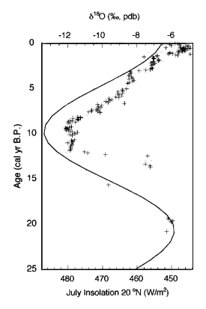
Figure 1-1- Oxygen isotopes from Xing Yun compared to summer insolation at 20°N. Image adapted from Error: Reference source not found
A number of studies have sought to understand the complexity of the AM as related to other climate patterns through computer modeling . In an attempt to realize the changing relationship between the AM and El Niño Southern Oscillation (ENSO), Error: Reference source not found, took historical data from the last 50 years and ran simulations of the yearly interactions. The results of the study showed that prior to 1976, ENSO cycles were preceded by a period of a strong AM . After 1976, AM strength was no longer a good indicator of ENSO and cause and effect become difficult to separate . Possible causes for the change in this relationship are still being investigated, but one possibility is the cycling of the North Atlantic Oscillation (NAO) . Thus, the AM, ENSO, and NAO are connected in complex ways with wide-reaching consequences.
The Asian monsoon has two components, South Asian and East Asian, of which the East Asian component is frequently investigated because it is linked to other climate phenomena, such as the West Pacific monsoon in the United States, ENSO, and the Australian summer monsoon . The East Asian monsoon affects southwestern China including provinces such as Yunnan, Sichuan, Guizhou, Guangxi, and Hunan (Figure 1-2). The Yunnan Province is well suited for a paleoclimate study because it has many lakes with the proper sediments to record the precipitation-evaporation (P-E) balance over many thousands of years.

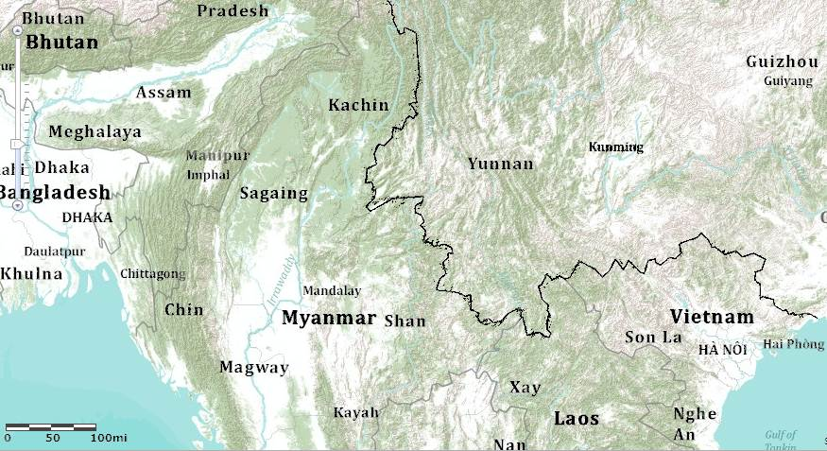
Figure 1-2- Map of Yunnan Province adapted from ESRI 2010 with Chinese border highlighted for emphasis.

SETTING
The Yunnan Province lies in southwestern China, east of Tibet, and north of Myanmar, Laos, and Vietnam. Xing Yun Lake (24°10’N, 102°46’E, 1723 m) is in the Yunnan Province, underlain by Paleozoic limestone which has several mineral deposits of economic interest as well as marble . Xing Yun is connected to Fuxian Lake by a small stream and sits 3 m higher than Fuxian (Figure 1-3) . Xing Yun is a relatively small lake with an area of 34.7 km², a catchment area of 383 km², and a mean depth of 5.9 m (Figure 1-4) . The volume of Xing Yun decreases rapidly after a depth of 6 m (Figure 1-5). Xing Yun is a shallow lake that was formed by karst solution, whereas Fuxian is much larger and is the result of tectonic faulting . Xing Yun has several inflowing and one outflowing stream into Fuxian that has been artificially widened several times .
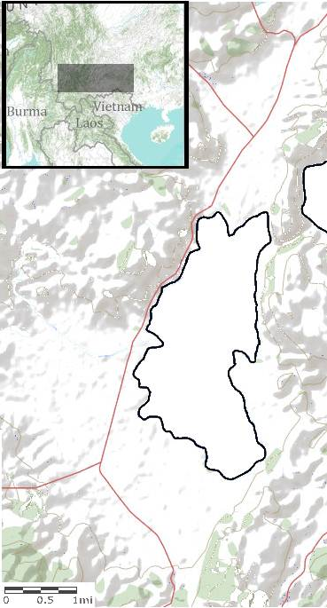
Figure 1-3- Map of Xing Yun lake and watershed adapted from ESRI 2010. Areas of low relief are light in color and represent the boundaries of the watershed.
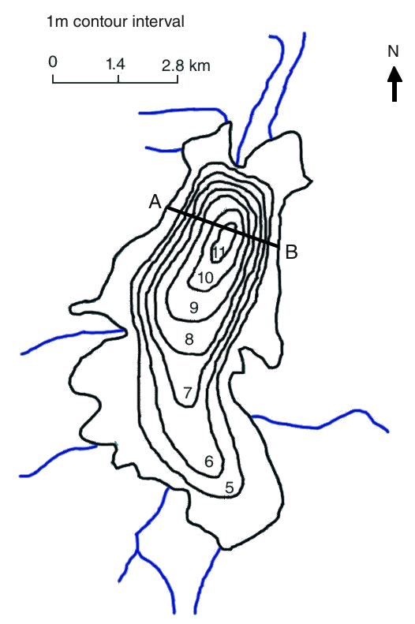
Figure 1-4- Bathymetry of Xing Yun Lake showing cross section in Figure 1-5.

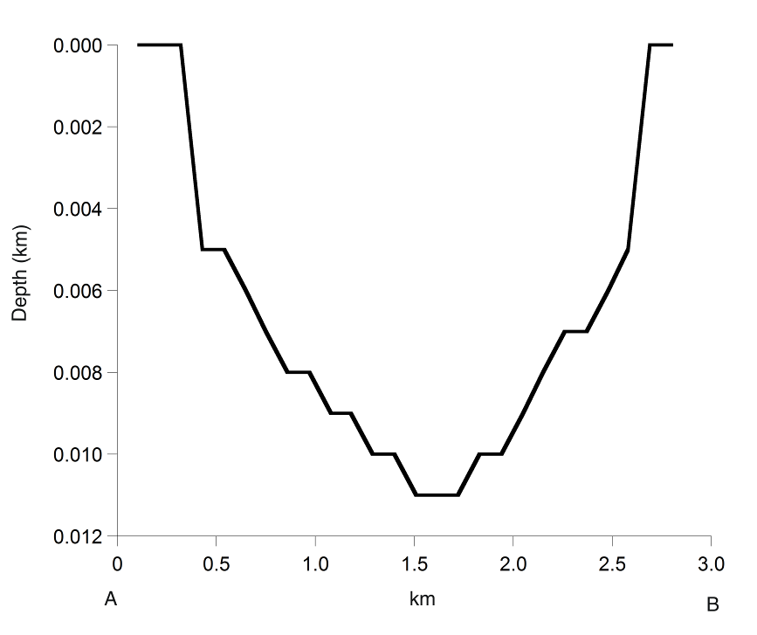
Figure 1-5- Hypsographic profile of Xing Yun from A to B in Figure 1-4.

Xing Yun and the entire region of southwestern China is strongly influenced by the AM, specifically the Eastern AM. Kunming (25°20’N, 102°43’E, 6200 km) is 70 km away from Xing Yun and receives 70% of its annual precipitation during the months of June to September. The months from December to March account for only 5% of the annual precipitation. Thus the annual water budget in this area is controlled by annual summer monsoon strength. Based on precipitation amount and measured values of δD and δ¹⁸O of precipitation, precipitation falling on the Xing Yun watershed should have a δD value of -66.2‰ and δ¹⁸O of -9.6‰, which places it on the global meteoric water line (GMWL); however, measured values of δD and δ¹⁸O of lake water plot to the right of the GMWL, indicating enrichment of δ¹⁸O through the process of evaporation. For this reason, Xing Yun is sensitive to changes in the P-E balance because it loses most of its water through evaporative processes. This is confirmed through water sample analysis where typical δ¹⁸O values are enriched at -5.7‰ . Since lake waters are enriched through evaporation, precipitate minerals such as CaCO₃ are also enriched and can be used to document the timing, direction, duration, extent, and possible the magnitude of changes in the moisture balance.

A 2500 YEAR HISTORY OF DROUGHT IN SOUTHWESTERN CHINA

INTRODUCTION
Paleoclimate analysis in southwestern China has thus far been concentrated on cave deposits and the analysis of δ¹⁸O in speleothems. High resolution δ¹⁸O cave records provide data for comparison with the lake sediment including Shihua Cave (39°90’N, 116°40’E), Dongge Cave (25°17’N, 108°50’E), Heshang Cave (30°27’N, 110°25’E), and Wanxiang Cave (33°19’N, 105°00’E) . Speleothem records are extensively used because they can be accurately dated using ²³⁸U/²³²Th. However, δ¹⁸O of precipitated calcite in caves is influenced by a number of complicating factors: atmospheric temperature and humidity, groundwater mixing and infiltration, cave humidity, and kinetic fractionation . In order for any speleothem to be interpreted in terms of paleoclimate, annual measurements of drip water should be taken in order to ensure minimal kinetic fractionation and to assess the seasonality of calcite precipitation . The effects of altitude and continentality on cave conditions are not well understood, yet many of the speleothem records from China are located in high altitude areas, creating another confounding factor for interpretation .
Wanxiang Cave is situated in more central China but has valuable data for the last 1,800 years of monsoonal strength . δ¹⁸O fluctuations are small with a 0.5 to 1.0‰ shift during transition periods . In this record, 530-930 AD is a period of declining monsoon strength with a sharp drop at 860 AD . Thereafter, monsoon strength increases to a peak at 1020 AD. Values remain high with moderate variations until 1360 AD . A sudden drop in monsoon strength occurs at 1360 AD and remains low until 1880 AD which the authors believe in the influence of the Little Ice Age (LIA) . The authors connect AM strength to North Atlantic temperatures and solar variability, though they note several periods where the record lags behind these factors, such as during the LIA .
Error: Reference source not found) note that periods of weak (strong) monsoons correlate with decline (rise) of certain Chinese dynasties . The period of weak monsoon strength from 850-940 AD is corresponds to when the Tang Dynasty ended and ushered in a period of political chaos known as the Five Dynasties and Ten Kingdoms . Conversely, the strong monsoon strength from 960-1020 AD is when the Song Dynasty flourished . However, other authors have questioned this interpretation for several reasons. Wanxiang Cave is strongly influenced by AM precipitation; since precipitation is a very local phenomenon, it may not be appropriate to apply such records to the whole of China . Additionally, they note that there are several periods of history which directly contradict this interpretation; the Ming Dynasty thrived when the AM was weak and the Qing Dynasty began to fall when the AM was strong .
Paleolimnological analysis has been performed on a few lakes of the Yunnan Province. These include closed basin lakes Qilu (24°10’N, 102°45’E) and Xing Yun (24°10’N, 102°46’E) and open basin lake Erhai (25°45’N, 100°11’E). Closed basin lakes provide an opportunity for paleoclimatic analysis because they record evaporative losses through authigenic calcite. Both Qilu and Xing Yun Lakes have outflow to surrounding sources, so they are not considered topographically closed basin . However, they can be considered hydrologically closed basin because they lose most of their inflow to evaporation . Erhai is an open basin lake and is not as sensitive to evaporation variability, as shown by surface lake water analysis with a δD value of -64.5‰ and δ¹⁸O of -7.6‰. However, Erhai can serve as a control for processes that influence stable isotope variation over time.
Erhai has been the subject of much study because it is one of the larger lakes in the Yunnan Province and has a long record of human occupation, which makes it useful in an effort to quantify human disturbance to the watershed. A multi-proxy study covering the last 7,500 years BP, which included analysis of pollen, particle size, stable carbon isotopes, magnetic susceptibility, mineral assemblage, and trace metal concentration, found that as early as 7,000 years BP, sediments record a disturbed vegetation pattern likely due to deforestation and irrigation . Such disturbance continues in conjunction with shifting monsoon strength until roughly 2,000 years BP when erosion and hydraulic engineering show another significant change in the watershed hydrology . This is confirmed by a pollen assessment of Erhai Lake where magnetic susceptibility and sedimentation rates increase and pollen from pine and deciduous trees decrease significantly after 1,100 years BP .
The basis for this study of Xing Yun comes from a study by Error: Reference source not found) of Xing Yun and Qilu Lakes. In this study the age model is not very robust since bulk sediments and shells were used for ¹⁴C measurements which are prone to reservoir effects. Thus, the timing of certain events is not clear; however this study provides a firm basis for this analysis . Analyses of the sediments included percent organic and inorganic carbon, grain size, magnetic susceptibility, and stable isotopic analysis of δ¹⁸O of authigenic carbonate every 3-5 cm . This study showed that during the last glacial maximum, δ¹⁸O values were high, suggesting a weak summer monsoon and a strong winter monsoon . The glacial section of the core also had high magnetic susceptibility values which were the result of detrital magnetic particles delivered to the lake by winter monsoon winds .
After 12,000 years BP, southwestern Asia experienced glacial retreat and warming temperatures which led to increased carbonate deposition, lower δ¹⁸O values, and lower magnetic susceptibility . The δ¹⁸O values cannot be solely explained by increased productivity and must be attributed, in part, to increasing summer monsoon strength until 8,000 years BP . From 8,000 to 0 years BP, gradual weakening of the summer monsoon is caused by precessional forcing resulting in decreased carbonate deposition and higher δ¹⁸O values . Increasing magnetic susceptibility beginning 3,000 years BP is explained as human disturbance to the watershed .

METHODS

Chronology
Xing Yun cores were taken in the summer of 2009. One core (D1) was taken with a piston core filled with a 5.5 cm diameter removable polycarbonate tube and measures 133.5 cm. Once the sediments became too difficult to penetrate with the polycarbonate tube, a steel barrel Livingston corer was used. The two Livingston cores D2 and D3 were taken and extruded in the field. They measure 92 cm and 96 cm respectively. Altogether these three cores produce a total record of 2.640 m. D1 and D2 overlap by 47.5 cm and D2 and D3 overlap by 10 cm on the basis of field notes and stratigraphic comparison of oxygen isotopes, carbon isotopes, and magnetic susceptibility.
The age model was produced using ¹⁴C radiocarbon, ²¹⁰Pb, and ¹³⁷Cs measurements. The upper 56 cm of D1 was extruded in the field at 0.5 cm intervals and used for ²¹⁰Pb and ¹³⁷Cs dating. Samples were freeze dried and equilibrated in a cold storage room at the University of Pittsburgh. Dating was performed on a Canberra Germanium Detector BE2020 at the University of Pittsburgh for 23 hours to detect γ radiation. An age depth model of ²¹⁰Pb dating was created on the basis of the CRS model . ¹⁴C radiocarbon dating was performed on 6 samples which were pretreated using the standard acid, base, acid procedure of Error: Reference source not foundSamples were measured the University of California Irvine. Dates were calibrated using Calib 6.0 (Table 2-1) . On basis of these 2 dating techniques, the following age-depth model was produced (Figure 2-6).
Table 2-1- Radiocarbon dates.
Core | Drive Depth (cm) | Total Depth (cm) | Material | ¹⁴C age (¹⁴C years BP) | ¹⁴C age error | Median calibrated age (cal years BP) | 2-sigma calibrated age range (cal years BP)
A-09 D1 | 35.5 | 35.5 | Wood | 110 | 25 | 112 | -4-268
A-09 D1 | 37.5 | 37.5 | Charcoal | 110 | 50 | 123 | -4-277
A-09 D1 | 59.0 | 59.0 | Charcoal | 130 | 25 | 124 | -3-273
A-09 D2 | 59.0 | 145.0 | Charcoal | 1060 | 25 | 962 | 928-1052
A-09 D3 | 82.0 | 250.0 | Wood | 2105 | 20 | 2078 | 2003-2140
A-09 D3 | 95.0 | 263.0 | Charcoal | 2220 | 20 | 2226 | 2153-2347

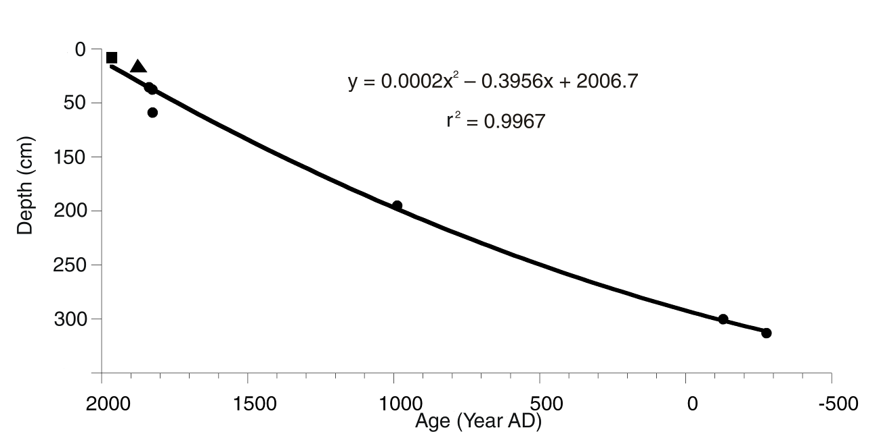
Figure 2-6- Age depth model for Xing Yun A09. Circles denote ¹⁴C dates, squares denote ¹³⁷Cs dates, and triangles denote ²¹⁰Pb dates.

Sampling
Three samples spaced throughout Drive 1 (4 cm, 70 cm, 130 cm) were analyzed on the University of Pittsburgh’s scanning electron microscope (SEM). SEM analysis revealed ample euhedral to subhedral calcite and siliceous diatoms. X-ray diffraction analysis (XRD) was performed on 19 samples evenly spaced from all 3 cores (Table 2-2). XRD results from Drive 1 presented in Figure 2-7 were analyzed at Duquesne University (16.0, 16.5, 40, 80, 110 cm). XRD results from the remaining samples of Drive 1, and Drives 2 and 3 were analyzed at the University of Pittsburgh.

Table 2-2- Xing Yun A09 samples measured with XRD.
Drive 1 (cm) | 4 | 16.0 | 16.5 | 30 | 40 | 60 | 70 | 80 | 90 | 110 | 120 | 130
Drive 2 (cm) | 30 | 60 | 70 | 90
Drive 3 (cm) | 30 | 60 | 90
Bulk density samples measuring 1 g cm⁻³ were taken every 2 cm down the entire length of the core less than 24 hours after the core had been opened. These were weighed immediately and again after 36 hours in a drying oven. Loss on ignition (LOI) analysis was performed on these samples and they were burned in a muffle furnace at 550°C and 1000°C to estimate the weight percent of organic matter and carbonate, respectively .
Archive halves of each drive were measured on the Bartington Susceptibility meter for magnetic susceptibility equipped with a ME2EI sensor. The entire length of each drive was chopped into 0.5 cm samples and saved in a scintillation vial. Samples were disaggregated with 7% H₂O₂ and sieved through a 63 μm screen to remove biological carbonate. Carbonate samples were prepared and measured on the University of Pittsburgh mass spectrometer (GV Instruments Micromass IsoPrimeTM) for δ¹⁸O and δ¹³C isotopes. Samples were replicated every 10 cm and analyzed two to three times to ensure accurate results.
In order to compare Xing Yun’s stable isotope results with other cave records, Δδ¹⁸O was calculated, which is the difference between speleothem δ¹⁸O and Xing Yun δ¹⁸O, as a technique for removing secondary controls on δ¹⁸O fractionation and quantifying precipitation . Prior to calculating Δδ¹⁸O, the data from the speleothems was interpolated at one year resolution using MatLab 7.10.0 and the following code:

t = -500:1:2000;
NewDataSet = interp1(series1(:,1),series1(:,2), t, ‘linear’);

RESULTS
XRD results revealed that the predominant minerals are calcite and hexagonal quartz. D1 samples are mostly quartz with some calcite (Figure 2-8). D2 samples are evenly mixed quartz and calcite, with calcite increasing down the bottom of the core (Figure 2-8). D3 samples are dominated by calcite with some small amounts of quartz (Figure 2-9). This analysis is confirmed by the results of the SEM which indicate euhedral to subhedral calcite (Figure 2-10, Figure 2-11).
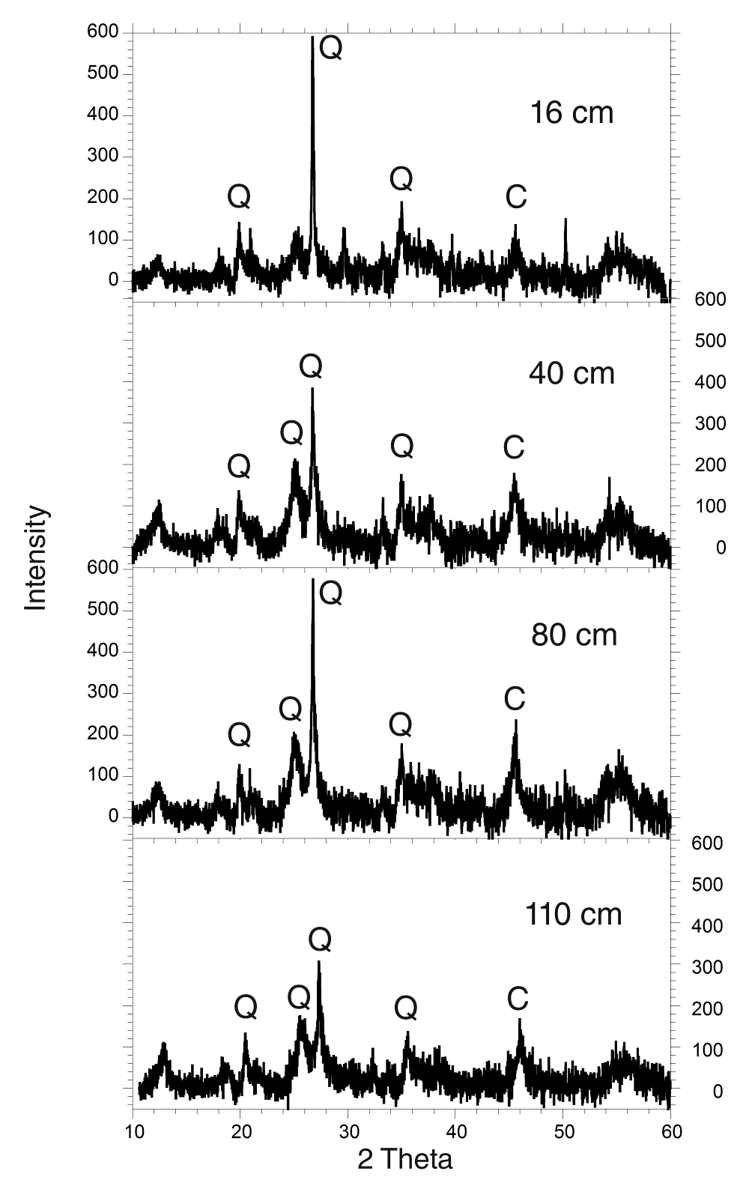
Figure 2-7 – Selected X-ray diffraction peaks for Drive 1. Calcite peaks are marked with a C, quartz peaks are marked with a Q.
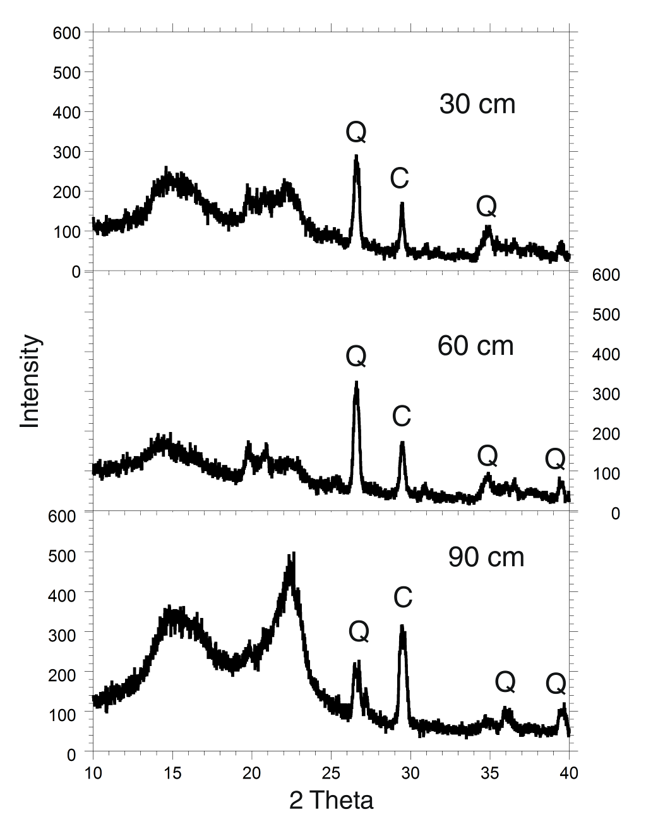
Figure 2-8- X-ray diffraction peaks for Drive 2. Calcite peaks are marked with a C, quartz peaks are marked with a Q.

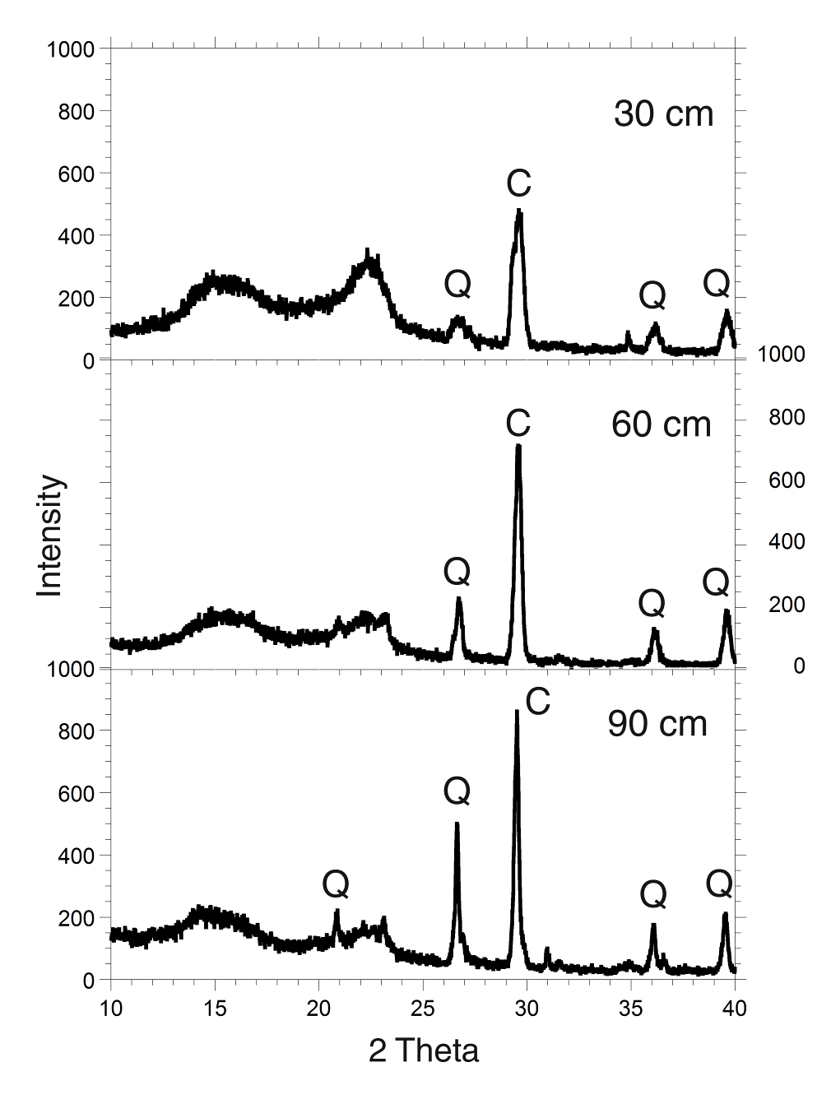
Figure 2-9- X-ray diffraction peaks for Drive 3. Calcite peaks are marked with a C, quartz peaks are marked with a Q.
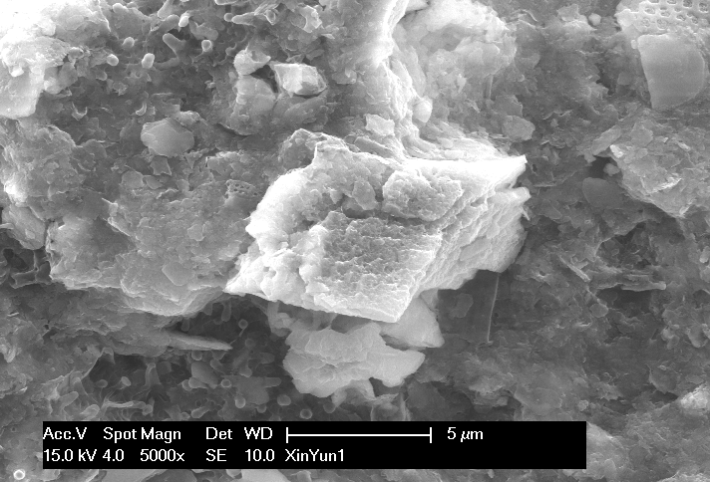
Figure 2-10- Euhedral calcite from Xing Yun A09 D1 4 cm.

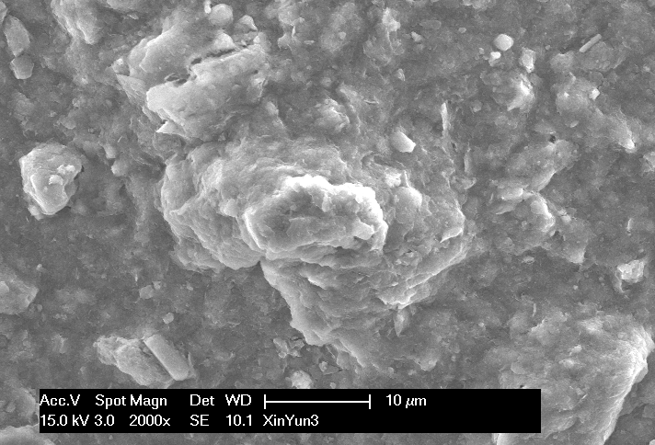
Figure 2-11- Subhedral calcite from Xing Yun A09 D1 130 cm.

The results of both δ¹⁸O and δ¹³C exhibit a wide range of variability in the span of 2,640 years BP or to the year 432 BC according to the age depth model. δ¹⁸O values reach a minimum of -8.50‰, a maximum of -4.33‰, and have a range of 4.17‰. δ¹³C values reach a minimum of -5.26‰, a maximum of 1.32‰, and have a range of 6.59‰. Repeated measurements of δ¹⁸O and δ¹³C have an average standard deviation of 0.1275‰ and 0.2251‰, respectively. The record can be split into 5 distinct units (Figure 2-12).
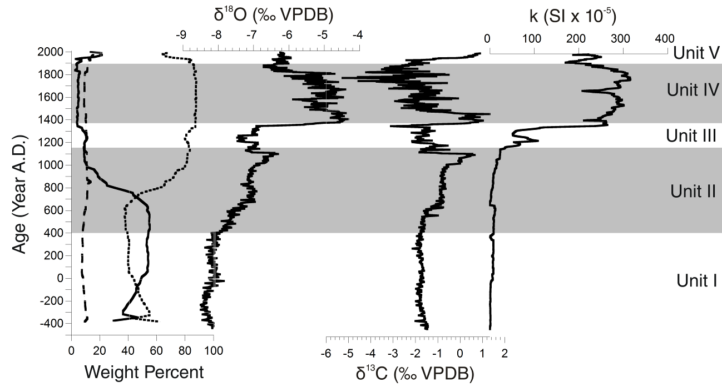
Figure 2-12- % organic matter in dashed line, % carbonate in solid line, % residual mineral matter in dotted line, stable isotopes, and magnetic susceptibility of Xing Yun A09.

Unit I occurs from 400 BC to 400 AD and is characterized by relatively little change with 40-60% carbonate, 5-12% organic matter, and 0.00-8.00 units of magnetic susceptibility. δ¹⁸O values are stable and range from -8.50‰ to -7.84‰, as are δ¹³C values which range from -2.13‰ to -1.44‰.
Unit II occurs from 400 to 1140 AD and shows gradual change with carbonate content slowly decreasing from roughly 60% to 10%. Both δ¹⁸O and δ¹³C values become less negative and each shift by approximately 1.00‰ and 1.50‰, respectively. There is little change in magnetic susceptibility.
Unit III is marked by abrupt change occurring over roughly 246 years from 1140-1360 AD. Carbonate content remains relatively stable around 10% and consequently, relatively large samples were weighed out for analysis on the mass spectrometer. Magnetic susceptibility briefly increases to 107.7 units. δ¹⁸O values shift back to a low of -7.46‰ and δ¹³C values shift to a low of -3.10‰.
Unit IV is a period of rapid change over approximately 50 years during which both δ¹⁸O and δ¹³C shift by 3.50‰. Unit IV lasts from 1360-1880 AD and is characterized by enriched δ¹⁸O values that reach a maximum of -4.33‰ and depleted δ¹³C values that reach a minimum of -5.26‰. Unit IV also has a rapid increase in magnetic susceptibility with values consistently higher than 150 units with a maximum of 316.30 units.
Unit V is the most present day segment from 1880-2005 AD and is characterized by slightly more depleted isotope values. δ¹⁸O values remain consistent around -6.20‰ and δ¹³C values hover around 0.50‰. Unit V has an increase in carbonate content to roughly 15-20%. Magnetic susceptibility values reach a low point of 170 units at the beginning of Unit V and then increase to roughly 250 units.
One of the most reliable paleoclimate records for comparison with Xing Yun is the speleothem record from Dongge Cave. The Dongge Cave record spans a similar time period and has a similar resolution of 5-6 years, so we performed interpolation and subsequently calculated Δδ¹⁸O . The calculated values of Δδ¹⁸O are very similar to the δ¹⁸O record of Xing Yun (Figure 2-13).
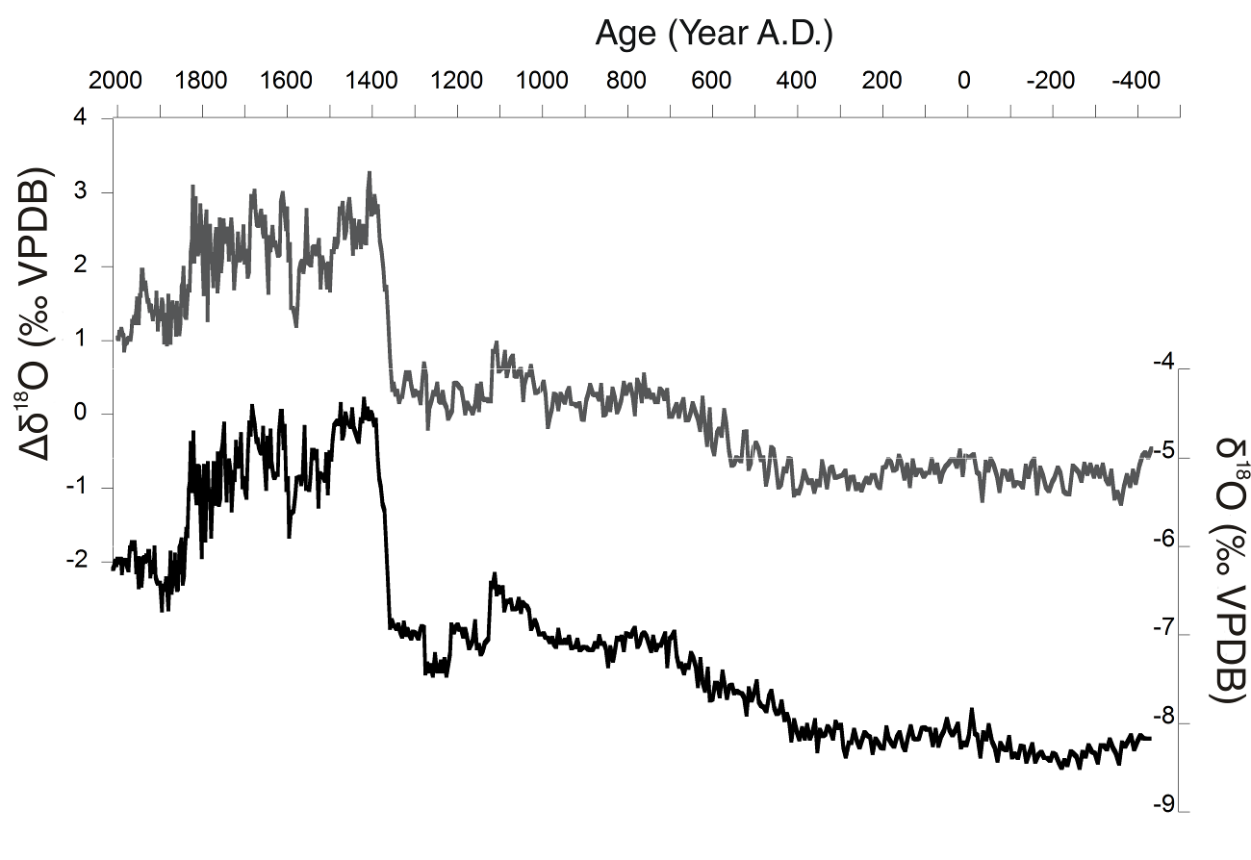
Figure 2-13- Calculated Δδ¹⁸O values compared with Xing Yun δ¹⁸O record.

DISCUSSION

Isotopes
The results of XRD and SEM analysis indicate that the authigenic carbonate is calcite. Given that some sections of the core have as little as 10% carbonate content, discussion will be focused on transition periods where δ¹⁸O values shift by a value greater than 1.00‰. The validity of the isotope record is confirmed by the fact that Xing Yun δ¹⁸O matches very closely with the record previously found by Error: Reference source not found albeit with much higher resolution of 5-6 years and better age control. The core recovered in 2009 from Xing Yun only contains 2,500 years so it is difficult to identify Holocene scale monsoonal patterns. However, when overlaid with Hodell’s record, Unit I corresponds to a period of moderate monsoon strength. Magnetic susceptibility values are low because summer monsoons were strong while winter monsoons were weak, decreasing dust deposition . Unit II’s gradual change is evidence of changing monsoon strength likely in response to changing precession. It is only in the uppermost section of Unit II that abrupt change occurs as seen in the isotope records.
Unit III is an expression of the Medieval Climate Anomaly (MCA) given the time period in which it occurs and the change to wetter conditions . δ¹⁸O values shift by -1.00‰ and δ¹³C values shift by as much as -2.50‰ during the entire period of Unit III. Such depleted values indicate wet conditions with increased monsoon strength during a time when orbital precession predicts that monsoon strength should be decreasing . A wet MCA in southwestern Asia has been previously confirmed by extensive analysis and computer simulation . Xing Yun is a hydrologically closed basin lake so δ¹³C should covary with δ¹⁸O; however δ¹³C exhibits a greater shift than δ¹⁸O. Possible reasons for this will be discussed in more detail later (see page 36) and it is likely due to increasing anthropogenic influence on the watershed.
The rapid change that occurs in Unit IV is characterized by a shift towards more positive δ¹⁸O values which indicates drier conditions associated with a weaker summer monsoon. The LIA occurred from 1500-1850 AD, so Unit IV is part of this climate shift in southwestern Asia . Such a large shift in isotope values is unique in the Xing Yun sediment record, since many other speleothem records do not record such a large enrichment of δ¹⁸O. This means that the LIA in southwestern Asia must have been exceptionally dry and arid. This is further confirmed by high magnetic susceptibility values that occur in Unit IV and are likely a result of increased aridity, stronger winter monsoon strength, and increased deposition of magnetic detritus as Error: Reference source not found. This section of the core had large precipitated pieces of pyrite and quickly oxidized to a reddish color when exposed to the air, confirming the presence of magnetic minerals. This interpretation of the LIA is supported by many other paleoclimate records . However, what makes Xing Yun’s record unique is that the loss of precipitation is far more severe than other records have been able to quantify.
Xing Yun’s shift in δ¹⁸O values cannot be explained by a change in temperature, since it is also seen in the Δδ¹⁸O calculations (Figure 2-13). The Δδ¹⁸O calculations originate from Dongge cave which is located approximately 540 km away from Xing Yun and is at an elevation 1000 m lower than Xing Yun . However, the comparison between Xing Yun and Dongge is valid because of the similarity in the isotopic composition of precipitation. Average weighted precipitation of Xing Yun has a δD value of -66.2‰ and δ¹⁸O of -9.6‰ and Dongge has a δD value of -48.3‰ and δ¹⁸O of -7.4‰. Thus Xing Yun and Dongge start with similar climate factors influencing δ¹⁸O isotopes, but Xing Yun’s lake water better records precipitation controls whereas Dongge’s speleothems better record temperature. Subtracting Xing Yun’s δ¹⁸O from Dongge’s δ¹⁸O leaves a record of drought.
It is not until roughly 1880 AD that the LIA ends in southwestern China and transitions to Unit V, modern day values. Put into the perspective of 2,500 years, recent monsoon strength is quite weak. The average δ¹⁸O value for the last 115 years is -6.22‰, compared to an average of -6.73‰ for the entire record. Magnetic susceptibility values are also quite high indicating that there is currently a substantial amount of dust deposition occurring in the lake basin.

Covariance
The results for the δ¹³C values are unusual because Xing Yun behaves hydrologically like a closed basin lake. Closed basin lakes on short time scales (less than 5,000 years) with low alkalinity usually exhibit δ¹³C isotopes varying with δ¹⁸O isotopes in a 1:1 relationship . Yet covariance Xing Yun displays four distinct modes (Figure 2-14). Cluster one is the largest cluster and covers the longest time period from 400 BC to 1360 AD. The line of best fit for cluster one is y = 0.88902x + 5.4838, which is close to 1 and is an indicator of closed basin hydrological function as expected . Cluster two is from 1360 to 1880 AD, which takes place during Unit IV in the climate record and is a period of weakened monsoon strength. The line of best fit for cluster two is y = 1.8277x + 7.8085. Cluster three is from 1880 to 1970 AD and covers Xing Yun’s transition out of the LIA. The line of best fit for cluster three is y = 2.6986x + 14.932. Cluster four is from 1970 AD to the most present time period and displays a random data pattern which cannot be fit to a line.
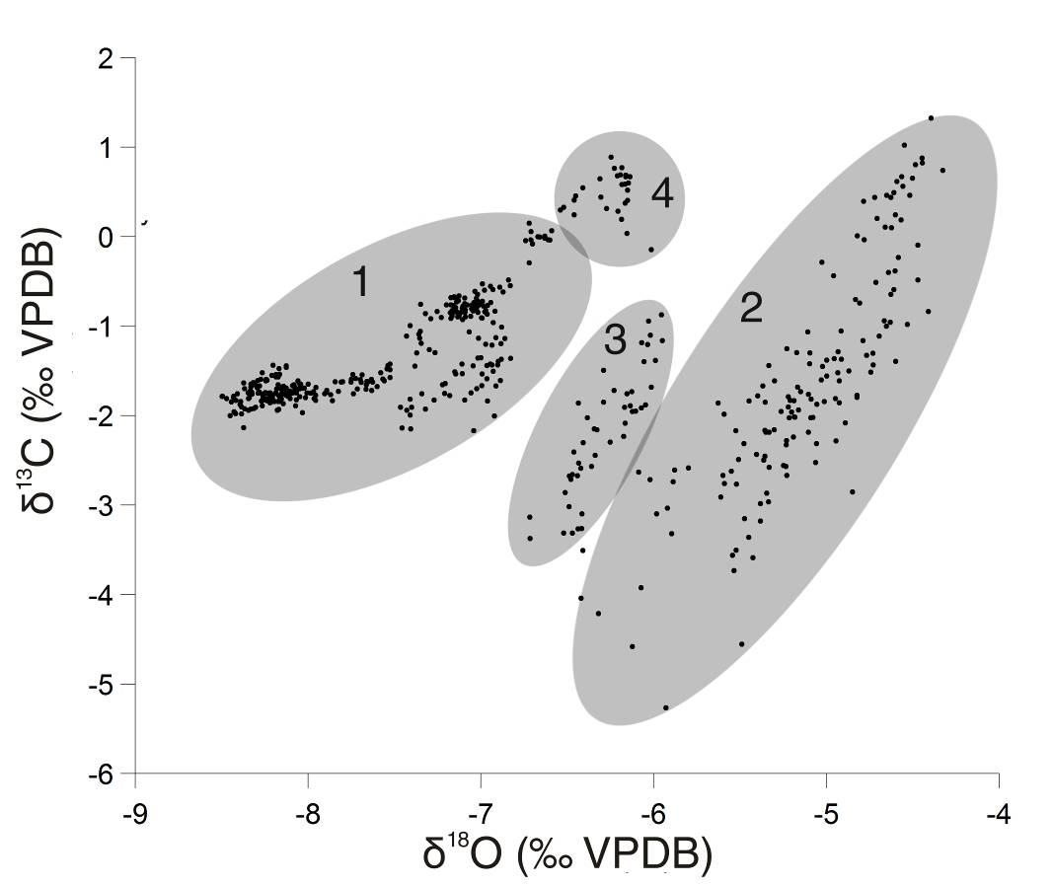
Figure 2-14- Covariance for Xing Yun A09 grouped into 4 time periods. 1- 400 BC to 1360 AD. 2- 1360 to 1880 AD. 3- 1880 to 1970 AD. 4- 1970 AD to present.

The clustering of surface water isotopic values suggests that this is not a random phenomenon. The isotopic evolution of Xing Yun’s lake water appears to be influenced by human activity. Beginning with the Yuan Dynasty around 1300 AD, people began large scale exploitation of the copper and silver ores in the province . Mining activity continued to increase which undoubtedly had an impact on the landscape. An even more drastic change to the landscape occurred during the Qing Dynasty, when the government began encouraging Han people to immigrate into the Yunnan Province . These immigrants brought a new style of agriculture and new crops such as maize, sweet potatoes, peanuts, tobacco, and opium (see page 44 for more detail). A rapid expansion in not only the scale of agricultural activities but also the carbon pathway of the plants would have had an impact on the soil. The soil from the catchment area washed into Xing Yun Lake and caused the δ¹³C record to diverge from the δ¹⁸O record. After 1360 AD, much of the change in the data points takes place across the δ¹³C (‰ VPDB) axis (Figure 2-14). This is evidence that human activity was having a profound impact on the watershed of Xing Yun as early as 1360 AD and that environmental degradation of the landscape has not been confined to the nineteenth century onwards.

Other Climate Comparisons
As discussed in the previous section, Xing Yun has a greater shift in oxygen isotopes during the LIA than the speleothem records in this region, suggesting that the effects of evaporation on the lake are important. However, the speleothem records, which are not evaporation sensitive, do seem to show the same transition periods when compared with Xing Yun, though smaller in magnitude (Figure 2-15). Wanziang is located in more central China and only spans back to 200 AD, however the transition into and out of the LIA is documented with shifts of as much as 1.00‰ . It also appears that Wanziang displays the transition into the MCA, but subsequent δ¹⁸O values do not show a wet period as Xing Yun does. So evaporation is important and occurs in speleothems, but there must also be changes in the source of precipitation related to the amount of effect of the monsoon.
Dongge Cave is located close to Xing Yun, has a high resolution, and has slightly greater shifts in δ¹⁸O than Wanxiang . However, when the two records are closely examined, there is little resemblance. Dongge does appear to document the transition into the LIA and δ¹⁸O values during the LIA appear to be enriched. There is also some potential agreement during the wet period of the MCA, yet given the proximity of Dongge Cave, there should be more agreement. Xing Yun is recording evaporative moisture changes, whereas the speleothem records are only recording slight temperature changes; Xing Yun records δ¹⁸O shifts of as much as 3.00‰, while the speleothems shift only by 1.50‰. Thus, the effects of evaporation, precipitation, and monsoon strength might be better recorded in lake sediments.

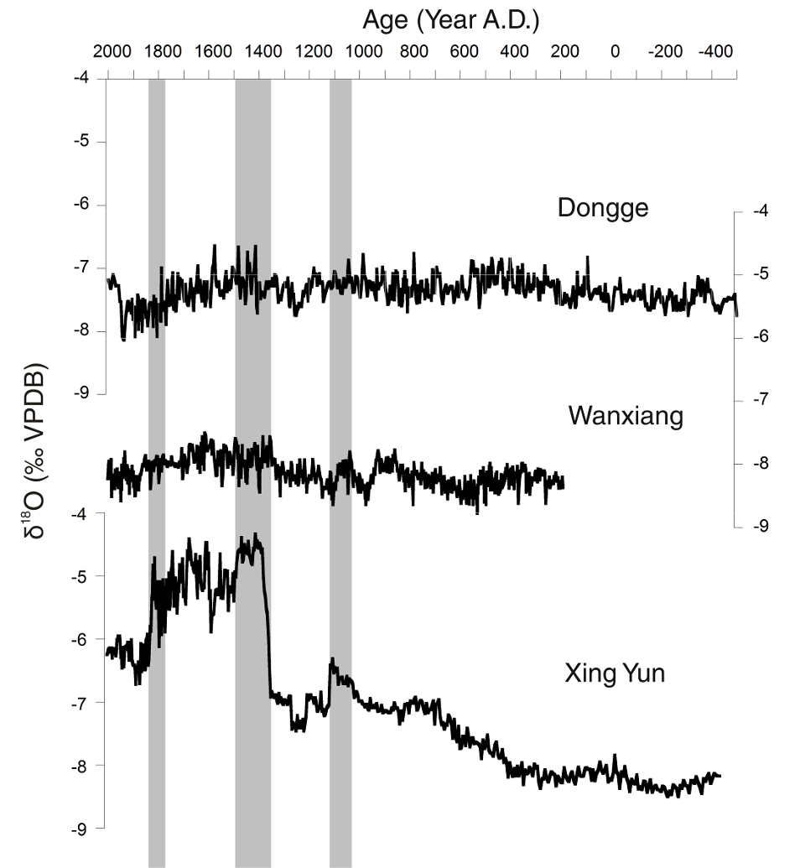
Figure 2-15- Xing Yun compared to Dongge and Wanxiang Cave records. Highlighted areas are potential periods of agreement.

Tree rings have been used to reconstruct the PDSI (Palmer Severity Drought Index) for southwest Asia for the past 700 years using gridded computer models . We took the grid point closest to Xing Yun, calculated a 10 year running average of PDSI and compared it to Xing Yun (Figure 2-16). Periods where PDSI was greater than 1.0 are often periods of δ¹⁸O enrichment in Xing Yun, yet while Xing Yun shows persistent drought throughout the LIA, the PDSI reconstruction only shows short periods of drought. The majority of the last 700 years have been dominated by the LIA so the PDSI record gives little long term context. Dendrochronology has been invaluable in understanding short term climate signals; however, long term cooling trends, such as the LIA, are difficult to capture in tree rings due to biological complications and the short life span of trees . This is likely the reason that the PDSI record does not show the substantial drought in the LIA as Xing Yun does.
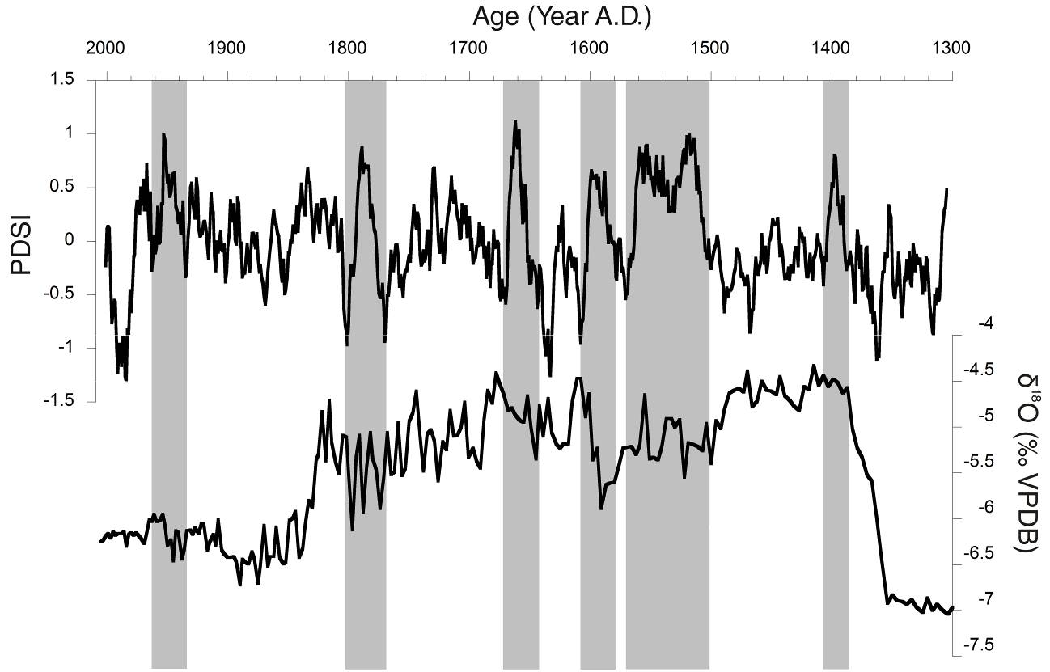
Figure 2-16- Error: Reference source not found PDSI reconstruction compared to Xing Yun. Highlighted areas indicate potential periods of agreement.

Lastly, because the AM is known to have a complex relationship with ENSO, Xing Yun was compared to a multi-proxy ENSO reconstruction that dates back to 1500 AD . Based on previous research, Xing Yun is anti-correlated with ENSO strength at certain time periods (Figure 2-17) . The most notable period of anti-correlation occurs late in 1500 AD when an unusually strong ENSO is linked to a moderately wet period in Xing Yun during the LIA. In this period, as in other periods of anti-correlation, it appears that the ENSO cycle slightly precedes the shift in δ¹⁸O isotopes of Xing Yun. This runs counter to what previous researchers have found about the linkage between ENSO and the AM; however, most research about the relationship between the two has concentrated on only the last 100 or so years . Xing Yun potentially shows that the relationship between ENSO and the AM may have been continually changing over centuries.

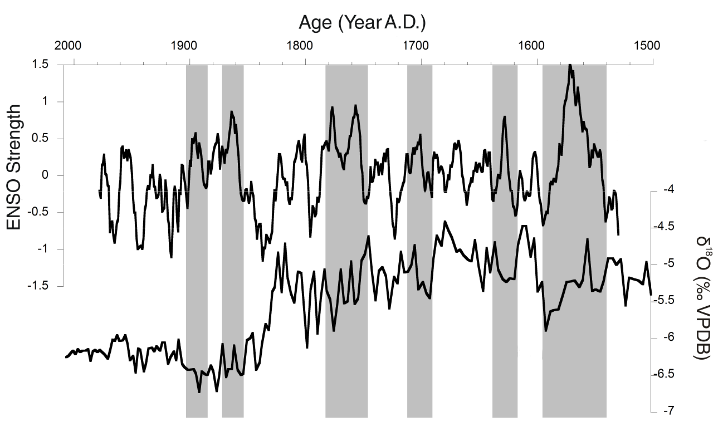
Figure 2-17- Error: Reference source not found ENSO reconstruction compared to Xing Yun. Highlighted areas are potential periods of anti-correlation.

CONcLUSION
Using the authigenic carbonate precipitated from lake sediments in Xing Yun has resulted in a useful paleoclimate record that illuminates the details of climate change in southwestern China. Our record shows good agreement with other existing records in this region, but highlights some important new features. The MCA was a brief period of increased monsoon strength in an otherwise weakening monsoonal trend. The LIA was a period of weak monsoons, the strength of which has not been seen before. The advantage of using lake sediments over speleothems, which many paleoclimate records rely on, is that shifts in precipitation rather than temperature are recorded. Paleolimnological records better insight into the cyclical nature of drought in this region, particularly when overlain with factors such as ENSO. Another advantage of using lake sediments is capturing the covariance of δ¹⁸O and δ¹³C, providing insight into the extent of human activity.

A 2500 YEAR HISTORY OF HUMAN ACTIVITY IN SOUTHWESTERN CHINA

INTRODUCTION
The earliest hominid occupation of China likely occurred in northern regions approximately 1 million years ago and people were settled in the Yunnan Province by the Neolithic period . A few archaeological sites from the Dali region have been radiocarbon dated to 3000-1800 BC while many more sites throughout the Yunnan Province are dated to 1800-1000 BC . The region where Xing Yun Lake is situated has several archaeological sites of interest. Shell mounds and other evidence of fishing and hunting are located near many lake basins such as Fuxian and Dian .
During the Bronze Age, the archaeological evidence of bronze production in Yunnan is disputed, mainly on the basis of radiocarbon dates. Sites of bronze mining and manufacturing at Haimenkou and Nagu have radiocarbon dates of 1000 BC, which are rejected by some scholars . Further investigation in 2008 confirmed these dates with supported stratigraphic evidence . Little archaeological information is available between the first tentative bronze mining and the emergence of the Dian culture around 800 BC surrounding Lake Dian . The site closest to Xing Yun Lake is Lijiashan, which was rich in bronze artifacts and was likely related to the Dian culture (Figure 3-18) .
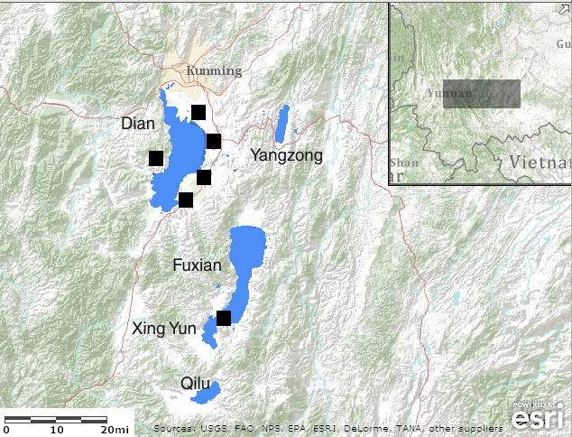
Figure 3-18- Map of archaeological sites of interest in the Yunnan Province adapted from ESRI 2010. All sites are from the Dian culture mentioned in Error: Reference source not found
Subsequent history of Yunnan, in relation to the history of China, is difficult to unravel since Yunnan has frequently broken off from Chinese government and remained independent. James Scott describes Yunnan and much of southeast Asia as a region called “Zomia”, characterized by populations that avoid government and are fairly self-contained . Self-containment is possible through the conscious use of escape agriculture in direct opposition to the monoculture agriculture typically used by the state . Escape agriculture is typified by shifting methods of cultivation where diverse crops are planted continuously leading to staggered crop maturity . Staggered maturity allows crops to remain in the ground for long periods of time while providing a constant food supply to the population . Typical crops that fit this requirement include sorghum, barley, cotton, buckwheat, and pearl millet .
This style of agriculture was pursued in the Yunnan Province with little to moderate interaction with the Chinese government. However, the Chinese dynasties had an interest in Yunnan because of its mineral deposits such as gold, tin, lead, copper, and silver (Figure 3-19) (Figure 3-20) (Figure 3-21) . Of particular interest was the mineral chalcosite (CuS₂) because it yields up to 79.9% Cu, which is twice as much copper as most ores . As early as the first century AD, Yunnan was well-known for its metal and continued to be mined throughout history . Yunnan was so prodigious in metal deposits that beginning with the Yuan Dynasty in 1300 AD, copper and silver were taxed . Tax records show that Yunnan was producing approximately half of all silver in China . Similar levels of mining and taxing continued through the Ming Dynasty with Yunnan producing perhaps as much as 75% of China’s total silver during some years (Table 3-3) . These figures probably underestimate actual silver production since regional mining activities were not recorded or taxed . The method of extracting silver was through a process known as cupellation where the ore was heated, oxidizing waste materials such as lead, and leaving valuable materials such as silver in a useable state (Figure 3-22) . This method was likely used as early as the Warring States period in 600 BC, but explicit mention of it in historical records did not occur until roughly 900 AD .

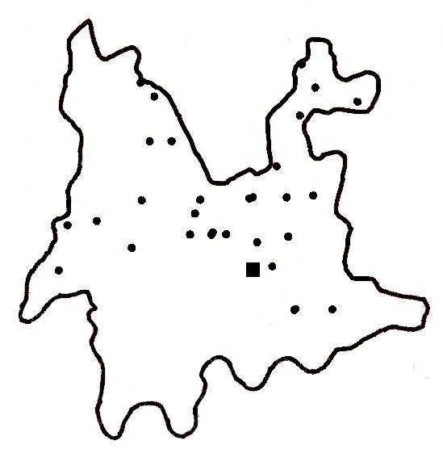
Figure 3-19- Map of pre-20th century copper mines in the Yunnan province adapted from Error: Reference source not found The square is the approximate location of Xing Yun.

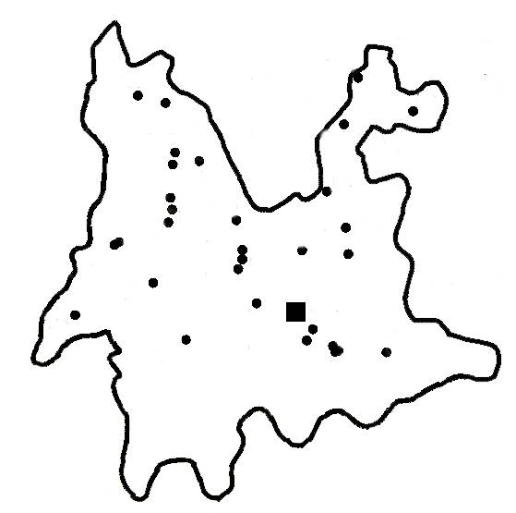
Figure 3-20- Map of pre-20th century silver mines in the Yunnan province adapted from Error: Reference source not found The square is the approximate location of Xing Yun.
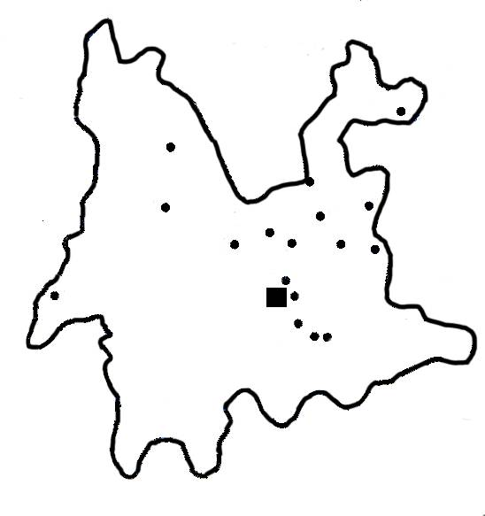
Figure 3-21- Map of pre-20th century tin and lead mines in the Yunnan province adapted from Error: Reference source not found The square is the approximate location of Xing Yun.

Table 3-3- Estimates of silver taxation from the Yunnan Province during the Ming dynasty from Error: Reference source not found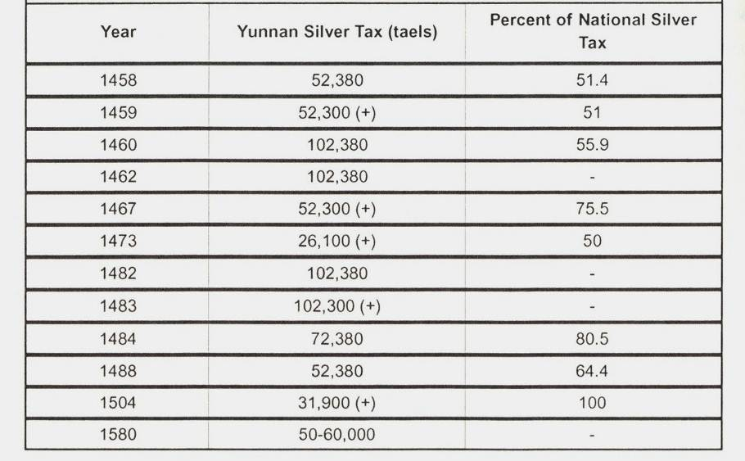

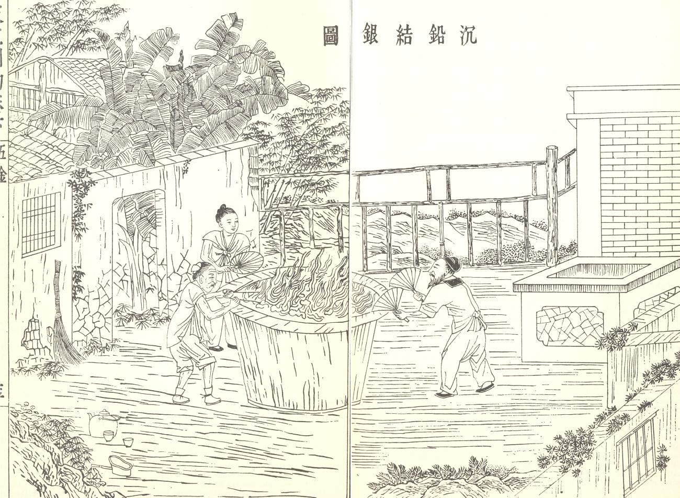
Figure 3-22- Cupellation of argentiferous lead in the Yunnna province from Error: Reference source not found
With the beginning of the Qing Dynasty in 1644 AD, Yunnan experienced sweeping cultural and economic changes. A rapidly growing population led immigrants to settle further into the Yunnan Province, spurred by government tax exemption and grants . Unlike previous immigrants during the Ming Dynasty, immigrants from the Qing Dynasty were able to push into mountainous areas previously only accessed by the native populations . Immigrants transformed the mountainous regions by practicing slash and burn agriculture and introducing new agricultural techniques like terracing . The old crops of escape agriculture were replaced by New World crops such as maize, sweet potatoes, peanuts, tobacco, and opium . The influx of workers led to the intensification of mining, particularly copper . Copper mining in Yunnan became so important that a great deal of the Qing economy depended on Yunnan meeting production quotas set by the Chinese government . Initially copper was supplied by Japan until Japan implemented trading regulations that limited the amount of copper China could buy . Thus it was in 1726 AD that the Yunnan province and its many copper ores entered the peak of mining (Table 3-4) .

Table 3-4- Estimates of yearly copper production in Yunnan from Error: Reference source not found 1 jin is equivalent to 2 kg.
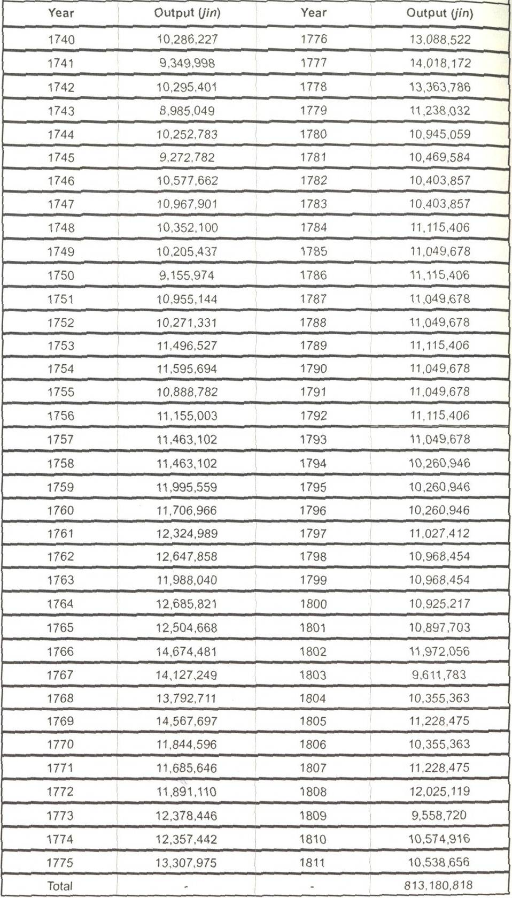

The opportunity for jobs and government tax credits led to huge growth in Yunnan and surrounding areas. Yunnan and Guizhou Provinces had a population of 5 million in 1700 AD and 20 million in 1850 AD . Early demographics for this region of China before the Ming Dynasty are not always included in Chinese historical documents and those census records that are available are often inaccurate since women, children, and certain minority groups were not counted . Historical records and demographic extrapolation estimate the population of Yunnan in the sixteenth century to be around 2 million with regions around Dian Lake being densely populated . The Ming Dynasty encouraged immigration into the Yunnan Province before the Qing Dynasty, however it was not as successful and most immigration was concentrated on the western edge of the province . Consequently, the population grew sporadically with slow overall growth and Yunnan likely reached a population of 3 million by 1740 AD . By 1850 AD the population in Yunnan was 10 million with increased urbanization and perhaps as much as 10% of the population living in the city . Meanwhile, the bulk of food production and agriculture took place away from the city .
By the nineteenth century, Yunnan’s ores were the source of much conflict. The French and British empires were attempting to make inroads to the Yunnan province to access the ores . The Han and Muslim Chinese fought over control of the silver mines which erupted into a rebellion . By 1900 AD, Yunnan had one of the few minting operations that were permitted to create the silver dollar . As the political situation in China became tumultuous and the Chinese Republic was founded, the situation in Yunnan became increasingly chaotic with numerous rebellions . It has been pointed out that Chinese mining did not undergo any technological innovations over the thousands of years due to the huge source of manual labor that was available . Thus a miner in the Yunnan province in 900 AD would not find the technology much changed by 1900 AD .
The river basins of the Yunnan Province continued to play an important role in human agriculture and irrigation, as they still do today. In 1923 AD and again in 1956 AD, the only outflowing river of Xing Yun lake was dredged and widened the channel that connects Xing Yun and Fuxian today . This allowed water to flow from Xing Yun into Fuxian and dropped Xing Yun Lake level by 2.0 m in 1923 AD and an additional 1.0 m in 1956 AD . As of 2000 AD, the Yunnan Province is home to 43 million people with 10 million ethnic minorities . Yunnan has suffered cumulative environmental damage that has only recently been quantified. Using historical documents, a reconstruction of forest coverage rates estimates that in 1850 AD the province was covered in 45% forest and had declined to 30% by 1949 AD . Water samples from Xing Yun were taken in 1994 AD and revealed elevated nutrient concentrations which indicate pollution from deforestation and agriculture . More recent water studies also indicate moderate eutrophication and effluent pollution .

METHODS

Chronology
Xing Yun cores were taken in the summer of 2009. One core (D1) was taken with a piston core filled with a 5.5 cm diameter removable polycarbonate tube and measures 133.5 cm. Once the sediments became too difficult to penetrate with the polycarbonate tube, a steel barrol Livingston corer was used. The two Livingston cores D2 and D3 were taken and extruded in the field. They measure 92 cm and 96 cm respectively. Altogether these three cores produce a total record of 2.640 m. D1 and D2 overlap by 47.5 cm and D2 and D3 overlap by 10 cm on the basis of field notes and stratigraphic comparison of oxygen isotopes, carbon isotopes, and magnetic susceptibility.
The age model was produced using ¹⁴C radiocarbon, ²¹⁰Pb, and ¹³⁷Cs measurements. The upper 56 cm of D1 was extruded in the field at 0.5 cm intervals and used for ²¹⁰Pb and ¹³⁷Cs dating. Samples were freeze dried and equilibrated in a cold storage room at the University of Pittsburgh. Dating was performed on a Canberra Germanium Detector BE2020 at the University of Pittsburgh for 23 hours to detect γ radiation. An age depth model of ²¹⁰Pb dating was created on the basis of the CRS model . ¹⁴C radiocarbon dating was performed on 6 samples which were pretreated using the standard acid, base, acid procedure of . Samples were measured the University of California Irvine. Dates were calibrated using Calib 6.0 (Table 3-5) . On the basis of these 2 dating techniques, the following age-depth model was produced (Figure 3-23).

Table 3-5- Radiocarbon dates.
Core | Drive Depth (cm) | Total Depth (cm) | Material | ¹⁴C age (¹⁴C years BP) | ¹⁴C age error | Median calibrated age (cal years BP) | 2-sigma calibrated age range (cal years BP)
A-09 D1 | 35.5 | 35.5 | Wood | 110 | 25 | 112 | -4-268
A-09 D1 | 37.5 | 37.5 | Charcoal | 110 | 50 | 123 | -4-277
A-09 D1 | 59.0 | 59.0 | Charcoal | 130 | 25 | 124 | -3-273
A-09 D2 | 59.0 | 145.0 | Charcoal | 1060 | 25 | 962 | 928-1052
A-09 D3 | 82.0 | 250.0 | Wood | 2105 | 20 | 2078 | 2003-2140
A-09 D3 | 95.0 | 263.0 | Charcoal | 2220 | 20 | 2226 | 2153-2347

Figure 3-23- Age depth model for Xing Yun A09. Circles denote ¹⁴C dates, squares denote ¹³⁷Cs dates, and triangles denote ²¹⁰Pb dates.

Sampling
The cores were sampled at a 0.5 cm interval and stored in polycarbonate scintillation vials. Samples for ICP-MS measurements were taken every 6 cm from the depth of 211.5 cm to 53 cm. From the depth of 53 cm to the top of the core, samples were measured every 1-3 cm. All samples were freeze dried and weighed at the University of Pittsburgh. Elements were extracted using 10 mL of 1 M HNO₃ overnight, a standard method for extracting trace metals from organic lake sediments . 0.2 g of the acid extraction was measured on the ICP-MS at the University of Alberta (Table 3-6). Sedimentation rate was calculated as the change in depth in cm divided by the age of the sediment according to the age model. Bulk density samples measuring 1 g cm⁻³ were taken every 2 cm down the entire length of the core less than 24 hours after the core had been opened. These were weighed immediately and again after 36 hours in a drying oven. Concentrations in ppm were converted to flux by multiplying sedimentation rate, dry bulk density, and concentration.

Table 3-6- Measured elements and detection limits.
Element | Detection Limit (ppm) | Element | Detection Limit (ppm)
Na | 0.50 | Sn | 0.06
Mg | 2.00 | Sb | 0.01
Al | 0.20 | La | 0.03
P | 5.00 | Ce | 0.03
K | 6.00 | Pr | 0.04
Ca | 31.00 | Nd | 0.03
Sc | 0.10 | Sm | 0.04
Ti | 0.09 | Eu | 0.03
V | 0.05 | Gd | 0.03
Cr | 0.05 | Tb | 0.03
Mn | 0.03 | Dy | 0.04
Fe | 3.70 | Ho | 0.02
Co | 0.03 | Er | 0.04
Ni | 0.06 | Tm | 0.06
Cu | 0.03 | Yb | 0.05
Zn | 0.08 | Lu | 0.04
As | 0.06 | W | 0.08
Se | 0.20 | Os | 0.08
Sr | 0.03 | Ir | 0.04
Y | 0.02 | Au | 0.01
Zr | 0.09 | Tl | 0.05
Mo | 0.08 | Pb | 0.03
Ag | 0.01 | Bi | 0.01
Cd | 0.06 | In | 0.03

Principal component analysis was performed using MatLab 7.10.0 and the following code:

stdr = std(data);
sr = data./repmat(stdr,56,1);
[coefs,scores,variances,t2] = princomp(sr);
biplot(coefs(:,1:2))
percent_explained = 100*variances/sum(variances)

Weight percent carbon and nitrogen was sampled every 2 cm for the length of each drive. Samples were covered in 1 M HCl for 24 hours to dissolve organic carbon. Samples were then freeze dried at the University of Pittsburgh and analyzed at the University of Florida. Weight percent carbon and nitrogen as well as carbon to nitrogen ratio were measured.

RESULTS
For the purposes of isolating the effects of local mining and smelting on the landscape, we will focus on the trace metal concentrations of Bi, Pb, and Sb which have been previously shown to indicate pollution from ores . Pb is particularly useful because it is relatively immobile in sediments . The earliest sample was taken from 2.115 m, corresponding to a cal year of 275 AD. Samples from 275-928 AD have low flux for all elements and represent background levels (Figure 3-24). After 928 AD, all elements show a slow rise in flux with Pb having a lower slope than Bi and Sb. Flux reaches a temporary peak at 1213 AD and fluctuates until 1584 AD. After 1584 AD, flux begins to increase again until a peak is reached at 1788 AD. Pb continues to decrease and Bi and Sb fluctuate over the rest of the period.
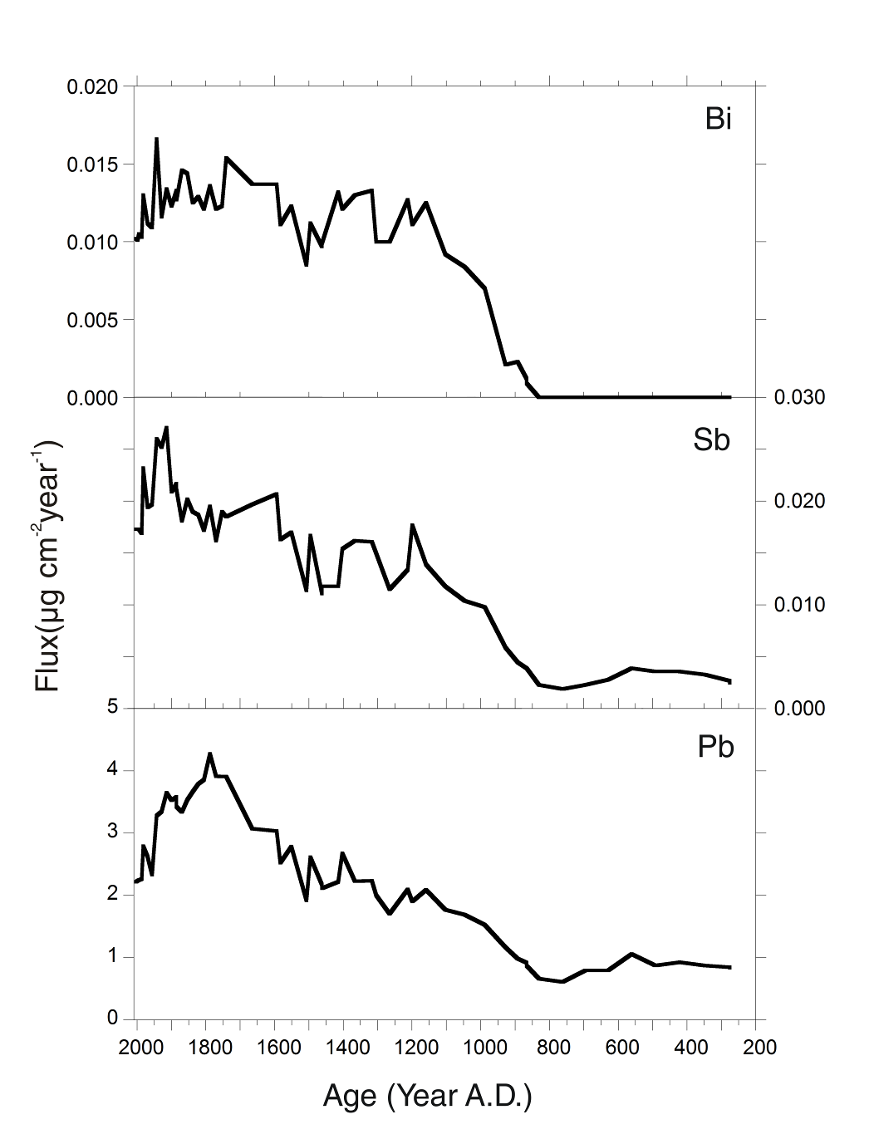
Figure 3-24- Calculated metal flux for selected elements.

Principal component analysis revealed that component 1 explained 74.5% of the variance and component 2 explained 11.8% of the variance, for a total of 86.3%. A plot of 41 measured elements reveals that there are 3 distinct groupings (Figure 3-25). Elements associated with lithogenic inputs plot negatively for component 1 and positively for component 2. Elements associated with metal pollution plot positively for component 1 but negative for component 2. All other elements plot positively for both component 1 and 2. No elements plot negatively for both component 1 and 2.
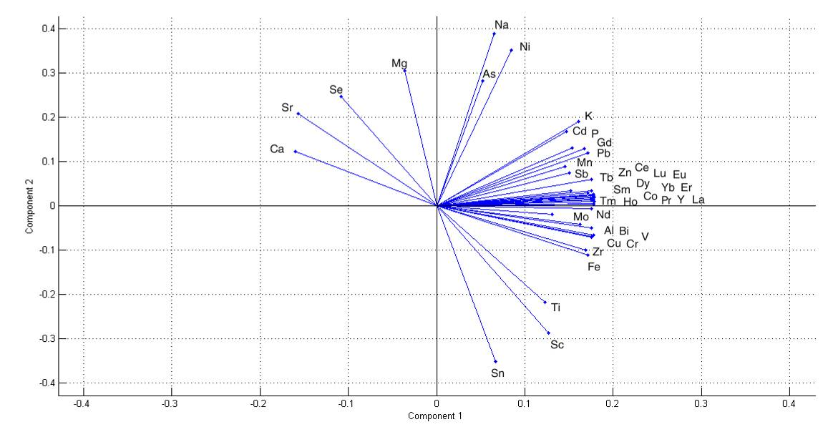
Figure 3-25- Biplot of PCA loadings for 41 measured elements.

Carbon to nitrogen ratio is low through the whole record. The ratio stays stable between 10 and 12 from 200 to 1100 AD (Figure 3-26). Thereafter, the ratio fluctuates but generally decreases until 1500 AD. From 1500 to 1850 AD, the ratio drops to 7. From 1850 AD to present day, the ratio fluctuates between 8 and 10. These results, coupled with δ¹³C values between -25 and -30‰ indicate that the dominant organic matter source is lacustrine algae .
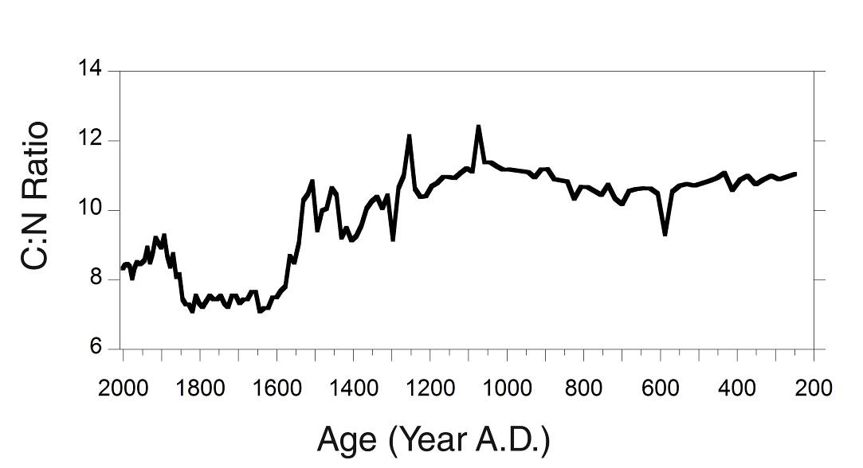
Figure 3-26- Carbon to nitrogen ratio in Xing Yun A09.

DISCUSSION
Metal concentrations were converted to flux (μg cm⁻² year⁻¹) to better understand metal enrichment over time. Likewise, the age model was used to convert core depths into years for comparison with other sediment records and human history. Period of Chinese history were noted to see how cultural changes compare with geochemical results (Figure 3-27). The initial rise takes place at the end of the Tang Dynasty and into the period of political instability known as the Five Dynasties and Ten Kingdoms where there was no unified dynasty . It is possible that this metal enrichment reflects greater human activity, increased land clearing, and more erosional input to the watershed. However, historical records indicate that the population in Yunnan remained relatively stable until roughly 1700 AD . Additionally, reconstruction of forest coverage suggests that in the last 150 years only 15% of forest was lost and land clearing was not a major operation in the province . Calculated sedimentation rates, magnetic susceptibility, and carbon to nitrogen ratio results of Xing Yun also indicate that significant changes to the watershed did not begin until 1300 AD (Figure 3-28).
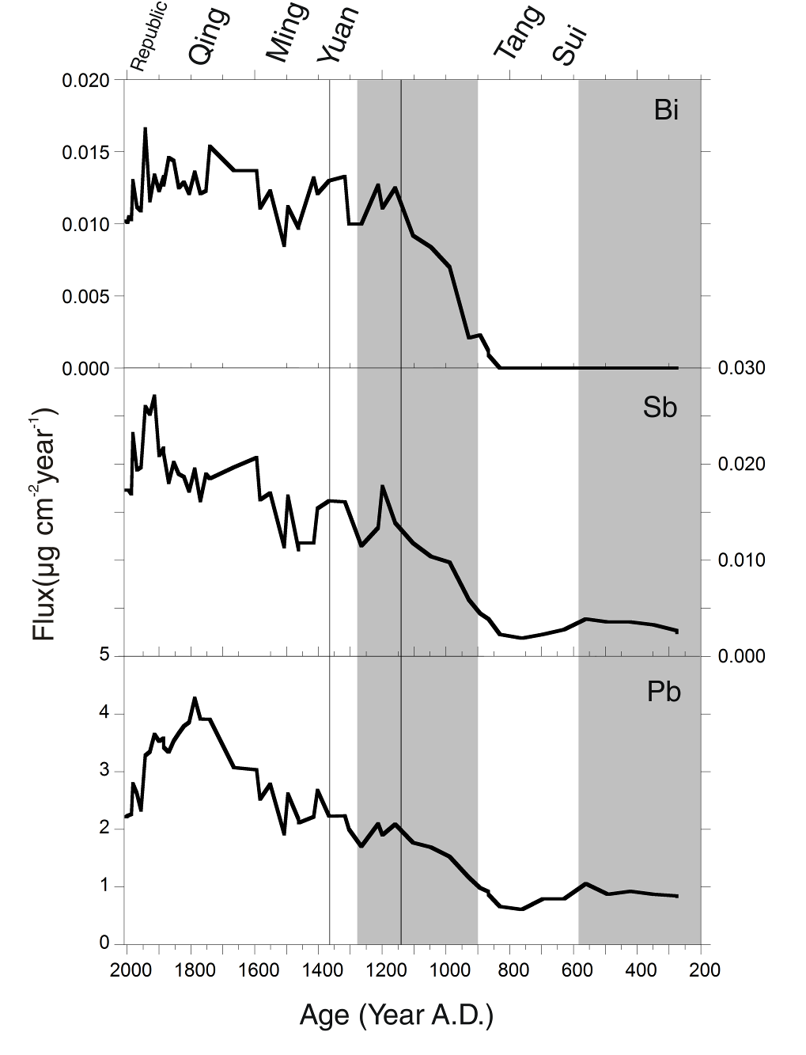
Figure 3-27- Calculated metal flux for selected elements. Shaded areas represent periods where there was no unified empire. Lines represent transitions into the MCA and the LIA.

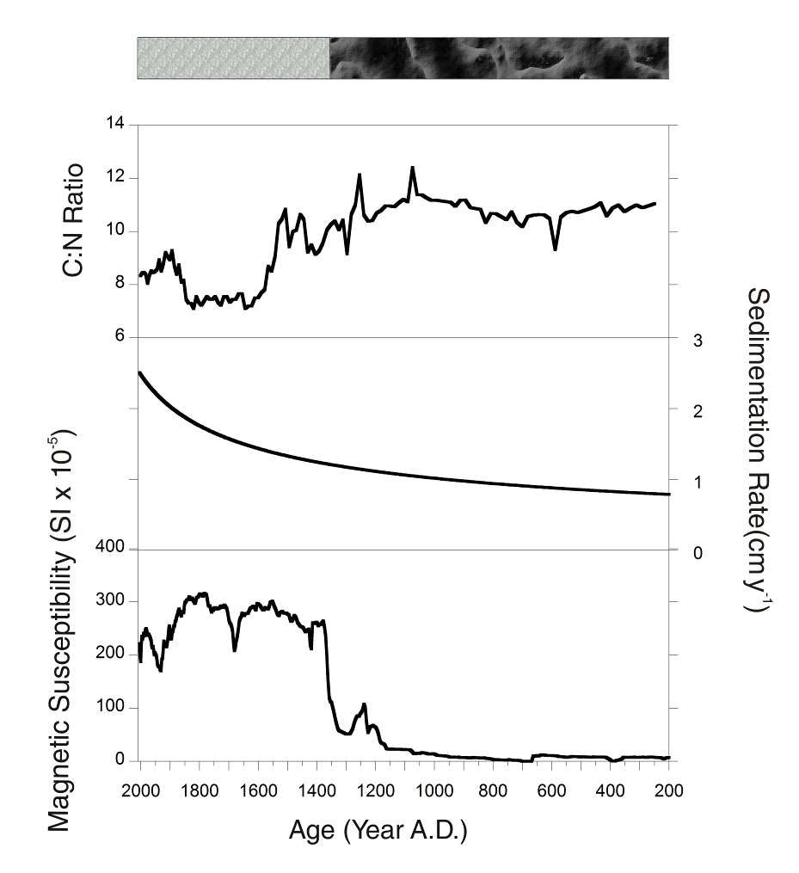
Figure 3-28- Stratigraphic column indicating red color and presence of pyrite in light pattern, dark color and lack of pyrite in dark pattern, carbon to nitrogen ratio, calculated sedimentation rate, and magnetic susceptibility for Xing Yun A09.

While historical records document mining before 930 AD, the geochemical record does record this activity, which indicates that early mining probably took place in small select areas distant to XY. Historical records are ambiguous as to when the technique of refining silver and gold using cupellation first began . While it may have been used as early as 600 BC, explicit mention of cupellation in texts does not occur until roughly 900 AD . Hence, an alternative interpretation is that XY is registering atmospheric deposition of the waste products of cupellation which was in wide use by 900 AD.
Flux then drops again at the beginning of the Ming Dynasty and as southwestern China enters the cold and arid LIA. However, it is unlikely that the LIA had a great impact on mining activities since flux rises again with the onset of the Qing Dynasty even as the climate remains dry. As historical accounts indicate, the mines in Yunnan were especially prone to flooding and had to frequently be pumped dry, so it is possible that less monsoon activity was actually beneficial to the miners . Another consideration is the fact that because the Qing Dynasty encouraged migration into the Yunnan Province, the increased flux may be attributed to the sheer increase in mining labor rather than an increase in the scale of mining operations. This is plausible since Chinese mines relied on a great deal of cheap manual labor to haul the ores out of the mine . As Yunnan entered its peak of mining in 1700 AD, there is a corresponding rise in flux as metals reach their peak during this time period.
Additional proxies indicate that the Xing Yun watershed experienced changes as early as 1100 AD which increased substantially by 1500 AD (Figure 3-28). This is the time period where immigrants increased in number and began intensively working the land with terracing . Terracing likely increased the runoff, lithogenic, and nutrient input to the lake which caused eutrophication and algal blooms as evidenced by the increased sedimentation and decreasing carbon to nitrogen ratio. Eutrophication decreases the amount of dissolved oxygen in the water column, which caused Xing Yun to become enriched in reduced iron. The high magnetic susceptibility values, precipitated pyrite, and rapid oxygenation of the core at the surface all support this interpretation. Increased terracing of the land does not necessarily imply increased deforestation of the watershed, since carbon to nitrogen ratios typically increase with deforestation .
After 1790 AD, lead reached a peak whereas bismuth and tin continued to increase. As the Qing dynasty came to power, focus shifted from silver to copper . This is likely why lead reached a peak and began to decrease even though mining activity in Yunnan was still extensive. Subsequent decline in flux is likely due to the political instability in the region. As the Qing dynasty fell, Yunnan was subject to foreign and indigenous takeover and after the Chinese republic was formed, Yunnan is hardly mentioned in history books. The declining meal flux is due to declining interest in mining and what flux remains is due to pollution from human activities in the watershed.
PCA suggests that component 1 defines the gradient between those elements that originate lithogenically from the landscape and those that are the result of human activity . Arranging the samples in stratigraphic order, component 1 scores increase which indicates increasing anthropogenic influence that tails off around 1800 AD (Figure 3-29) . The increase in component 1 scores takes place in the year 930 AD, supporting the interpretation that this is the first indication of increasing anthropogenic mining and metallurgy in the watershed. Component 2 also seems to play a role in identifying elements of anthropogenic origin, but it is more ambiguous, since elements such as Bi and Sb plot negatively, while Pb plots positively.
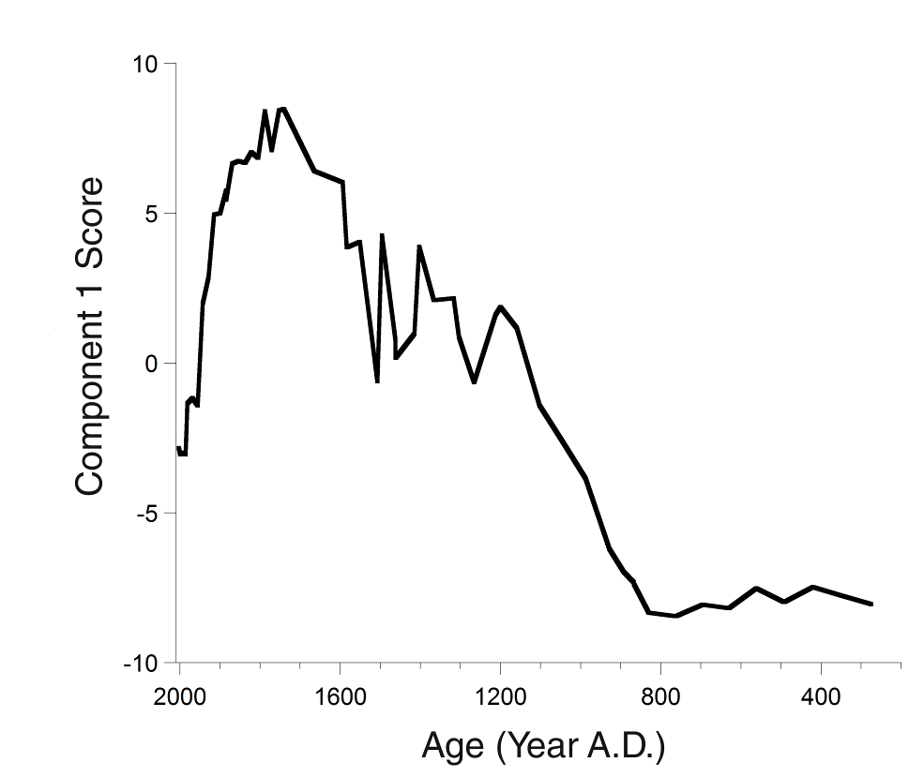
Figure 3-29- Fifty six samples plotted with component 1 scores.

CONCLUSION
Performing trace metal analysis on 56 samples spanning a time period of roughly 1,800 years gives valuable insight into the timing and extent of the metallurgy activities of early Yunnan people. While historical records suggest that Yunnan people were mining by 800 BC, the record from Xing Yun does not pick up this activity, which indicates that early mining probably took place in small select areas not near Xing Yun Lake. The Yunnan Province has traditionally been isolated from the Chinese government, but once the Chinese dynasties took an interest in Yunnan’s ores, mining intensified to such an extent that the pollution is seen in Xing Yun Lake. More importantly, this record shows that the encouragement by the Qing Dynasty to migrate into Yunnan had a drastic impact on the magnitude of mining activities and the subsequent pollution to the watershed.
Future work is to measure Hg concentration and Hg and Pb isotopes at the same intervals as the other trace metals. Measuring Hg and Pb isotopes has the potential to reveal the source of the ore used for smelting which could help explain why Xing Yun does not show the impact of mining prior to 930 AD. Taking these proxies and combining them with other environmental indicators is essential to understanding how people interacted with their environment in the past and what this can say about interaction today.

THE INTERACTION BETWEEN HUMAN activity AND LANDSCAPE DEVELOPMENT
History teaches us that those who ignore the environment and its changing climate can often face devastating consequences. There are numerous examples, but none more striking than the Mayan civilization whose collapse was likely influenced by the intensification of drought . Throughout our work in southwestern China, it is clear that no society is immune to the impact of rapid climate change. While some would make the claim that Chinese history and dynastic transitions have been directly impacted by changing climate patterns, what we see is a much more subtle impact on society .
Using the stable isotopes of authigenic carbonate from Xing Yun Lake, it is clear that southwestern China has experienced several dramatic shifts in climate in the last 2,500 years. Due to precessional forcing, the strength of the AM was slowly weakening for at least 1,500 years of Xing Yun’s record. Several speleothem records have interpreted small shifts in δ¹⁸O as evidence of drastically changing monsoon strength, but Xing Yun puts these shifts into perspective and suggests that many of the shifts may be trivial. Using the trace metal record to track mining and other human activity, it appears that the slowly shifting monsoon strength had a negligible impact on society in southwestern China. As James Scott has proposed, the Yunnan Province also appears immune to the political chaos of dynastic China since trace metal flux continued to rise despite government instability.
The Medieval Climate Anomaly (MCA) is the first major perturbation in an otherwise stable period, causing a brief wet period that lasted for roughly 250 years. This is also a period of time when trace metal flux increases for which there are two possible explanations. The rise in trace metal flux might have occurred at the same time as the MCA by pure coincidence. Trace metals were already on the rise 200 years prior to the MCA and continued to rise as a result of increased mining demand. However, it is also possible that the wetter conditions of the MCA caused greater agricultural yield, leading to a greater population, and increased mining activity. The onset of the MCA is when the trace metal fluxes show the greatest increase as well as when component 1 scores become positive. If this increase in trace metal flux were purely the result of increased land clearance and erosional input to the watershed, evapotranspiration would decrease, increasing water flow to the lake, and causing oxygen isotopes values to decrease . However, this is not the case for the oxygen isotopes of the Xing Yun throughout the entire period of metal enrichment.
The transition from the MCA into the Little Ice Age (LIA) is extraordinarily rapid, taking place well within a human lifetime. The climate in southwestern China during the LIA matches well with what has been modeled; however the severity of the drought is far beyond what many speleothem records in this region record . The dry LIA lasted for at least 500 years and likely had an impact on mining activities as trace metal flux takes a slight downturn. The values of trace metal flux still remain high and are comparable to the values of the MCA, but the increase is not as great as expected had flux continued on a similar increasing trajectory. However, this is by no means an indication of environmental determinism. Other proxies indicate that society in the Yunnan Province continued to grow, specifically after the Qing Dynasty encouraged migration into the province. Indeed, this is likely why trace metal flux begins to rise again as more Han immigrants meant more mining labor. It is also important to note that around the same time, the δ¹³C record took an unprecedented negative shift and no longer matched the δ¹⁸O record. Carbon to nitrogen ratio, magnetic susceptibility, and stratigraphic characteristics all indicate that this was the result of increased nutrient delivery to the watershed producing eutrophication.
As the LIA ends in the nineteenth century conditions became wetter, but not as wet as they were roughly 1,000 years ago. Xing Yun indicates that present day monsoon strength is weak compared to the past 2,500 years. With this data set, it is impossible to predict what the future will hold for the Asian Monsoon, but regardless of the outcome there are important lessons to be learned from the past. With such a variable climate occurring in this small sector of the world, we must ask ourselves how society responded to these changes. How were Yunnan people able to shift their lifestyles to accommodate a dry climate without major disruption to society? Do historical or archaeological records indicate these periods of drought? Were people consciously aware of their shifting environment or did they make unconscious adaptations? Additionally, it is important to note that environmental degradation has been taking place for hundreds of years. While we may traditionally think of the Industrial Revolution as the start of widespread pollution, instead we see that wherever humans cluster together for long periods of time, they can dramatically change their landscape. Learning lessons from past civilizations may prove to be the key to adapting to future climate change.
APPENDIX A
TABLE OF DATA FOR DRIVE 1
Total Depth (mm) | Core Depth (mm) | Age (years BP) | Cal Year | Corr. δ¹⁸O | Corr. δ¹³C | Magnetic Susceptibility (k x 10⁻⁵ SI)
5 | 5 | -55 | 2005 | -6.25 | 0.89 | 221.55
10 | 10 | -53 | 2003 | -6.23 | 0.77 | 198.55
15 | 15 | -51 | 2001 | -6.19 | 0.69 | 187.45
20 | 20 | -49 | 1999 | -6.16 | 0.67 | 219.30
25 | 25 | -47 | 1997 | -6.21 | 0.68 | 235.60
30 | 30 | -45 | 1995 | -6.14 | 0.67 | 229.15
35 | 35 | -43 | 1993 | -6.18 | 0.77 | 233.40
40 | 40 | -41 | 1991 | -6.16 | 0.59 | 241.65
45 | 45 | -39 | 1988 | -6.16 | 0.69 | 240.85
50 | 50 | -36 | 1986 | -6.14 | 0.60 | 235.65
55 | 55 | -34 | 1984 | -6.30 | 0.44 | 247.00
60 | 60 | -32 | 1982 | -6.17 | 0.37 | 250.20
65 | 65 | -30 | 1980 | -6.15 | 0.41 | 245.70
70 | 70 | -28 | 1978 | -6.18 | 0.59 | 241.70
75 | 75 | -26 | 1976 | -6.15 | 0.52 | 237.30
80 | 80 | -24 | 1974 | -6.18 | 0.20 | 239.75
85 | 85 | -22 | 1972 | -6.21 | 0.29 | 236.60
90 | 90 | -20 | 1969 | -6.27 | 0.32 | 235.70
95 | 95 | -17 | 1967 | -6.15 | 0.04 | 231.10
100 | 100 | -15 | 1965 | -6.01 | -0.14 | 226.40
105 | 105 | -13 | 1963 | -6.03 | -0.94 | 218.90
110 | 110 | -11 | 1961 | -5.95 | -0.87 | 213.15
115 | 115 | -9 | 1959 | -6.03 | -1.20 | 216.35
120 | 120 | -6 | 1956 | -6.02 | -1.10 | 208.85
125 | 125 | -4 | 1954 | -5.95 | -1.16 | 200.10
130 | 130 | -2 | 1952 | -6.07 | -1.18 | 204.55
135 | 135 | 0 | 1950 | -6.29 | -1.49 | 200.00
140 | 140 | 3 | 1947 | -6.23 | -1.72 | 200.10
145 | 145 | 5 | 1945 | -6.46 | -2.41 | 191.15
150 | 150 | 7 | 1943 | -6.13 | -1.73 | 181.85
155 | 155 | 9 | 1941 | -6.15 | -1.75 | 179.10
160 | 160 | 12 | 1938 | -6.44 | -1.86 | 178.35
165 | 165 | 14 | 1936 | -6.33 | -2.16 | 176.80
170 | 170 | 16 | 1934 | -6.13 | -1.89 | 171.80
175 | 175 | 19 | 1931 | -6.12 | -1.95 | 170.30
180 | 180 | 21 | 1929 | -6.17 | -1.90 | 191.90
185 | 185 | 23 | 1927 | -6.10 | -1.95 | 193.90
190 | 190 | 26 | 1924 | -6.16 | -2.08 | 205.20
195 | 195 | 28 | 1922 | -6.05 | -1.88 | 226.55
200 | 200 | 30 | 1920 | -6.05 | -1.39 | 222.60
205 | 205 | 33 | 1917 | -6.34 | -2.15 | 216.00
210 | 210 | 35 | 1915 | -6.25 | -2.29 | 222.75
215 | 215 | 37 | 1912 | -6.17 | -2.23 | 215.60
220 | 220 | 40 | 1910 | -6.29 | -1.85 | 222.00
225 | 225 | 42 | 1908 | -6.01 | -1.68 | 233.15
230 | 230 | 45 | 1905 | -6.34 | -2.44 | 249.05
235 | 235 | 47 | 1903 | -6.38 | -2.02 | 254.80
240 | 240 | 50 | 1900 | -6.42 | -2.59 | 246.75
245 | 245 | 52 | 1898 | Sample lost |  | 229.90
250 | 250 | 54 | 1895 | -6.41 | -2.30 | 231.25
255 | 255 | 57 | 1893 | -6.47 | -2.66 | 244.25
260 | 260 | 59 | 1890 | -6.72 | -3.13 | 243.70
265 | 265 | 62 | 1888 | -6.44 | -2.67 | 254.65
270 | 270 | 64 | 1885 | -6.48 | -2.71 | 254.25
275 | 275 | 67 | 1883 | -6.49 | -2.67 | 263.25
280 | 280 | 70 | 1880 | -6.36 | -2.57 | 265.60
285 | 285 | 72 | 1878 | -6.44 | -3.27 | 272.50
290 | 290 | 75 | 1875 | -6.71 | -3.37 | 275.85
295 | 295 | 77 | 1873 | -6.51 | -2.86 | 282.20
300 | 300 | 80 | 1870 | -6.07 | -1.91 | 287.00
305 | 305 | 82 | 1867 | -6.52 | -3.31 | 283.95
310 | 310 | 85 | 1865 | -6.41 | -3.50 | 277.95
315 | 315 | 87 | 1862 | -6.41 | -3.10 | 273.10
320 | 320 | 90 | 1860 | -6.09 | -2.63 | 281.95
325 | 325 | 93 | 1857 | -6.42 | -3.26 | 279.90
330 | 330 | 95 | 1854 | -6.49 | -3.02 | 279.20
335 | 335 | 98 | 1852 | -6.47 | -3.31 | 293.95
340 | 340 | 101 | 1849 | -6.02 | -2.71 | 300.20
345 | 345 | 103 | 1846 | -5.99 | -1.38 | 299.85
350 | 350 | 106 | 1844 | -5.92 | -3.03 | 303.70
355 | 355 | 109 | 1841 | -6.42 | -4.04 | 304.40
360 | 360 | 111 | 1838 | -6.32 | -4.21 | 305.15
365 | 365 | 114 | 1836 | -6.07 | -3.92 | 309.75
370 | 370 | 117 | 1833 | -5.80 | -2.58 | 309.00
375 | 375 | 119 | 1830 | -5.88 | -2.61 | 304.35
380 | 380 | 122 | 1827 | -5.36 | -2.16 | 306.20
385 | 385 | 125 | 1825 | -5.30 | -2.16 | 307.40
390 | 390 | 128 | 1822 | -4.83 | -0.70 | 302.45
395 | 395 | 130 | 1819 | -5.37 | -1.67 | 301.25
400 | 400 | 133 | 1816 | -4.71 | -0.51 | 297.10
405 | 405 | 136 | 1814 | -5.17 | -1.68 | 298.75
410 | 410 | 139 | 1811 | -5.38 | -2.98 | 307.45
415 | 415 | 142 | 1808 | -5.51 | -2.49 | 309.00
420 | 420 | 144 | 1805 | -5.09 | -1.82 | 309.25
425 | 425 | 147 | 1802 | -5.11 | -1.06 | 311.45
430 | 430 | 150 | 1800 | -5.52 | -3.50 | 315.25
435 | 435 | 153 | 1797 | -6.12 | -4.58 | 311.50
440 | 440 | 156 | 1794 | -5.33 | -2.58 | 314.75
445 | 445 | 159 | 1791 | -5.09 | -2.02 | 312.85
450 | 450 | 161 | 1788 | -5.93 | -5.26 | 310.45
455 | 455 | 164 | 1785 | -5.43 | -3.58 | 315.60
460 | 460 | 167 | 1782 | -5.06 | -2.31 | 316.30
465 | 465 | 170 | 1780 | -5.35 | -2.87 | 314.60
470 | 470 | 173 | 1777 | -5.47 | -3.15 | 314.40
475 | 475 | 176 | 1774 | -5.89 | -3.32 | 305.55
480 | 480 | 179 | 1771 | -5.54 | -3.56 | 294.10
485 | 485 | 182 | 1768 | -5.06 | -2.52 | 291.90
490 | 490 | 185 | 1765 | -5.52 | -2.76 | 292.70
495 | 495 | 188 | 1762 | -5.49 | -4.55 | 287.80
500 | 500 | 191 | 1759 | -4.95 | -1.81 | 280.60
505 | 505 | 194 | 1756 | -5.53 | -3.73 | 286.45
510 | 510 | 197 | 1753 | -5.45 | -3.36 | 284.10
515 | 515 | 200 | 1750 | -4.94 | -2.28 | 289.20
520 | 520 | 203 | 1747 | -4.85 | -2.85 | 289.45
525 | 525 | 206 | 1744 | -4.61 | -0.59 | 289.15
530 | 530 | 209 | 1741 | -5.10 | -1.42 | 286.55
535 | 535 | 212 | 1738 | -5.48 | -2.31 | 287.00
540 | 540 | 215 | 1735 | -5.08 | -2.02 | 289.00
545 | 545 | 218 | 1732 | -5.03 | -1.60 | 287.95
550 | 550 | 221 | 1729 | -5.15 | -1.73 | 292.65
555 | 555 | 224 | 1726 | -5.59 | -2.76 | 291.15
560 | 560 | 227 | 1722 | -5.16 | -1.94 | 292.75
565 | 565 | 230 | 1719 | -5.25 | -2.56 | 289.15
570 | 570 | 233 | 1716 | -4.82 | -1.77 | 294.10
575 | 575 | 236 | 1713 | -5.10 | -2.18 | 293.20
580 | 580 | 240 | 1710 | -5.09 | -1.30 | 289.90
585 | 585 | 243 | 1707 | -5.00 | -1.56 | 287.45
590 | 590 | 246 | 1704 | -4.73 | -1.30 | 277.75
595 | 595 | 249 | 1701 | -5.33 | -2.96 | 266.50
600 | 600 | 252 | 1697 | -5.23 | -2.67 | 260.65
605 | 605 | 255 | 1694 | -5.38 | -3.18 | 258.75
610 | 610 | 259 | 1691 | -5.45 | -1.84 | 253.90
615 | 615 | 262 | 1688 | -4.92 | -1.86 | 246.10
620 | 620 | 265 | 1685 | -4.60 | -1.39 | 223.90
625 | 625 | 268 | 1681 | -4.74 | -1.51 | 208.15
630 | 630 | 271 | 1678 | -4.41 | -0.84 | 214.55
635 | 635 | 275 | 1675 | -4.53 | -0.98 | 226.90
640 | 640 | 278 | 1672 | -4.63 | -0.96 | 233.90
645 | 645 | 281 | 1668 | -4.82 | -1.79 | 247.85
650 | 650 | 284 | 1665 | -4.79 | -1.16 | 262.85
655 | 655 | 288 | 1662 | -4.87 | -1.50 | 268.70
660 | 660 | 291 | 1658 | -4.93 | -1.52 | 272.45
665 | 665 | 294 | 1655 | -4.95 | -1.36 | 279.45
670 | 670 | 298 | 1652 | -4.66 | -0.94 | 276.20
675 | 675 | 301 | 1649 | -5.01 | -1.84 | 274.20
680 | 680 | 304 | 1645 | -5.35 | -2.18 | 277.05
685 | 685 | 308 | 1642 | -4.77 | -1.32 | 278.40
690 | 690 | 311 | 1639 | -5.10 | -1.76 | 278.60
695 | 695 | 314 | 1635 | -4.69 | -1.11 | 279.00
700 | 700 | 318 | 1632 | -5.06 | -1.87 | 282.55
705 | 705 | 321 | 1628 | -5.19 | -2.23 | 287.40
710 | 710 | 324 | 1625 | -5.23 | -2.28 | 289.20
715 | 715 | 328 | 1622 | -5.18 | -2.02 | 289.55
720 | 720 | 331 | 1618 | -5.19 | -2.01 | 292.10
725 | 725 | 335 | 1615 | -4.73 | -1.43 | 291.00
730 | 730 | 338 | 1611 | -4.47 | -0.48 | 288.15
735 | 735 | 341 | 1608 | -4.47 | -0.09 | 284.40
740 | 740 | 345 | 1604 | -4.89 | -2.08 | 297.35
745 | 745 | 348 | 1601 | -4.64 | -0.40 | 297.10
750 | 750 | 352 | 1598 | -5.36 | -2.45 | 295.60
755 | 755 | 355 | 1594 | -5.23 | -2.57 | 293.50
760 | 760 | 359 | 1591 | -5.89 | -2.74 | 289.95
765 | 765 | 362 | 1587 | -5.63 | -1.86 | 287.75
770 | 770 | 366 | 1584 | -5.61 | -2.91 | 285.00
775 | 775 | 369 | 1580 | -5.60 | -2.67 | 285.60
780 | 780 | 373 | 1576 | -5.40 | -2.43 | 289.70
785 | 785 | 376 | 1573 | -5.23 | -2.32 | 288.30
790 | 790 | 380 | 1569 | -5.22 | -1.90 | 287.85
795 | 795 | 384 | 1566 | -5.21 | -2.02 | 286.85
800 | 800 | 387 | 1562 | -5.30 | -1.61 | 293.20
805 | 805 | 391 | 1559 | -5.20 | -1.96 | 299.95
810 | 810 | 394 | 1555 | -4.65 | -1.00 | 300.60
815 | 815 | 398 | 1551 | -5.35 | -1.85 | 301.40
820 | 820 | 401 | 1548 | -5.33 | -2.18 | 295.45
825 | 825 | 405 | 1544 | -5.36 | -2.49 | 290.90
830 | 830 | 409 | 1541 | -5.22 | -1.79 | 286.85
835 | 835 | 412 | 1537 | -4.91 | -1.05 | 279.95
840 | 840 | 416 | 1533 | -4.91 | -1.37 | 275.95
845 | 845 | 420 | 1530 | -5.00 | -1.38 | 274.15
850 | 850 | 423 | 1526 | -4.92 | -1.61 | 279.65
855 | 855 | 427 | 1522 | -5.55 | -2.62 | 281.05
860 | 860 | 431 | 1519 | -5.17 | -1.29 | 282.40
865 | 865 | 434 | 1515 | -5.19 | -1.83 | 280.20
870 | 870 | 438 | 1511 | -5.21 | -1.83 | 278.75
875 | 875 | 442 | 1507 | -5.26 | -1.95 | 279.05
880 | 880 | 446 | 1504 | -4.96 | -0.43 | 279.20
885 | 885 | 449 | 1500 | -5.40 | -1.78 | 276.70
890 | 890 | 453 | 1496 | -4.93 | -1.28 | 276.40
895 | 895 | 457 | 1492 | -5.02 | -1.45 | 269.00
900 | 900 | 461 | 1489 | -4.81 | -0.74 | 263.25
905 | 905 | 464 | 1485 | -4.63 | -0.64 | 264.60
910 | 910 | 468 | 1481 | -4.60 | -0.38 | 269.15
915 | 915 | 472 | 1477 | -4.58 | -0.23 | 274.65
920 | 920 | 476 | 1473 | -4.62 | 0.10 | 272.60
925 | 925 | 480 | 1470 | -4.39 | 1.32 | 267.90
930 | 930 | 483 | 1466 | -4.78 | 0.40 | 261.30
935 | 935 | 487 | 1462 | -4.72 | 0.44 | 258.70
940 | 940 | 491 | 1458 | -4.50 | 0.66 | 255.45
945 | 945 | 495 | 1454 | -4.60 | 0.25 | 253.75
950 | 950 | 499 | 1450 | -4.61 | 0.49 | 253.50
955 | 955 | 503 | 1446 | -4.65 | 0.46 | 251.55
960 | 960 | 507 | 1443 | -4.45 | 0.88 | 247.35
965 | 965 | 510 | 1439 | -4.66 | 0.11 | 243.60
970 | 970 | 514 | 1435 | -4.71 | 0.20 | 246.00
975 | 975 | 518 | 1431 | -4.78 | -0.03 | 247.90
980 | 980 | 522 | 1427 | -4.82 | 0.01 | 249.10
985 | 985 | 526 | 1423 | -4.56 | 0.57 | 220.45
990 | 990 | 530 | 1419 | -4.59 | 0.62 | 211.65
995 | 995 | 534 | 1415 | -4.33 | 0.74 | 261.00
1000 | 1000 | 538 | 1411 | -4.55 | 1.02 | 260.15
1005 | 1005 | 542 | 1407 | -4.44 | 0.83 | 259.15
1010 | 1010 | 546 | 1403 | -4.56 | 0.67 | 262.00
1015 | 1015 | 550 | 1399 | -4.48 | 0.80 | 260.50
1020 | 1020 | 554 | 1395 | -4.52 | 0.46 | 254.95
1025 | 1025 | 558 | 1391 | -4.63 | 0.44 | 258.80
1030 | 1030 | 562 | 1387 | -4.57 | 0.19 | 257.45
1035 | 1035 | 566 | 1383 | -5.02 | -0.28 | 261.25
1040 | 1040 | 570 | 1379 | -5.23 | -1.25 | 264.40
1045 | 1045 | 574 | 1375 | -5.33 | -1.44 | 254.30
1050 | 1050 | 578 | 1371 | -5.52 | -2.17 | 236.85
1055 | 1055 | 582 | 1367 | -5.59 | -1.98 | 201.10
1060 | 1060 | 586 | 1363 | -5.98 | -3.10 | 157.80
1065 | 1065 | 591 | 1359 | -6.43 | -2.53 | 121.20
1070 | 1070 | 595 | 1354 | -6.92 | -2.00 | 113.05
1075 | 1075 | 599 | 1350 | -6.83 | -1.36 | 110.70
1080 | 1080 | 603 | 1346 | -6.89 | -1.61 | 102.40
1085 | 1085 | 607 | 1342 | -6.90 | -1.43 | 90.75
1090 | 1090 | 611 | 1338 | -6.93 | -1.50 | 80.05
1095 | 1095 | 615 | 1334 | -6.88 | -1.37 | 70.60
1100 | 1100 | 619 | 1330 | -6.96 | -1.44 | 62.60
1105 | 1105 | 624 | 1325 | -7.02 | -1.70 | 58.20
1110 | 1110 | 628 | 1321 | -6.86 | -1.13 | 57.25
1115 | 1115 | 632 | 1317 | -7.00 | -1.35 | 56.00
1120 | 1120 | 636 | 1313 | -6.93 | -1.43 | 54.65
1125 | 1125 | 640 | 1309 | -6.99 | -1.53 | 53.70
1130 | 1130 | 645 | 1304 | -7.04 | -2.17 | 52.30
1135 | 1135 | 649 | 1300 | -6.96 | -1.84 | 51.05
1140 | 1140 | 653 | 1296 | -6.97 | -1.59 | 51.20
1145 | 1145 | 657 | 1292 | -6.99 | -1.66 | 51.50
1150 | 1150 | 662 | 1287 | -7.04 | -1.44 | 52.10
1155 | 1155 | 666 | 1283 | -6.94 | -1.42 | 55.85
1160 | 1160 | 670 | 1279 | -6.90 | -1.39 | 60.65
1165 | 1165 | 675 | 1274 | -6.91 | -1.67 | 70.15
1170 | 1170 | 679 | 1270 | -7.43 | -1.94 | 77.50
1175 | 1175 | 683 | 1266 | -7.32 | -1.92 | 83.25
1180 | 1180 | 688 | 1261 | -7.41 | -1.99 | 85.70
1185 | 1185 | 692 | 1257 | -7.34 | -1.75 | 84.50
1190 | 1190 | 696 | 1253 | -7.46 | -1.91 | 89.45
1195 | 1195 | 701 | 1248 | -7.21 | -1.64 | 92.70
1200 | 1200 | 705 | 1244 | -7.40 | -1.90 | 97.30
1205 | 1205 | 709 | 1240 | -7.41 | -1.81 | 107.70
1210 | 1210 | 714 | 1235 | -7.30 | -1.26 | 100.95
1215 | 1215 | 718 | 1231 | -7.41 | -2.15 | 72.85
1220 | 1220 | 723 | 1226 | -7.27 | -1.83 | 53.95
1225 | 1225 | 727 | 1222 | -7.46 | -2.14 | 59.80
1230 | 1230 | 731 | 1218 | Sample lost |  | 65.60
1235 | 1235 | 736 | 1213 | -7.21 | -1.75 | 66.60
1240 | 1240 | 740 | 1209 | -6.88 | -1.19 | 67.80
1245 | 1245 | 745 | 1204 | -6.97 | -1.20 | 65.30
1250 | 1250 | 749 | 1200 | -6.91 | -1.13 | 64.60
1255 | 1255 | 754 | 1195 | -6.88 | -1.01 | 59.40
1260 | 1260 | 758 | 1191 | -6.94 | -0.55 | 51.80
1265 | 1265 | 763 | 1186 | -6.93 | -0.96 | 39.75
1270 | 1270 | 767 | 1182 | -7.02 | -1.35 | 35.55
1275 | 1275 | 772 | 1177 | -6.93 | -1.21 | 33.90
1280 | 1280 | 776 | 1173 | -7.01 | -1.13 | 33.10
1285 | 1285 | 781 | 1168 | -7.15 | -1.51 | 30.30
1290 | 1290 | 785 | 1164 | -7.11 | -1.42 | 24.30
1295 | 1295 | 790 | 1159 | -7.06 | -1.74 | 23.00
1300 | 1300 | 794 | 1154 | -6.84 | -0.48 | 23.05
1305 | 1305 | 799 | 1150 | -7.15 | -1.53 | 22.95
1310 | 1310 | 804 | 1145 | -7.11 | -1.53 | 23.30
1315 | 1315 | 808 | 1141 | -7.22 | -1.65 | 23.15
1320 | 1320 | 813 | 1136 | -7.18 | -1.77 | 22.90
1325 | 1325 | 817 | 1131 | -7.09 | -1.82 | 22.90
1330 | 1330 | 822 | 1127 | -7.07 | -1.06 | 22.95
1335 | 1335 | 827 | 1122 | -7.04 | -0.83 | 22.90

APPENDIX b
TABLE OF DATA FOR DRIVE 2
Total Depth (mm) | Core Depth (mm) | Age (years BP) | Cal Year | Corr. δ¹⁸O | Corr. δ¹³C | Magnetic Susceptibility (k x 10⁻⁵ SI)
865 | 5 | 434 | 1515 | -5.12 | 1.06 | 25.20
870 | 10 | 438 | 1511 | -4.80 | 1.61 | 26.35
875 | 15 | 442 | 1507 | -4.85 | 0.25 | 26.00
880 | 20 | 446 | 1504 | -5.15 | 0.73 | 26.35
885 | 25 | 449 | 1500 | -5.34 | -0.10 | 26.50
890 | 30 | 453 | 1496 | -5.11 | -0.02 | 26.15
895 | 35 | 457 | 1492 | -5.25 | -0.21 | 25.00
900 | 40 | 461 | 1489 | -4.81 | 0.61 | 26.05
905 | 45 | 464 | 1485 | -4.56 | -0.21 | 26.75
910 | 50 | 468 | 1481 | -4.58 | 0.80 | 26.70
915 | 55 | 472 | 1477 | -4.54 | 0.55 | 27.10
920 | 60 | 476 | 1473 | -4.53 | 0.38 | 27.45
925 | 65 | 480 | 1470 | -4.47 | 0.81 | 27.35
930 | 70 | 483 | 1466 | -4.50 | 1.00 | 27.60
935 | 75 | 487 | 1462 | -4.55 | 0.95 | 27.70
940 | 80 | 491 | 1458 | -4.62 | 0.78 | 28.55
945 | 85 | 495 | 1454 | -4.55 | 0.90 | 28.15
950 | 90 | 499 | 1450 | -4.55 | 0.95 | 28.40
955 | 95 | 503 | 1446 | -4.53 | 1.00 | 28.75
960 | 100 | 507 | 1443 | -4.48 | 0.94 | 28.10
965 | 105 | 510 | 1439 | -4.46 | 1.39 | 27.50
970 | 110 | 514 | 1435 | -4.48 | 0.65 | 27.35
975 | 115 | 518 | 1431 | -4.53 | 1.26 | 26.70
980 | 120 | 522 | 1427 | -4.32 | 1.68 | 27.25
985 | 125 | 526 | 1423 | -4.22 | 1.77 | 28.30
990 | 130 | 530 | 1419 | -4.05 | 2.10 | 28.20
995 | 135 | 534 | 1415 | -4.00 | 2.12 | 28.40
1000 | 140 | 538 | 1411 | -4.22 | 1.73 | 29.10
1005 | 145 | 542 | 1407 | -4.42 | 1.33 | 28.75
1010 | 150 | 546 | 1403 | -4.49 | 0.34 | 28.60
1015 | 155 | 550 | 1399 | -4.24 | 2.19 | 28.90
1020 | 160 | 554 | 1395 | -4.47 | 1.23 | 28.80
1025 | 165 | 558 | 1391 | -4.84 | -0.45 | 28.40
1030 | 170 | 562 | 1387 | -4.90 | -0.45 | 25.60
1035 | 175 | 566 | 1383 | -5.07 | -0.89 | 23.05
1040 | 180 | 570 | 1379 | -5.76 | -1.83 | 22.45
1045 | 185 | 574 | 1375 | -6.50 | -1.32 | 21.40
1050 | 190 | 578 | 1371 | -6.88 | -1.02 | 19.80
1055 | 195 | 582 | 1367 | -7.14 | -1.39 | 20.15
1060 | 200 | 586 | 1363 | -6.97 | -1.46 | 21.35
1065 | 205 | 591 | 1359 | -6.89 | -0.81 | 21.50
1070 | 210 | 595 | 1354 | -7.19 | -1.13 | 21.20
1075 | 215 | 599 | 1350 | -7.02 | -1.23 | 22.50
1080 | 220 | 603 | 1346 | -7.00 | -0.61 | 19.65
1085 | 225 | 607 | 1342 | -7.14 | -0.89 | 17.35
1090 | 230 | 611 | 1338 | -7.02 | -1.16 | 14.45
1095 | 235 | 615 | 1334 | -7.44 | -1.67 | 10.05
1100 | 240 | 619 | 1330 | -7.40 | -1.05 | 6.50
1105 | 245 | 624 | 1325 | -7.27 | -0.85 | 6.85
1110 | 250 | 628 | 1321 | -7.20 | -1.40 | 9.20
1115 | 255 | 632 | 1317 | -7.26 | -0.83 | 10.30
1120 | 260 | 636 | 1313 | -7.18 | -1.11 | 11.40
1125 | 265 | 640 | 1309 | -7.20 | -1.20 | 12.75
1130 | 270 | 645 | 1304 | -7.27 | -0.99 | 13.45
1135 | 275 | 649 | 1300 | -7.31 | -0.60 | 13.55
1140 | 280 | 653 | 1296 | -7.28 | -0.80 | 13.60
1145 | 285 | 657 | 1292 | -7.12 | -0.88 | 15.95
1150 | 290 | 662 | 1287 | -7.28 | -0.83 | 16.50
1155 | 295 | 666 | 1283 | -7.12 | -1.06 | 16.40
1160 | 300 | 670 | 1279 | -7.10 | -1.13 | 15.60
1165 | 305 | 675 | 1274 | -7.26 | -1.30 | 15.80
1170 | 310 | 679 | 1270 | -7.27 | -0.73 | 16.35
1175 | 315 | 683 | 1266 | -7.02 | -1.03 | 15.45
1180 | 320 | 688 | 1261 | -7.02 | -0.95 | 12.90
1185 | 325 | 692 | 1257 | -7.10 | -0.97 | 12.05
1190 | 330 | 696 | 1253 | -7.21 | -0.71 | 12.90
1195 | 335 | 701 | 1248 | -7.26 | -1.32 | 12.00
1200 | 340 | 705 | 1244 | -7.12 | -0.91 | 10.50
1205 | 345 | 709 | 1240 | -7.20 | -1.31 | 9.00
1210 | 350 | 714 | 1235 | -7.05 | -0.88 | 8.15
1215 | 355 | 718 | 1231 | -6.90 | -0.73 | 7.70
1220 | 360 | 723 | 1226 | -6.87 | -0.66 | 7.55
1225 | 365 | 727 | 1222 | -6.59 | -0.14 | 6.80
1230 | 370 | 731 | 1218 | -6.88 | -0.60 | 6.20
1235 | 375 | 736 | 1213 | -6.67 | -0.26 | 5.70
1240 | 380 | 740 | 1209 | -6.41 | 0.09 | 5.35
1245 | 385 | 745 | 1204 | -6.19 | 0.51 | 5.20
1250 | 390 | 749 | 1200 | -6.03 | 0.87 | 5.20
1255 | 395 | 754 | 1195 | -6.20 | 0.39 | 5.15
1260 | 400 | 758 | 1191 | -6.25 | 0.38 | 5.35
1265 | 405 | 763 | 1186 | -6.22 | 0.23 | 5.40
1270 | 410 | 767 | 1182 | -6.30 | 0.39 | 5.30
1275 | 415 | 772 | 1177 | -6.45 | 0.19 | 5.20
1280 | 420 | 776 | 1173 | -6.35 | 0.21 | 4.95
1285 | 425 | 781 | 1168 | -6.39 | 0.16 | 4.35
1290 | 430 | 785 | 1164 | -6.42 | 0.35 | 5.50
1295 | 435 | 790 | 1159 | -6.24 | 0.43 | 13.95
1300 | 440 | 794 | 1154 | -6.18 | 0.36 | 16.00
1305 | 445 | 799 | 1150 | -6.21 | 0.46 | 15.45
1310 | 450 | 804 | 1145 | -6.38 | 0.25 | 17.65
1315 | 455 | 808 | 1141 | -6.31 | 0.35 | 20.90
1320 | 460 | 813 | 1136 | -6.17 | 0.66 | 21.75
1325 | 465 | 817 | 1131 | -6.47 | 0.48 | 22.10
1330 | 470 | 822 | 1127 | -6.27 | 0.71 | 23.05
1335 | 475 | 827 | 1122 | -6.23 | 0.80 | 23.40
1340 | 480 | 831 | 1117 | -6.41 | 0.55 | 22.55
1345 | 485 | 836 | 1113 | -6.46 | 0.41 | 22.55
1350 | 490 | 841 | 1108 | -6.31 | 0.65 | 22.05
1355 | 495 | 845 | 1103 | -6.54 | 0.30 | 21.85
1360 | 500 | 850 | 1099 | -6.45 | 0.46 | 22.25
1365 | 505 | 855 | 1094 | -6.52 | 0.33 | 22.00
1370 | 510 | 859 | 1089 | -6.46 | 0.25 | 22.15
1375 | 515 | 864 | 1085 | -6.72 | 0.15 | 22.15
1380 | 520 | 869 | 1080 | -6.61 | -0.03 | 20.85
1385 | 525 | 874 | 1075 | -6.63 | 0.01 | 17.95
1390 | 530 | 878 | 1070 | -6.60 | -0.04 | 14.85
1395 | 535 | 883 | 1066 | -6.71 | 0.06 | 14.15
1400 | 540 | 888 | 1061 | -6.71 | -0.03 | 15.40
1405 | 545 | 893 | 1056 | -6.70 | -0.08 | 14.70
1410 | 550 | 897 | 1051 | -6.59 | 0.07 | 14.80
1415 | 555 | 902 | 1046 | -6.74 | -0.04 | 15.85
1420 | 560 | 907 | 1042 | -6.63 | -0.01 | 16.40
1425 | 565 | 912 | 1037 | -6.66 | 0.00 | 15.95
1430 | 570 | 917 | 1032 | -6.67 | 0.00 | 15.70
1435 | 575 | 922 | 1027 | -6.72 | -0.29 | 15.10
1440 | 580 | 926 | 1022 | -6.93 | -0.59 | 14.35
1445 | 585 | 931 | 1017 | -6.87 | -0.62 | 13.70
1450 | 590 | 936 | 1013 | -6.83 | -0.55 | 13.80
1455 | 595 | 941 | 1008 | -6.89 | -0.56 | 14.20
1460 | 600 | 946 | 1003 | -6.99 | -0.53 | 14.55
1465 | 605 | 951 | 998 | -6.99 | -0.72 | 13.75
1470 | 610 | 956 | 993 | -6.98 | -0.59 | 11.95
1475 | 615 | 961 | 988 | -7.03 | -0.61 | 11.15
1480 | 620 | 966 | 983 | -7.03 | -0.79 | 11.10
1485 | 625 | 970 | 978 | -7.08 | -0.76 | 10.85
1490 | 630 | 975 | 973 | -7.03 | -0.69 | 10.55
1495 | 635 | 980 | 968 | -7.10 | -0.77 | 10.60
1500 | 640 | 985 | 963 | -7.13 | -0.66 | 10.30
1505 | 645 | 990 | 958 | -6.94 | -0.73 | 9.70
1510 | 650 | 995 | 953 | -7.09 | -0.84 | 9.50
1515 | 655 | 1000 | 948 | -7.09 | -0.75 | 8.40
1520 | 660 | 1005 | 943 | -7.05 | -0.80 | 7.75
1525 | 665 | 1010 | 938 | -7.09 | -0.82 | 7.65
1530 | 670 | 1015 | 933 | -7.02 | -0.72 | 7.95
1535 | 675 | 1020 | 928 | -7.15 | -0.83 | 7.65
1540 | 680 | 1025 | 923 | -7.13 | -0.88 | 7.60
1545 | 685 | 1031 | 918 | -7.14 | -0.79 | 8.15
1550 | 690 | 1036 | 913 | -7.05 | -0.77 | 7.55
1555 | 695 | 1041 | 908 | -7.17 | -0.82 | 6.95
1560 | 700 | 1046 | 903 | -7.15 | -0.68 | 7.00
1565 | 705 | 1051 | 898 | -7.13 | -0.71 | 7.25
1570 | 710 | 1056 | 893 | -7.14 | -0.84 | 7.30
1575 | 715 | 1061 | 888 | -7.16 | -0.77 | 6.90
1580 | 720 | 1066 | 882 | -7.17 | -0.76 | 6.55
1585 | 725 | 1071 | 877 | -7.16 | -0.84 | 6.55
1590 | 730 | 1077 | 872 | -7.09 | -0.77 | 7.10
1595 | 735 | 1082 | 867 | -7.13 | -0.87 | 7.50
1600 | 740 | 1087 | 862 | -7.01 | -0.75 | 7.15
1605 | 745 | 1092 | 857 | -7.10 | -0.79 | 6.70
1610 | 750 | 1097 | 851 | -7.09 | -0.68 | 6.75
1615 | 755 | 1102 | 846 | -7.15 | -0.67 | 6.80
1620 | 760 | 1108 | 841 | -7.35 | -0.75 | 6.20
1625 | 765 | 1113 | 836 | -7.14 | -0.73 | 5.95
1630 | 770 | 1118 | 830 | -7.29 | -0.92 | 6.80
1635 | 775 | 1123 | 825 | -7.17 | -0.68 | 6.05
1640 | 780 | 1129 | 820 | -7.03 | -0.81 | 5.50
1645 | 785 | 1134 | 815 | -7.05 | -0.76 | 5.10
1650 | 790 | 1139 | 809 | -7.02 | -0.64 | 4.85
1655 | 795 | 1144 | 804 | -7.17 | -0.91 | 4.40
1660 | 800 | 1150 | 799 | -6.98 | -0.84 | 3.60
1665 | 805 | 1155 | 794 | -6.99 | -0.91 | 3.30
1670 | 810 | 1160 | 788 | -7.02 | -0.84 | 3.00
1675 | 815 | 1166 | 783 | -6.96 | -0.86 | 3.25
1680 | 820 | 1171 | 778 | -6.92 | -0.83 | 2.80
1685 | 825 | 1176 | 772 | -7.13 | -0.89 | 2.50
1690 | 830 | 1182 | 767 | -7.09 | -0.89 | 2.30
1695 | 835 | 1187 | 762 | -7.00 | -0.90 | 2.35
1700 | 840 | 1192 | 756 | -6.97 | -0.83 | 2.10
1705 | 845 | 1198 | 751 | -7.01 | -0.76 | 2.05
1710 | 850 | 1203 | 745 | -7.11 | -0.80 | 3.05
1715 | 855 | 1208 | 740 | -7.18 | -0.85 | 2.75
1720 | 860 | 1214 | 735 | -7.02 | -0.72 | 2.40
1725 | 865 | 1219 | 729 | -7.17 | -0.88 | 2.00
1730 | 870 | 1225 | 724 | -7.11 | -0.92 | 1.85
1735 | 875 | 1230 | 718 | -7.12 | -0.85 | 1.95
1740 | 880 | 1236 | 713 | -7.06 | -0.89 | 1.90
1745 | 885 | 1241 | 707 | -6.98 | -0.77 | 1.30
1750 | 890 | 1247 | 702 | -7.35 | -1.05 | 0.60
1755 | 895 | 1252 | 696 | -7.04 | -0.73 | 0.10
1760 | 900 | 1258 | 691 | -7.02 | -0.78 | 0.10
1765 | 905 | 1263 | 685 | -6.96 | -0.77 | 0.15
1770 | 910 | 1269 | 680 | -7.23 | -0.90 | -0.05
1775 | 915 | 1274 | 674 | -7.36 | -1.09 | 0.00
1780 | 920 | 1280 | 669 | -7.32 | -0.86 | -0.10

APPENDIX C
TABLE OF DATA FOR DRIVE 3
Total Depth (mm) | Core Depth (mm) | Age (years BP) | Cal Year | Corr. δ¹⁸O | Corr. δ¹³C | Magnetic Susceptibility (k x 10⁻⁵ SI)
1685 | 5 | 1176 | 772 | -7.11 | -0.95 | 6.70
1690 | 10 | 1182 | 767 | -7.21 | -0.87 | 7.45
1695 | 15 | 1187 | 762 | -7.05 | -0.67 | 7.55
1700 | 20 | 1192 | 756 | -7.07 | -0.83 | 6.25
1705 | 25 | 1198 | 751 | -7.21 | -0.92 | 6.30
1710 | 30 | 1203 | 745 | -7.03 | -0.73 | 8.95
1715 | 35 | 1208 | 740 | -7.07 | -0.88 | 12.30
1720 | 40 | 1214 | 735 | -7.06 | -0.80 | 14.50
1725 | 45 | 1219 | 729 | -7.05 | -0.83 | 15.00
1730 | 50 | 1225 | 724 | -7.00 | -0.68 | 15.25
1735 | 55 | 1230 | 718 | -7.14 | -0.76 | 16.10
1740 | 60 | 1236 | 713 | -7.20 | -1.01 | 15.55
1745 | 65 | 1241 | 707 | -7.39 | -0.94 | 16.50
1750 | 70 | 1247 | 702 | -7.14 | -0.89 | 15.90
1755 | 75 | 1252 | 696 | -7.27 | -0.87 | 15.65
1760 | 80 | 1258 | 691 | -7.18 | -0.90 | 14.70
1765 | 85 | 1263 | 685 | -7.14 | -0.99 | 14.35
1770 | 90 | 1269 | 680 | -7.23 | -0.81 | 14.30
1775 | 95 | 1274 | 674 | -7.38 | -1.08 | 14.80
1780 | 100 | 1280 | 669 | -7.54 | -1.11 | 12.75
1785 | 105 | 1285 | 663 | -7.43 | -1.11 | 10.20
1790 | 110 | 1291 | 658 | -7.34 | -1.19 | 9.15
1795 | 115 | 1296 | 652 | -7.37 | -1.30 | 10.90
1800 | 120 | 1302 | 647 | -7.20 | -0.76 | 9.85
1805 | 125 | 1307 | 641 | -7.25 | -0.83 | 10.70
1810 | 130 | 1313 | 635 | -7.35 | -1.13 | 12.25
1815 | 135 | 1319 | 630 | -7.58 | -1.52 | 12.35
1820 | 140 | 1324 | 624 | -7.27 | -1.29 | 11.90
1825 | 145 | 1330 | 619 | -7.53 | -1.49 | 11.25
1830 | 150 | 1335 | 613 | -7.63 | -1.62 | 10.70
1835 | 155 | 1341 | 607 | -7.38 | -1.45 | 10.65
1840 | 160 | 1347 | 602 | -7.74 | -1.54 | 10.75
1845 | 165 | 1352 | 596 | -7.72 | -1.58 | 10.90
1850 | 170 | 1358 | 590 | -7.54 | -1.48 | 10.60
1855 | 175 | 1364 | 585 | -7.54 | -1.44 | 10.40
1860 | 180 | 1369 | 579 | -7.69 | -1.54 | 9.85
1865 | 185 | 1375 | 573 | -7.41 | -0.99 | 8.95
1870 | 190 | 1381 | 568 | -7.53 | -1.42 | 8.80
1875 | 195 | 1387 | 562 | -7.71 | -1.70 | 8.90
1880 | 200 | 1392 | 556 | -7.57 | -1.59 | 8.00
1885 | 205 | 1398 | 550 | -7.56 | -1.61 | 7.45
1890 | 210 | 1404 | 545 | -7.66 | -1.65 | 7.90
1895 | 215 | 1409 | 539 | -7.63 | -1.71 | 8.15
1900 | 220 | 1415 | 533 | -7.65 | -1.62 | 9.25
1905 | 225 | 1421 | 527 | -7.66 | -1.62 | 9.15
1910 | 230 | 1427 | 521 | -7.70 | -1.60 | 8.80
1915 | 235 | 1433 | 516 | -7.90 | -1.75 | 8.65
1920 | 240 | 1438 | 510 | -7.60 | -1.67 | 8.65
1925 | 245 | 1444 | 504 | -7.74 | -1.75 | 8.20
1930 | 250 | 1450 | 498 | -7.66 | -1.70 | 8.35
1935 | 255 | 1456 | 492 | -7.52 | -1.57 | 8.45
1940 | 260 | 1462 | 487 | -7.75 | -1.59 | 8.50
1945 | 265 | 1468 | 481 | -7.80 | -1.62 | 8.20
1950 | 270 | 1473 | 475 | -7.81 | -1.62 | 8.15
1955 | 275 | 1479 | 469 | -7.86 | -1.83 | 7.65
1960 | 280 | 1485 | 463 | -7.69 | -1.63 | 7.70
1965 | 285 | 1491 | 457 | -7.63 | -1.59 | 8.50
1970 | 290 | 1497 | 451 | -7.82 | -1.73 | 8.05
1975 | 295 | 1503 | 445 | -7.89 | -1.72 | 8.25
1980 | 300 | 1509 | 439 | -7.87 | -1.76 | 8.05
1985 | 305 | 1515 | 433 | -7.75 | -1.62 | 8.25
1990 | 310 | 1521 | 427 | -7.96 | -1.77 | 8.30
1995 | 315 | 1527 | 421 | -7.89 | -1.74 | 8.15
2000 | 320 | 1533 | 416 | -7.97 | -1.73 | 7.80
2005 | 325 | 1539 | 410 | -8.19 | -1.84 | 5.60
2010 | 330 | 1545 | 404 | -7.96 | -1.80 | 4.45
2015 | 335 | 1551 | 398 | -8.09 | -1.75 | 1.55
2020 | 340 | 1557 | 392 | -8.18 | -1.94 | 0.65
2025 | 345 | 1563 | 385 | -8.05 | -1.70 | 0.60
2030 | 350 | 1569 | 379 | -8.17 | -1.83 | 1.90
2035 | 355 | 1575 | 373 | -8.01 | -1.74 | 2.25
2040 | 360 | 1581 | 367 | -8.17 | -1.84 | 3.35
2045 | 365 | 1587 | 361 | -8.09 | -1.66 | 4.35
2050 | 370 | 1593 | 355 | -7.96 | -1.83 | 7.70
2055 | 375 | 1599 | 349 | -8.31 | -1.92 | 7.75
2060 | 380 | 1605 | 343 | -8.07 | -1.89 | 7.35
2065 | 385 | 1611 | 337 | -8.14 | -1.87 | 7.45
2070 | 390 | 1617 | 331 | -8.12 | -1.78 | 7.80
2075 | 395 | 1623 | 325 | -8.03 | -1.96 | 7.45
2080 | 400 | 1630 | 319 | -8.07 | -1.74 | 7.90
2085 | 405 | 1636 | 312 | -8.17 | -1.93 | 7.40
2090 | 410 | 1642 | 306 | -7.98 | -1.75 | 7.55
2095 | 415 | 1648 | 300 | -8.05 | -1.79 | 7.60
2100 | 420 | 1654 | 294 | -8.01 | -1.80 | 7.75
2105 | 425 | 1660 | 288 | -8.26 | -1.79 | 7.90
2110 | 430 | 1667 | 282 | -8.37 | -2.13 | 7.50
2115 | 435 | 1673 | 275 | -8.21 | -1.84 | 7.40
2120 | 440 | 1679 | 269 | -8.22 | -1.86 | 8.25
2125 | 445 | 1685 | 263 | -8.07 | -1.82 | 8.00
2130 | 450 | 1691 | 257 | -8.19 | -1.75 | 8.05
2135 | 455 | 1698 | 250 | -8.27 | -1.89 | 7.80
2140 | 460 | 1704 | 244 | -8.17 | -1.77 | 7.35
2145 | 465 | 1710 | 238 | -8.10 | -1.72 | 6.95
2150 | 470 | 1716 | 232 | -8.13 | -1.69 | 6.95
2155 | 475 | 1723 | 225 | -8.15 | -1.76 | 6.60
2160 | 480 | 1729 | 219 | -8.33 | -1.93 | 4.45
2165 | 485 | 1735 | 213 | -8.17 | -1.83 | 5.85
2170 | 490 | 1742 | 206 | -8.22 | -1.78 | 7.25
2175 | 495 | 1748 | 200 | -8.27 | -1.83 | 7.25
2180 | 500 | 1754 | 194 | -8.28 | -1.67 | 7.50
2185 | 505 | 1761 | 187 | -8.04 | -1.67 | 7.75
2190 | 510 | 1767 | 181 | -8.16 | -1.69 | 6.95
2195 | 515 | 1773 | 175 | -8.22 | -1.74 | 6.85
2200 | 520 | 1780 | 168 | -8.26 | -1.77 | 6.55
2205 | 525 | 1786 | 162 | -8.15 | -1.81 | 6.15
2210 | 530 | 1792 | 156 | -8.10 | -1.74 | 6.75
2215 | 535 | 1799 | 149 | -8.24 | -1.75 | 6.95
2220 | 540 | 1805 | 143 | -8.30 | -1.69 | 6.85
2225 | 545 | 1812 | 136 | -8.15 | -1.71 | 7.20
2230 | 550 | 1818 | 130 | -8.03 | -1.69 | 6.85
2235 | 555 | 1825 | 123 | -8.16 | -1.68 | 6.60
2240 | 560 | 1831 | 117 | -8.18 | -1.70 | 6.20
2245 | 565 | 1837 | 111 | -8.17 | -1.65 | 7.00
2250 | 570 | 1844 | 104 | -8.05 | -1.65 | 8.15
2255 | 575 | 1850 | 98 | -8.04 | -1.65 | 7.80
2260 | 580 | 1857 | 91 | -8.07 | -1.69 | 7.25
2265 | 585 | 1863 | 85 | -8.06 | -1.61 | 6.95
2270 | 590 | 1870 | 78 | -8.24 | -1.83 | 7.30
2275 | 595 | 1876 | 72 | -8.07 | -1.71 | 7.95
2280 | 600 | 1883 | 65 | -8.25 | -1.81 | 7.50
2285 | 605 | 1889 | 59 | -8.14 | -1.68 | 6.45
2290 | 610 | 1896 | 52 | -8.08 | -1.69 | 4.95
2295 | 615 | 1903 | 45 | -7.95 | -1.68 | 5.05
2300 | 620 | 1909 | 39 | -8.07 | -1.74 | 5.50
2305 | 625 | 1916 | 32 | -8.13 | -1.77 | 5.35
2310 | 630 | 1922 | 26 | -8.08 | -1.65 | 5.55
2315 | 635 | 1929 | 19 | -8.00 | -1.64 | 6.10
2320 | 640 | 1936 | 12 | -8.27 | -1.76 | 6.40
2325 | 645 | 1942 | 6 | -8.21 | -1.79 | 5.65
2330 | 650 | 1949 | -1 | -8.24 | -1.81 | 3.65
2335 | 655 | 1955 | -7 | -8.14 | -1.67 | 2.55
2340 | 660 | 1962 | -14 | -7.84 | -1.62 | 2.20
2345 | 665 | 1969 | -21 | -8.11 | -1.77 | 1.65
2350 | 670 | 1975 | -27 | -8.13 | -1.75 | 1.50
2355 | 675 | 1982 | -34 | -8.37 | -1.92 | 1.30
2360 | 680 | 1989 | -41 | -8.10 | -1.81 | 1.50
2365 | 685 | 1995 | -48 | -8.18 | -1.74 | 1.80
2370 | 690 | 2002 | -54 | -8.02 | -1.69 | 1.50
2375 | 695 | 2009 | -61 | -8.20 | -1.84 | 1.35
2380 | 700 | 2016 | -68 | -8.27 | -1.84 | 1.30
2385 | 705 | 2022 | -74 | -8.42 | -1.98 | 1.25
2390 | 710 | 2029 | -81 | -8.22 | -1.82 | 1.30
2395 | 715 | 2036 | -88 | -8.28 | -1.74 | 0.95
2400 | 720 | 2043 | -95 | -8.30 | -1.90 | 1.05
2405 | 725 | 2049 | -102 | -8.15 | -1.74 | 0.75
2410 | 730 | 2056 | -108 | -8.38 | -1.90 | 0.95
2415 | 735 | 2063 | -115 | -8.34 | -1.94 | 1.00
2420 | 740 | 2070 | -122 | -8.39 | -1.87 | 0.80
2425 | 745 | 2077 | -129 | -8.25 | -1.74 | 0.65
2430 | 750 | 2083 | -136 | -8.26 | -1.82 | 0.95
2435 | 755 | 2090 | -142 | -8.43 | -1.79 | 0.95
2440 | 760 | 2097 | -149 | -8.33 | -1.75 | 0.75
2445 | 765 | 2104 | -156 | -8.23 | -1.81 | 0.75
2450 | 770 | 2111 | -163 | -8.43 | -1.78 | 1.15
2455 | 775 | 2118 | -170 | -8.35 | -1.81 | 1.40
2460 | 780 | 2125 | -177 | -8.32 | -1.76 | 1.15
2465 | 785 | 2132 | -184 | -8.39 | -1.98 | 0.85
2470 | 790 | 2138 | -191 | -8.39 | -1.84 | 0.50
2475 | 795 | 2145 | -198 | -8.42 | -1.83 | 0.55
2480 | 800 | 2152 | -204 | -8.33 | -1.72 | 0.40
2485 | 805 | 2159 | -211 | -8.35 | -1.74 | 0.20
2490 | 810 | 2166 | -218 | -8.43 | -1.96 | 0.25
2495 | 815 | 2173 | -225 | -8.50 | -1.78 | 0.50
2500 | 820 | 2180 | -232 | -8.41 | -1.75 | 0.65
2505 | 825 | 2187 | -239 | -8.47 | -1.81 | 0.65
2510 | 830 | 2194 | -246 | -8.31 | -1.66 | 0.70
2515 | 835 | 2201 | -253 | -8.34 | -1.80 | 0.95
2520 | 840 | 2208 | -260 | -8.37 | -1.70 | 0.95
2525 | 845 | 2215 | -267 | -8.50 | -1.78 | 0.70
2530 | 850 | 2222 | -274 | -8.32 | -1.63 | 0.75
2535 | 855 | 2229 | -281 | -8.37 | -1.63 | 0.85
2540 | 860 | 2236 | -288 | -8.24 | -1.60 | 0.80
2545 | 865 | 2243 | -296 | -8.32 | -1.74 | 0.95
2550 | 870 | 2250 | -303 | -8.33 | -1.68 | 0.90
2555 | 875 | 2257 | -310 | -8.44 | -1.85 | 0.95
2560 | 880 | 2264 | -317 | -8.24 | -1.59 | 1.20
2565 | 885 | 2272 | -324 | -8.24 | -1.61 | 1.30
2570 | 890 | 2279 | -331 | -8.29 | -1.61 | 1.20
2575 | 895 | 2286 | -338 | -8.18 | -1.57 | 1.25
2580 | 900 | 2293 | -345 | -8.27 | -1.59 | 1.05
2585 | 905 | 2300 | -352 | -8.33 | -1.65 | 0.80
2590 | 910 | 2307 | -360 | -8.45 | -2.00 | 1.00
2595 | 915 | 2314 | -367 | -8.21 | -1.55 | 0.95
2600 | 920 | 2322 | -374 | -8.26 | -1.52 | 0.95
2605 | 925 | 2329 | -381 | -8.19 | -1.54 | 1.00
2610 | 930 | 2336 | -388 | -8.13 | -1.46 | 1.05
2615 | 935 | 2343 | -395 | -8.29 | -1.75 | 0.90
2620 | 940 | 2350 | -403 | -8.20 | -1.44 | 0.50
2625 | 945 | 2358 | -410 | -8.13 | -1.44 | 0.05
2630 | 950 | 2365 | -417 | -8.16 | -1.54 | 0.00
2635 | 955 | 2372 | -424 | -8.17 | -1.56 | 0.10
2640 | 960 | 2379 | -432 | -8.17 | -1.47 | 0.10

APPENDIX D
TABLE OF TRACE METAL DATA
Drive | Total Core Depth (cm) | Cal Year | Na (ppm) | Mg (ppm) | Al (ppm) | P (ppm) | K (ppm) | Ca (ppm) | Sc (ppm)
D1 | 1.0 | 2003 | 223.71 | 5259 | 1911 | 1961 | 513 | 90220 | 1.29
D1 | 2.0 | 1999 | 193.35 | 5008 | 1718 | 2125 | 499 | 84875 | 1.25
D1 | 3.0 | 1995 | 163.53 | 4908 | 1855 | 2171 | 477 | 75598 | 1.30
D1 | 5.0 | 1986 | 146.78 | 4981 | 2069 | 2000 | 462 | 71584 | 1.36
D1 | 6.0 | 1982 | 144.63 | 4805 | 1791 | 2033 | 439 | 71366 | 1.24
D1 | 9.0 | 1969 | 122.73 | 4198 | 1794 | 1460 | 416 | 50071 | 1.49
D1 | 12.0 | 1956 | 97.66 | 3664 | 1618 | 989 | 404 | 37604 | 1.54
D1 | 15.0 | 1943 | 88.54 | 3121 | 1824 | 875 | 397 | 21945 | 1.70
D1 | 18.0 | 1929 | 79.67 | 3094 | 1745 | 798 | 371 | 20543 | 1.75
D1 | 21.0 | 1915 | 81.45 | 3209 | 1957 | 935 | 358 | 20159 | 2.09
D1 | 24.0 | 1900 | 84.06 | 3143 | 2137 | 813 | 346 | 17301 | 2.16
D1 | 27.0 | 1885 | 70.23 | 2924 | 2073 | 774 | 324 | 13802 | 2.19
D1 | 27.0 | 1885 | 67.28 | 2900 | 1966 | 773 | 323 | 13841 | 2.13
D1 | 30.0 | 1870 | 77.08 | 3234 | 2389 | 892 | 355 | 14862 | 2.49
D1 | 33.0 | 1854 | 66.01 | 3150 | 2182 | 897 | 336 | 13713 | 2.40
D1 | 36.0 | 1838 | 56.98 | 2950 | 2383 | 840 | 334 | 10576 | 2.37
D1 | 39.0 | 1822 | 57.12 | 2865 | 2313 | 858 | 317 | 9147 | 2.37
D1 | 42.0 | 1805 | 55.43 | 2691 | 2247 | 841 | 311 | 8139 | 2.24
D1 | 45.0 | 1788 | 56.64 | 2817 | 2484 | 884 | 308 | 7933 | 2.47
D1 | 48.0 | 1771 | 55.97 | 2647 | 2631 | 869 | 304 | 6864 | 2.49
D1 | 51.0 | 1753 | 55.17 | 2546 | 2503 | 1266 | 318 | 6676 | 2.37
D1 | 53.0 | 1741 | 53.07 | 2684 | 2589 | 948 | 302 | 6503 | 5.05
D1 | 65.0 | 1665 | 43.33 | 2297 | 2480 | 883 | 279 | 6522 | 4.99
D2 | 75.5 | 1594 | 32.15 | 2384 | 2388 | 861 | 251 | 7143 | 5.09
D1 | 77.0 | 1584 | 39.06 | 2100 | 2304 | 812 | 262 | 6374 | 4.61
D2 | 81.5 | 1551 | 35.68 | 2539 | 2671 | 914 | 244 | 7932 | 5.56
D2 | 87.5 | 1507 | 43.52 | 2189 | 2705 | 774 | 264 | 10386 | 5.50
D1 | 89.0 | 1496 | 49.02 | 2463 | 2491 | 864 | 241 | 6849 | 5.07
D2 | 93.5 | 1462 | 34.82 | 2796 | 2840 | 647 | 264 | 25845 | 5.37
D2 | 93.5 | 1462 | 33.79 | 2660 | 2405 | 620 | 257 | 25852 | 4.84
D2 | 99.5 | 1415 | 39.42 | 3059 | 2700 | 693 | 268 | 28079 | 5.19
D1 | 101.0 | 1403 | 42.94 | 2312 | 2471 | 817 | 235 | 6981 | 5.28
D2 | 105.5 | 1367 | 34.45 | 3008 | 2845 | 1006 | 239 | 18549 | 6.06
D2 | 111.5 | 1317 | 34.28 | 2982 | 2347 | 917 | 231 | 20261 | 5.65
D1 | 113.0 | 1304 | 39.64 | 2754 | 2446 | 1111 | 276 | 25527 | 4.95
D2 | 117.5 | 1266 | 31.88 | 3176 | 2548 | 913 | 230 | 22555 | 5.83
D2 | 123.5 | 1213 | 33.33 | 3061 | 2501 | 815 | 242 | 25322 | 5.81
D1 | 125.0 | 1200 | 41.80 | 3081 | 2520 | 1119 | 269 | 20164 | 6.08
D2 | 129.5 | 1159 | 35.60 | 3084 | 2372 | 1061 | 246 | 28355 | 5.65
D2 | 135.5 | 1103 | 39.00 | 3488 | 2154 | 982 | 243 | 44850 | 4.63
D2 | 141.5 | 1046 | 44.41 | 3715 | 1947 | 781 | 247 | 58071 | 3.98
D2 | 147.5 | 988 | 47.13 | 4007 | 1732 | 670 | 244 | 70522 | 3.38
D2 | 153.5 | 928 | 56.21 | 5027 | 1221 | 525 | 195 | 118251 | 2.04
D3 | 157.0 | 893 | 64.46 | 5442 | 1059 | 521 | 193 | 146317 | 1.69
D2 | 159.5 | 867 | 62.79 | 5491 | 987 | 481 | 181 | 144507 | 1.51
D2 | 159.5 | 867 | 63.79 | 5495 | 964 | 494 | 185 | 149269 | 1.53
D3 | 163.0 | 830 | 66.13 | 5913 | 713 | 469 | 175 | 172717 | 1.09
D3 | 169.5 | 762 | 69.94 | 5937 | 682 | 534 | 182 | 183080 | 1.15
D3 | 175.5 | 696 | 72.47 | 6154 | 828 | 579 | 205 | 191240 | 1.41
D3 | 181.5 | 630 | 68.54 | 6051 | 639 | 575 | 202 | 192239 | 1.11
D3 | 187.5 | 562 | 65.33 | 5922 | 719 | 567 | 203 | 188555 | 1.20
D3 | 193.5 | 492 | 67.68 | 5979 | 701 | 581 | 185 | 186788 | 1.15
D3 | 199.5 | 421 | 73.10 | 6031 | 1055 | 571 | 280 | 184558 | 1.99
D3 | 205.5 | 349 | 70.14 | 6091 | 664 | 578 | 196 | 187001 | 1.07
D3 | 211.5 | 275 | 72.05 | 6110 | 696 | 566 | 185 | 181593 | 1.11
D3 | 211.5 | 275 | 72.08 | 6036 | 694 | 558 | 182 | 177489 | 1.07

Drive | Total Core Depth (cm) | Cal Year | Ti (ppm) | V (ppm) | Cr (ppm) | Mn (ppm) | Fe (ppm) | Co (ppm) | Ni (ppm)
D1 | 1.0 | 2003 | 54.81 | 45.60 | 11.17 | 649.27 | 13619.47 | 5.72 | 15.06
D1 | 2.0 | 1999 | 54.23 | 43.06 | 9.70 | 695.56 | 13075.88 | 5.08 | 13.07
D1 | 3.0 | 1995 | 54.34 | 43.05 | 10.22 | 695.36 | 13572.89 | 5.45 | 12.15
D1 | 5.0 | 1986 | 51.74 | 44.47 | 10.91 | 657.44 | 14142.10 | 5.74 | 11.58
D1 | 6.0 | 1982 | 50.41 | 42.63 | 9.61 | 689.46 | 13681.89 | 5.22 | 11.23
D1 | 9.0 | 1969 | 42.65 | 43.26 | 8.22 | 600.19 | 12367.41 | 5.72 | 8.70
D1 | 12.0 | 1956 | 34.24 | 38.94 | 6.82 | 560.32 | 10910.26 | 5.59 | 6.91
D1 | 15.0 | 1943 | 28.34 | 39.77 | 6.94 | 527.83 | 9923.67 | 6.26 | 5.99
D1 | 18.0 | 1929 | 25.96 | 37.89 | 6.34 | 506.42 | 9297.89 | 6.80 | 5.69
D1 | 21.0 | 1915 | 30.21 | 41.56 | 7.09 | 572.74 | 11480.06 | 7.14 | 5.94
D1 | 24.0 | 1900 | 26.51 | 39.97 | 7.41 | 558.73 | 11921.07 | 7.52 | 5.96
D1 | 27.0 | 1885 | 26.44 | 38.62 | 7.44 | 466.00 | 11779.76 | 7.06 | 5.53
D1 | 27.0 | 1885 | 26.35 | 38.06 | 7.04 | 466.61 | 11287.88 | 6.90 | 5.35
D1 | 30.0 | 1870 | 27.70 | 42.49 | 8.54 | 522.95 | 13373.45 | 7.69 | 6.11
D1 | 33.0 | 1854 | 30.58 | 41.10 | 7.88 | 475.11 | 12606.45 | 7.11 | 5.69
D1 | 36.0 | 1838 | 27.18 | 40.24 | 8.33 | 419.29 | 12595.84 | 7.24 | 5.77
D1 | 39.0 | 1822 | 27.83 | 40.37 | 8.29 | 401.30 | 12462.89 | 7.34 | 5.68
D1 | 42.0 | 1805 | 23.63 | 37.02 | 7.81 | 366.57 | 10836.63 | 7.07 | 5.26
D1 | 45.0 | 1788 | 25.02 | 39.52 | 8.87 | 447.27 | 12108.56 | 7.65 | 5.73
D1 | 48.0 | 1771 | 22.85 | 39.74 | 9.41 | 438.91 | 12531.33 | 7.72 | 5.71
D1 | 51.0 | 1753 | 23.99 | 38.47 | 9.06 | 590.17 | 12982.80 | 7.77 | 5.47
D1 | 53.0 | 1741 | 23.75 | 38.54 | 9.53 | 573.36 | 12610.59 | 7.80 | 4.56
D1 | 65.0 | 1665 | 25.89 | 40.04 | 10.07 | 408.54 | 12386.79 | 7.29 | 4.39
D2 | 75.5 | 1594 | 28.94 | 42.44 | 9.92 | 408.01 | 13653.70 | 6.41 | 4.33
D1 | 77.0 | 1584 | 25.12 | 37.53 | 9.19 | 328.63 | 11552.99 | 6.31 | 4.03
D2 | 81.5 | 1551 | 33.00 | 47.26 | 10.97 | 633.28 | 17544.12 | 6.89 | 5.43
D2 | 87.5 | 1507 | 39.27 | 48.61 | 10.57 | 497.36 | 16853.50 | 6.93 | 5.19
D1 | 89.0 | 1496 | 26.77 | 42.93 | 10.28 | 401.79 | 13073.97 | 7.04 | 4.42
D2 | 93.5 | 1462 | 53.51 | 47.84 | 10.64 | 336.75 | 17791.37 | 7.38 | 5.78
D2 | 93.5 | 1462 | 52.57 | 43.51 | 8.48 | 308.68 | 15031.28 | 6.30 | 5.09
D2 | 99.5 | 1415 | 60.55 | 48.07 | 9.61 | 325.14 | 16386.78 | 6.54 | 5.17
D1 | 101.0 | 1403 | 30.63 | 43.10 | 9.67 | 669.57 | 16936.50 | 6.44 | 4.31
D2 | 105.5 | 1367 | 49.64 | 53.55 | 12.09 | 320.76 | 15921.19 | 8.07 | 6.14
D2 | 111.5 | 1317 | 48.60 | 49.62 | 10.23 | 589.47 | 16946.22 | 6.86 | 5.25
D1 | 113.0 | 1304 | 58.43 | 45.27 | 9.03 | 371.52 | 16011.72 | 6.33 | 4.94
D2 | 117.5 | 1266 | 55.45 | 51.31 | 10.74 | 842.14 | 20548.94 | 7.56 | 5.80
D2 | 123.5 | 1213 | 55.50 | 51.69 | 10.18 | 809.92 | 19684.90 | 7.37 | 6.02
D1 | 125.0 | 1200 | 50.92 | 53.25 | 11.21 | 591.00 | 17436.32 | 8.26 | 5.97
D2 | 129.5 | 1159 | 60.66 | 49.95 | 9.56 | 670.77 | 17835.65 | 6.62 | 5.44
D2 | 135.5 | 1103 | 57.54 | 42.12 | 8.09 | 322.29 | 12359.96 | 5.42 | 5.17
D2 | 141.5 | 1046 | 55.67 | 35.29 | 6.68 | 265.62 | 10355.70 | 4.29 | 4.81
D2 | 147.5 | 988 | 52.08 | 29.98 | 5.39 | 256.91 | 8529.16 | 3.43 | 4.57
D2 | 153.5 | 928 | 31.25 | 16.60 | 3.03 | 299.35 | 5049.20 | 1.99 | 4.84
D3 | 157.0 | 893 | 23.35 | 11.23 | 2.64 | 380.56 | 4196.83 | 1.71 | 5.37
D2 | 159.5 | 867 | 20.69 | 10.53 | 2.55 | 350.49 | 3882.64 | 1.58 | 5.17
D2 | 159.5 | 867 | 21.24 | 10.67 | 2.45 | 354.72 | 3824.85 | 1.53 | 5.39
D3 | 163.0 | 830 | 14.40 | 6.26 | 1.84 | 412.66 | 2835.58 | 1.18 | 5.92
D3 | 169.5 | 762 | 14.26 | 5.12 | 1.97 | 432.94 | 2696.08 | 1.28 | 6.46
D3 | 175.5 | 696 | 13.24 | 4.49 | 2.37 | 467.56 | 2861.42 | 1.53 | 7.30
D3 | 181.5 | 630 | 12.94 | 4.82 | 1.73 | 447.25 | 2194.49 | 1.19 | 7.57
D3 | 187.5 | 562 | 11.76 | 3.97 | 1.82 | 422.26 | 2081.93 | 1.31 | 8.13
D3 | 193.5 | 492 | 12.22 | 4.59 | 1.64 | 418.00 | 1947.83 | 1.27 | 8.41
D3 | 199.5 | 421 | 27.88 | 5.02 | 2.34 | 412.51 | 2314.65 | 1.41 | 9.04
D3 | 205.5 | 349 | 12.16 | 4.31 | 1.54 | 422.94 | 1837.33 | 1.31 | 9.37
D3 | 211.5 | 275 | 11.77 | 3.92 | 1.66 | 416.88 | 1742.79 | 1.27 | 9.65
D3 | 211.5 | 275 | 11.33 | 3.81 | 1.61 | 407.35 | 1708.11 | 1.26 | 9.82

Drive | Total Core Depth (cm) | Cal Year | Cu (ppm) | Zn (ppm) | As (ppm) | Se (ppm) | Sr (ppm) | Y (ppm) | Zr (ppm)
D1 | 1.0 | 2003 | 30.25 | 57.92 | 8.60 | 5.63 | 74.64 | 15.48 | 1.49
D1 | 2.0 | 1999 | 28.45 | 52.20 | 8.57 | 4.65 | 70.94 | 15.02 | 1.49
D1 | 3.0 | 1995 | 29.36 | 49.84 | 7.93 | 3.84 | 64.05 | 15.30 | 1.60
D1 | 5.0 | 1986 | 29.82 | 49.04 | 7.52 | 3.73 | 61.77 | 15.50 | 1.61
D1 | 6.0 | 1982 | 28.75 | 46.22 | 7.61 | 3.55 | 61.53 | 15.25 | 1.63
D1 | 9.0 | 1969 | 29.67 | 30.66 | 4.97 | 2.70 | 41.14 | 15.70 | 1.49
D1 | 12.0 | 1956 | 30.63 | 19.44 | 3.86 | 2.13 | 27.97 | 16.47 | 1.36
D1 | 15.0 | 1943 | 31.56 | 18.60 | 2.82 | 1.46 | 17.17 | 17.69 | 1.17
D1 | 18.0 | 1929 | 37.27 | 17.07 | 2.50 | 1.48 | 15.45 | 17.86 | 1.13
D1 | 21.0 | 1915 | 35.48 | 17.13 | 2.75 | 1.44 | 15.12 | 19.68 | 1.28
D1 | 24.0 | 1900 | 35.40 | 16.64 | 2.11 | 1.32 | 12.98 | 19.53 | 1.09
D1 | 27.0 | 1885 | 35.05 | 16.15 | 2.00 | 1.15 | 10.60 | 19.40 | 1.08
D1 | 27.0 | 1885 | 34.65 | 15.67 | 2.00 | 1.11 | 10.51 | 19.24 | 1.06
D1 | 30.0 | 1870 | 37.57 | 18.01 | 2.07 | 1.29 | 10.96 | 20.38 | 0.92
D1 | 33.0 | 1854 | 37.56 | 17.22 | 2.35 | 1.22 | 10.17 | 20.55 | 1.09
D1 | 36.0 | 1838 | 36.76 | 18.10 | 1.97 | 1.16 | 8.77 | 19.92 | 1.02
D1 | 39.0 | 1822 | 37.40 | 18.58 | 2.01 | 1.20 | 8.14 | 20.18 | 1.09
D1 | 42.0 | 1805 | 36.63 | 18.04 | 1.80 | 1.17 | 7.39 | 20.11 | 1.00
D1 | 45.0 | 1788 | 38.69 | 19.42 | 2.05 | 1.25 | 7.52 | 20.92 | 1.07
D1 | 48.0 | 1771 | 38.46 | 19.49 | 1.86 | 1.21 | 6.97 | 20.78 | 1.07
D1 | 51.0 | 1753 | 38.27 | 18.63 | 1.93 | 1.18 | 6.84 | 20.64 | 1.09
D1 | 53.0 | 1741 | 39.33 | 19.44 | 2.08 | 1.63 | 7.18 | 22.88 | 1.25
D1 | 65.0 | 1665 | 38.25 | 18.12 | 2.01 | 1.72 | 6.92 | 22.13 | 1.41
D2 | 75.5 | 1594 | 41.13 | 20.10 | 2.03 | 1.16 | 6.57 | 19.83 | 1.48
D1 | 77.0 | 1584 | 38.94 | 17.34 | 1.91 | 1.61 | 6.50 | 20.31 | 1.37
D2 | 81.5 | 1551 | 43.78 | 22.29 | 2.12 | 1.29 | 7.09 | 20.22 | 1.52
D2 | 87.5 | 1507 | 43.76 | 21.25 | 2.12 | 1.30 | 8.26 | 18.42 | 2.65
D1 | 89.0 | 1496 | 40.82 | 19.34 | 1.98 | 1.78 | 6.67 | 20.54 | 1.41
D2 | 93.5 | 1462 | 40.50 | 22.63 | 2.07 | 1.03 | 14.27 | 16.97 | 1.20
D2 | 93.5 | 1462 | 39.57 | 20.13 | 2.01 | 0.92 | 14.26 | 16.56 | 1.15
D2 | 99.5 | 1415 | 41.61 | 21.92 | 2.14 | 1.15 | 15.14 | 17.56 | 1.23
D1 | 101.0 | 1403 | 42.48 | 20.59 | 1.95 | 1.59 | 6.70 | 19.32 | 1.40
D2 | 105.5 | 1367 | 46.31 | 24.65 | 2.09 | 0.81 | 11.86 | 20.10 | 1.53
D2 | 111.5 | 1317 | 45.83 | 22.67 | 1.87 | 0.81 | 12.10 | 18.79 | 1.59
D1 | 113.0 | 1304 | 39.83 | 20.32 | 2.62 | 1.37 | 14.42 | 16.83 | 1.29
D2 | 117.5 | 1266 | 47.22 | 23.66 | 2.21 | 0.84 | 13.31 | 18.29 | 1.54
D2 | 123.5 | 1213 | 48.46 | 23.18 | 1.89 | 0.88 | 14.42 | 18.40 | 1.44
D1 | 125.0 | 1200 | 45.54 | 24.05 | 2.13 | 1.03 | 12.50 | 19.76 | 1.64
D2 | 129.5 | 1159 | 46.84 | 21.74 | 2.06 | 0.90 | 15.53 | 17.97 | 1.44
D2 | 135.5 | 1103 | 39.66 | 17.91 | 2.02 | 0.99 | 21.17 | 15.92 | 1.19
D2 | 141.5 | 1046 | 36.00 | 15.65 | 2.21 | 1.11 | 25.47 | 13.99 | 1.06
D2 | 147.5 | 988 | 33.34 | 13.76 | 2.16 | 1.18 | 29.45 | 12.02 | 0.92
D2 | 153.5 | 928 | 22.99 | 9.37 | 2.58 | 2.23 | 43.60 | 8.13 | 0.61
D3 | 157.0 | 893 | 18.86 | 8.08 | 2.81 | 3.23 | 48.88 | 6.40 | 0.49
D2 | 159.5 | 867 | 18.75 | 8.26 | 2.75 | 3.01 | 49.85 | 6.15 | 0.46
D2 | 159.5 | 867 | 18.81 | 8.15 | 2.80 | 3.28 | 50.53 | 6.14 | 0.45
D3 | 163.0 | 830 | 14.76 | 6.26 | 2.71 | 4.23 | 55.17 | 4.82 | 0.36
D3 | 169.5 | 762 | 15.10 | 6.33 | 2.64 | 4.75 | 57.59 | 5.09 | 0.42
D3 | 175.5 | 696 | 15.52 | 7.29 | 2.50 | 5.30 | 60.66 | 5.51 | 0.42
D3 | 181.5 | 630 | 15.27 | 5.78 | 2.58 | 5.77 | 60.31 | 5.66 | 0.44
D3 | 187.5 | 562 | 14.69 | 5.83 | 2.53 | 5.90 | 59.19 | 6.00 | 0.41
D3 | 193.5 | 492 | 15.22 | 5.58 | 2.55 | 6.08 | 59.00 | 6.18 | 0.40
D3 | 199.5 | 421 | 15.72 | 6.81 | 2.46 | 6.02 | 58.15 | 6.11 | 0.60
D3 | 205.5 | 349 | 13.68 | 4.97 | 2.63 | 6.61 | 59.06 | 6.00 | 0.43
D3 | 211.5 | 275 | 13.44 | 5.03 | 2.60 | 6.69 | 57.97 | 5.92 | 0.44
D3 | 211.5 | 275 | 13.12 | 4.90 | 2.49 | 6.45 | 56.16 | 5.79 | 0.42

Drive | Total Core Depth (cm) | Cal Year | Mo (ppm) | Cd (ppm) | Sn (ppm) | Sb (ppm) | La (ppm) | Ce (ppm) | Pr (ppm)
D1 | 1.0 | 2003 | 0.32 | 0.92 | < | 0.28 | 9.6 | 29.0 | 3.27
D1 | 2.0 | 1999 | 0.30 | 0.91 | < | 0.28 | 9.5 | 29.4 | 3.28
D1 | 3.0 | 1995 | 0.29 | 0.92 | < | 0.29 | 9.8 | 30.8 | 3.45
D1 | 5.0 | 1986 | 0.28 | 0.89 | < | 0.29 | 10.3 | 32.0 | 3.59
D1 | 6.0 | 1982 | 0.28 | 0.91 | < | 0.31 | 10.1 | 31.7 | 3.51
D1 | 9.0 | 1969 | 0.23 | 0.56 | < | 0.23 | 10.8 | 34.8 | 3.88
D1 | 12.0 | 1956 | 0.24 | 0.38 | < | 0.23 | 11.7 | 37.4 | 4.21
D1 | 15.0 | 1943 | 0.18 | 0.36 | < | 0.23 | 12.4 | 40.1 | 4.61
D1 | 18.0 | 1929 | 0.16 | 0.38 | < | 0.20 | 12.1 | 40.0 | 4.56
D1 | 21.0 | 1915 | 0.16 | 0.38 | < | 0.20 | 13.1 | 43.4 | 4.97
D1 | 24.0 | 1900 | 0.13 | 0.37 | < | 0.15 | 13.0 | 42.1 | 4.90
D1 | 27.0 | 1885 | 0.12 | 0.35 | < | 0.14 | 13.3 | 42.0 | 4.92
D1 | 27.0 | 1885 | 0.12 | 0.34 | < | 0.14 | 13.0 | 41.3 | 4.81
D1 | 30.0 | 1870 | 0.13 | 0.33 | < | 0.11 | 13.2 | 40.8 | 4.72
D1 | 33.0 | 1854 | 0.14 | 0.32 | < | 0.13 | 14.0 | 42.9 | 4.97
D1 | 36.0 | 1838 | 0.11 | 0.31 | < | 0.12 | 14.5 | 43.1 | 5.06
D1 | 39.0 | 1822 | 0.12 | 0.32 | < | 0.11 | 15.1 | 44.9 | 5.19
D1 | 42.0 | 1805 | 0.09 | 0.34 | < | 0.10 | 15.2 | 45.1 | 5.22
D1 | 45.0 | 1788 | 0.10 | 0.36 | < | 0.11 | 15.3 | 45.8 | 5.27
D1 | 48.0 | 1771 | 0.08 | 0.35 | < | 0.10 | 15.2 | 45.3 | 5.23
D1 | 51.0 | 1753 | 0.11 | 0.35 | < | 0.11 | 14.6 | 43.9 | 5.07
D1 | 53.0 | 1741 | 0.11 | 0.38 | 0.08 | 0.11 | 16.2 | 43.7 | 5.64
D1 | 65.0 | 1665 | 0.09 | 0.33 | 0.08 | 0.13 | 16.0 | 44.2 | 5.62
D2 | 75.5 | 1594 | 0.13 | 0.32 | 0.08 | 0.14 | 14.6 | 42.6 | 5.17
D1 | 77.0 | 1584 | 0.08 | 0.31 | 0.08 | 0.12 | 15.7 | 43.1 | 5.43
D2 | 81.5 | 1551 | 0.14 | 0.33 | 0.09 | 0.14 | 14.6 | 42.9 | 5.15
D2 | 87.5 | 1507 | 0.14 | 0.29 | 0.10 | 0.14 | 14.2 | 42.5 | 5.07
D1 | 89.0 | 1496 | 0.09 | 0.32 | 0.08 | 0.12 | 14.7 | 42.0 | 5.21
D2 | 93.5 | 1462 | 0.16 | 0.26 | 0.07 | 0.10 | 12.1 | 36.6 | 4.35
D2 | 93.5 | 1462 | 0.17 | 0.25 | 0.07 | 0.11 | 11.8 | 36.4 | 4.25
D2 | 99.5 | 1415 | 0.22 | 0.26 | 0.08 | 0.11 | 11.7 | 36.0 | 4.24
D1 | 101.0 | 1403 | 0.11 | 0.31 | 0.09 | 0.12 | 14.3 | 41.6 | 5.03
D2 | 105.5 | 1367 | 0.19 | 0.30 | 0.10 | 0.15 | 12.4 | 39.2 | 4.64
D2 | 111.5 | 1317 | 0.17 | 0.30 | 0.09 | 0.14 | 11.9 | 37.9 | 4.45
D1 | 113.0 | 1304 | 0.15 | 0.26 | 0.09 | 0.14 | 11.9 | 36.4 | 4.26
D2 | 117.5 | 1266 | 0.19 | 0.29 | 0.09 | 0.14 | 12.3 | 38.5 | 4.61
D2 | 123.5 | 1213 | 0.15 | 0.29 | 0.08 | 0.13 | 13.0 | 40.5 | 4.73
D1 | 125.0 | 1200 | 0.15 | 0.29 | 0.10 | 0.17 | 12.5 | 38.6 | 4.59
D2 | 129.5 | 1159 | 0.14 | 0.28 | 0.08 | 0.14 | 12.8 | 40.1 | 4.71
D2 | 135.5 | 1103 | 0.14 | 0.27 | 0.06 | 0.13 | 12.0 | 36.0 | 4.29
D2 | 141.5 | 1046 | 0.13 | 0.24 | < | 0.11 | 11.6 | 33.5 | 4.02
D2 | 147.5 | 988 | 0.13 | 0.23 | < | 0.11 | 10.8 | 30.4 | 3.67
D2 | 153.5 | 928 | 0.11 | 0.16 | < | 0.07 | 8.35 | 22.5 | 2.69
D3 | 157.0 | 893 | 0.14 | 0.15 | < | 0.05 | 6.62 | 17.7 | 2.07
D2 | 159.5 | 867 | 0.12 | 0.14 | < | 0.05 | 6.85 | 18.2 | 2.16
D2 | 159.5 | 867 | 0.11 | 0.14 | < | 0.05 | 7.02 | 18.5 | 2.17
D3 | 163.0 | 830 | 0.11 | 0.12 | < | 0.03 | 5.35 | 14.2 | 1.64
D3 | 169.5 | 762 | 0.09 | 0.12 | < | 0.03 | 5.80 | 15.2 | 1.77
D3 | 175.5 | 696 | < | 0.14 | < | 0.03 | 6.38 | 16.8 | 1.94
D3 | 181.5 | 630 | < | 0.12 | < | 0.03 | 6.70 | 17.6 | 2.02
D3 | 187.5 | 562 | < | 0.13 | < | 0.04 | 7.39 | 19.2 | 2.23
D3 | 193.5 | 492 | < | 0.14 | < | 0.04 | 7.74 | 20.2 | 2.32
D3 | 199.5 | 421 | < | 0.13 | < | 0.04 | 7.89 | 20.5 | 2.33
D3 | 205.5 | 349 | 0.11 | 0.13 | < | 0.04 | 7.82 | 20.5 | 2.30
D3 | 211.5 | 275 | < | 0.13 | < | 0.03 | 7.85 | 20.5 | 2.31
D3 | 211.5 | 275 | < | 0.13 | < | 0.03 | 7.73 | 20.2 | 2.27

Drive | Total Core Depth (cm) | Cal Year | Nd (ppm) | Sm (ppm) | Eu (ppm) | Gd (ppm) | Tb (ppm) | Dy (ppm) | Ho (ppm)
D1 | 1.0 | 2003 | 14.11 | 3.02 | 0.77 | 4.84 | 0.46 | 2.06 | 0.40
D1 | 2.0 | 1999 | 13.78 | 3.04 | 0.77 | 4.85 | 0.46 | 2.09 | 0.40
D1 | 3.0 | 1995 | 14.65 | 3.18 | 0.81 | 5.16 | 0.49 | 2.21 | 0.42
D1 | 5.0 | 1986 | 15.15 | 3.36 | 0.85 | 5.27 | 0.51 | 2.31 | 0.44
D1 | 6.0 | 1982 | 14.88 | 3.29 | 0.82 | 5.17 | 0.51 | 2.27 | 0.44
D1 | 9.0 | 1969 | 16.52 | 3.62 | 0.88 | 5.72 | 0.57 | 2.51 | 0.47
D1 | 12.0 | 1956 | 17.94 | 3.97 | 0.94 | 6.56 | 0.62 | 2.73 | 0.52
D1 | 15.0 | 1943 | 20.00 | 4.44 | 1.05 | 7.22 | 0.71 | 3.09 | 0.58
D1 | 18.0 | 1929 | 19.83 | 4.46 | 1.07 | 7.24 | 0.71 | 3.15 | 0.59
D1 | 21.0 | 1915 | 21.58 | 4.87 | 1.17 | 7.73 | 0.77 | 3.44 | 0.64
D1 | 24.0 | 1900 | 21.46 | 4.82 | 1.16 | 7.92 | 0.77 | 3.41 | 0.64
D1 | 27.0 | 1885 | 21.34 | 4.72 | 1.14 | 7.82 | 0.75 | 3.39 | 0.64
D1 | 27.0 | 1885 | 20.70 | 4.65 | 1.12 | 7.52 | 0.74 | 3.29 | 0.62
D1 | 30.0 | 1870 | 20.40 | 4.53 | 1.09 | 7.45 | 0.73 | 3.22 | 0.61
D1 | 33.0 | 1854 | 21.31 | 4.71 | 1.12 | 7.83 | 0.76 | 3.31 | 0.62
D1 | 36.0 | 1838 | 21.59 | 4.67 | 1.12 | 7.85 | 0.74 | 3.29 | 0.61
D1 | 39.0 | 1822 | 22.00 | 4.79 | 1.13 | 8.01 | 0.76 | 3.29 | 0.61
D1 | 42.0 | 1805 | 21.92 | 4.76 | 1.10 | 8.19 | 0.76 | 3.28 | 0.60
D1 | 45.0 | 1788 | 22.36 | 4.89 | 1.13 | 8.27 | 0.78 | 3.37 | 0.63
D1 | 48.0 | 1771 | 22.30 | 4.85 | 1.12 | 8.25 | 0.76 | 3.34 | 0.62
D1 | 51.0 | 1753 | 21.72 | 4.76 | 1.11 | 8.08 | 0.75 | 3.27 | 0.62
D1 | 53.0 | 1741 | 25.97 | 5.38 | 1.21 | 5.93 | 0.71 | 3.70 | 0.72
D1 | 65.0 | 1665 | 25.38 | 5.33 | 1.19 | 5.80 | 0.70 | 3.57 | 0.70
D2 | 75.5 | 1594 | 23.10 | 4.87 | 1.10 | 5.44 | 0.66 | 3.25 | 0.63
D1 | 77.0 | 1584 | 24.64 | 5.02 | 1.14 | 5.53 | 0.66 | 3.30 | 0.64
D2 | 81.5 | 1551 | 22.98 | 4.83 | 1.11 | 5.39 | 0.66 | 3.28 | 0.64
D2 | 87.5 | 1507 | 22.54 | 4.67 | 1.08 | 5.16 | 0.63 | 3.08 | 0.59
D1 | 89.0 | 1496 | 23.47 | 4.87 | 1.11 | 5.48 | 0.66 | 3.32 | 0.65
D2 | 93.5 | 1462 | 19.43 | 4.05 | 0.95 | 4.51 | 0.57 | 2.79 | 0.54
D2 | 93.5 | 1462 | 18.91 | 3.99 | 0.94 | 4.38 | 0.55 | 2.76 | 0.52
D2 | 99.5 | 1415 | 19.71 | 4.12 | 0.97 | 4.61 | 0.56 | 2.92 | 0.57
D1 | 101.0 | 1403 | 23.19 | 4.77 | 1.07 | 5.23 | 0.63 | 3.18 | 0.62
D2 | 105.5 | 1367 | 21.38 | 4.60 | 1.07 | 5.17 | 0.64 | 3.36 | 0.66
D2 | 111.5 | 1317 | 20.87 | 4.38 | 1.03 | 4.88 | 0.60 | 3.11 | 0.61
D1 | 113.0 | 1304 | 19.07 | 4.00 | 0.93 | 4.53 | 0.56 | 2.76 | 0.53
D2 | 117.5 | 1266 | 21.05 | 4.47 | 1.06 | 5.01 | 0.61 | 3.09 | 0.60
D2 | 123.5 | 1213 | 21.70 | 4.57 | 1.08 | 5.14 | 0.62 | 3.19 | 0.61
D1 | 125.0 | 1200 | 21.21 | 4.48 | 1.06 | 5.05 | 0.64 | 3.14 | 0.62
D2 | 129.5 | 1159 | 21.47 | 4.57 | 1.08 | 5.11 | 0.60 | 3.14 | 0.59
D2 | 135.5 | 1103 | 19.41 | 4.14 | 0.97 | 4.51 | 0.55 | 2.78 | 0.53
D2 | 141.5 | 1046 | 17.66 | 3.76 | 0.86 | 4.09 | 0.50 | 2.51 | 0.47
D2 | 147.5 | 988 | 16.09 | 3.41 | 0.79 | 3.63 | 0.44 | 2.18 | 0.41
D2 | 153.5 | 928 | 11.12 | 2.40 | 0.56 | 2.47 | 0.30 | 1.45 | 0.27
D3 | 157.0 | 893 | 8.62 | 1.88 | 0.45 | 1.91 | 0.25 | 1.09 | 0.20
D2 | 159.5 | 867 | 9.00 | 1.92 | 0.45 | 1.95 | 0.24 | 1.11 | 0.20
D2 | 159.5 | 867 | 9.08 | 1.95 | 0.45 | 1.93 | 0.24 | 1.10 | 0.20
D3 | 163.0 | 830 | 6.78 | 1.49 | 0.36 | 1.50 | 0.19 | 0.84 | 0.15
D3 | 169.5 | 762 | 7.30 | 1.60 | 0.38 | 1.58 | 0.19 | 0.92 | 0.17
D3 | 175.5 | 696 | 8.04 | 1.72 | 0.41 | 1.76 | 0.21 | 0.99 | 0.18
D3 | 181.5 | 630 | 8.44 | 1.85 | 0.44 | 1.87 | 0.21 | 1.04 | 0.19
D3 | 187.5 | 562 | 9.30 | 1.98 | 0.47 | 2.03 | 0.23 | 1.12 | 0.21
D3 | 193.5 | 492 | 9.51 | 2.08 | 0.49 | 2.11 | 0.23 | 1.16 | 0.22
D3 | 199.5 | 421 | 9.70 | 2.07 | 0.49 | 2.16 | 0.23 | 1.18 | 0.22
D3 | 205.5 | 349 | 9.55 | 2.08 | 0.49 | 2.14 | 0.22 | 1.16 | 0.22
D3 | 211.5 | 275 | 9.49 | 2.09 | 0.49 | 2.16 | 0.23 | 1.16 | 0.22
D3 | 211.5 | 275 | 9.36 | 2.04 | 0.49 | 2.11 | 0.23 | 1.17 | 0.21

Drive | Total Core Depth (cm) | Cal Year | Er (ppm) | Tm (ppm) | Yb (ppm) | Lu (ppm) | Pb (ppm) | Bi (ppm)
D1 | 1.0 | 2003 | 1.22 | 0.14 | 0.88 | 0.13 | 36.15 | 0.17
D1 | 2.0 | 1999 | 1.23 | 0.15 | 0.88 | 0.13 | 36.78 | 0.17
D1 | 3.0 | 1995 | 1.29 | 0.15 | 0.94 | 0.14 | 37.45 | 0.17
D1 | 5.0 | 1986 | 1.34 | 0.16 | 0.98 | 0.14 | 38.28 | 0.17
D1 | 6.0 | 1982 | 1.32 | 0.16 | 0.96 | 0.14 | 37.40 | 0.17
D1 | 9.0 | 1969 | 1.46 | 0.17 | 1.04 | 0.15 | 31.24 | 0.13
D1 | 12.0 | 1956 | 1.58 | 0.18 | 1.14 | 0.16 | 27.29 | 0.13
D1 | 15.0 | 1943 | 1.78 | 0.21 | 1.28 | 0.18 | 28.71 | 0.15
D1 | 18.0 | 1929 | 1.81 | 0.21 | 1.28 | 0.19 | 26.17 | 0.09
D1 | 21.0 | 1915 | 1.95 | 0.23 | 1.40 | 0.20 | 26.46 | 0.10
D1 | 24.0 | 1900 | 1.94 | 0.23 | 1.38 | 0.20 | 24.66 | 0.09
D1 | 27.0 | 1885 | 1.93 | 0.22 | 1.36 | 0.20 | 22.77 | 0.08
D1 | 27.0 | 1885 | 1.88 | 0.22 | 1.35 | 0.20 | 22.20 | 0.08
D1 | 30.0 | 1870 | 1.86 | 0.22 | 1.34 | 0.19 | 20.80 | 0.09
D1 | 33.0 | 1854 | 1.91 | 0.22 | 1.36 | 0.20 | 22.09 | 0.09
D1 | 36.0 | 1838 | 1.88 | 0.21 | 1.32 | 0.19 | 22.52 | 0.08
D1 | 39.0 | 1822 | 1.89 | 0.21 | 1.33 | 0.19 | 23.07 | 0.08
D1 | 42.0 | 1805 | 1.90 | 0.21 | 1.32 | 0.19 | 23.00 | 0.07
D1 | 45.0 | 1788 | 1.94 | 0.22 | 1.37 | 0.20 | 24.59 | 0.08
D1 | 48.0 | 1771 | 1.94 | 0.22 | 1.36 | 0.20 | 24.03 | 0.07
D1 | 51.0 | 1753 | 1.90 | 0.21 | 1.35 | 0.19 | 22.63 | 0.07
D1 | 53.0 | 1741 | 2.08 | 0.26 | 1.55 | 0.22 | 23.97 | 0.09
D1 | 65.0 | 1665 | 2.02 | 0.24 | 1.50 | 0.22 | 20.48 | 0.09
D2 | 75.5 | 1594 | 1.81 | 0.22 | 1.34 | 0.19 | 20.09 | 0.09
D1 | 77.0 | 1584 | 1.86 | 0.23 | 1.37 | 0.20 | 18.58 | 0.08
D2 | 81.5 | 1551 | 1.84 | 0.23 | 1.35 | 0.19 | 22.41 | 0.10
D2 | 87.5 | 1507 | 1.69 | 0.21 | 1.26 | 0.18 | 22.91 | 0.10
D1 | 89.0 | 1496 | 1.88 | 0.23 | 1.38 | 0.19 | 19.26 | 0.08
D2 | 93.5 | 1462 | 1.57 | 0.19 | 1.15 | 0.16 | 20.32 | 0.09
D2 | 93.5 | 1462 | 1.51 | 0.19 | 1.12 | 0.16 | 19.76 | 0.09
D2 | 99.5 | 1415 | 1.63 | 0.21 | 1.21 | 0.17 | 20.72 | 0.12
D1 | 101.0 | 1403 | 1.77 | 0.22 | 1.28 | 0.18 | 20.53 | 0.09
D2 | 105.5 | 1367 | 1.90 | 0.23 | 1.39 | 0.20 | 21.09 | 0.12
D2 | 111.5 | 1317 | 1.76 | 0.22 | 1.30 | 0.19 | 20.08 | 0.12
D1 | 113.0 | 1304 | 1.53 | 0.19 | 1.12 | 0.16 | 18.36 | 0.09
D2 | 117.5 | 1266 | 1.72 | 0.21 | 1.23 | 0.17 | 20.62 | 0.12
D2 | 123.5 | 1213 | 1.74 | 0.21 | 1.25 | 0.18 | 20.32 | 0.12
D1 | 125.0 | 1200 | 1.77 | 0.22 | 1.29 | 0.19 | 18.23 | 0.11
D2 | 129.5 | 1159 | 1.68 | 0.20 | 1.22 | 0.17 | 20.51 | 0.12
D2 | 135.5 | 1103 | 1.49 | 0.18 | 1.09 | 0.15 | 19.20 | 0.10
D2 | 141.5 | 1046 | 1.35 | 0.16 | 0.96 | 0.13 | 18.61 | 0.09
D2 | 147.5 | 988 | 1.16 | 0.14 | 0.81 | 0.11 | 17.69 | 0.08
D2 | 153.5 | 928 | 0.75 | 0.09 | 0.53 | 0.07 | 13.39 | 0.02
D3 | 157.0 | 893 | 0.57 | 0.07 | 0.41 | 0.06 | 11.15 | 0.03
D2 | 159.5 | 867 | 0.58 | 0.07 | 0.40 | 0.06 | 10.96 | 0.01
D2 | 159.5 | 867 | 0.58 | 0.07 | 0.40 | 0.06 | 10.50 | 0.01
D3 | 163.0 | 830 | 0.42 | < | 0.30 | 0.04 | 8.23 | <
D3 | 169.5 | 762 | 0.47 | < | 0.32 | 0.05 | 8.28 | <
D3 | 175.5 | 696 | 0.51 | 0.06 | 0.36 | 0.05 | 9.36 | <
D3 | 181.5 | 630 | 0.54 | 0.07 | 0.38 | 0.05 | 9.60 | <
D3 | 187.5 | 562 | 0.59 | 0.07 | 0.41 | 0.06 | 10.27 | <
D3 | 193.5 | 492 | 0.61 | 0.07 | 0.44 | 0.06 | 10.60 | <
D3 | 199.5 | 421 | 0.63 | 0.07 | 0.44 | 0.06 | 11.0 | <
D3 | 205.5 | 349 | 0.61 | 0.07 | 0.44 | 0.06 | 10.3 | <
D3 | 211.5 | 275 | 0.60 | 0.07 | 0.44 | 0.06 | 10.5 | <
D3 | 211.5 | 275 | 0.61 | 0.07 | 0.43 | 0.06 | 10.4 | <

< indicates that sample was below detection limit
Ag, In, W, Os, Ir, Au, Tl were below detection limit for all samples

APPENDIX E
TABLE OF Carbon to nitrogen ratio DATA
Drive | Total Depth (cm) | Cal Year | Corr. δ¹⁵N | %N | Corr. δ¹³C | %C | C (%)/N (%)
D1 | 2 | 1999 | 7.40 | 0.80 | -25.13 | 6.67 | 8.34
D1 | 4 | 1991 | 6.75 | 0.67 | -25.52 | 5.66 | 8.45
D1 | 6 | 1982 | 6.20 | 0.66 | -25.68 | 5.59 | 8.47
D1 | 8 | 1974 | 6.05 | 0.63 | -25.60 | 5.29 | 8.40
D1 | 10 | 1965 | 5.56 | 0.45 | -26.64 | 3.62 | 8.04
D1 | 12 | 1956 | 4.85 | 0.31 | -27.52 | 2.59 | 8.35
D1 | 14 | 1947 | 5.19 | 0.23 | -27.82 | 1.96 | 8.52
D1 | 16 | 1938 | 5.06 | 0.22 | -28.02 | 1.86 | 8.45
D1 | 18 | 1929 | 4.98 | 0.20 | -27.56 | 1.70 | 8.50
D1 | 20 | 1920 | 4.65 | 0.17 | -27.49 | 1.46 | 8.59
D1 | 22 | 1910 | 4.47 | 0.16 | -27.50 | 1.43 | 8.94
D1 | 24 | 1900 | 4.45 | 0.16 | -27.60 | 1.36 | 8.50
D1 | 26 | 1890 | 4.48 | 0.15 | -27.68 | 1.32 | 8.80
D1 | 28 | 1880 | 4.24 | 0.14 | -27.47 | 1.29 | 9.21
D1 | 30 | 1870 | 4.28 | 0.15 | -27.46 | 1.36 | 9.07
D1 | 32 | 1860 | 4.17 | 0.15 | -27.31 | 1.34 | 8.93
D1 | 34 | 1849 | 4.25 | 0.14 | -27.14 | 1.30 | 9.29
D1 | 36 | 1838 | 4.22 | 0.14 | -26.90 | 1.22 | 8.71
D1 | 38 | 1827 | 4.37 | 0.13 | -26.44 | 1.09 | 8.38
D1 | 40 | 1816 | 4.38 | 0.12 | -26.39 | 1.05 | 8.75
D1 | 42 | 1805 | 4.57 | 0.12 | -26.24 | 0.97 | 8.08
D1 | 44 | 1794 | 4.57 | 0.11 | -25.96 | 0.90 | 8.18
D1 | 46 | 1782 | 4.85 | 0.11 | -25.57 | 0.82 | 7.45
D1 | 48 | 1771 | 4.93 | 0.10 | -25.18 | 0.73 | 7.30
D1 | 50 | 1759 | 4.94 | 0.10 | -25.42 | 0.73 | 7.30
D1 | 52 | 1747 | 5.12 | 0.10 | -25.27 | 0.71 | 7.10
D1 | 54 | 1735 | 5.30 | 0.09 | -24.72 | 0.68 | 7.56
D1 | 56 | 1722 | 5.50 | 0.09 | -24.62 | 0.66 | 7.33
D1 | 58 | 1710 | 5.36 | 0.09 | -24.62 | 0.65 | 7.22
D1 | 62 | 1685 | 5.06 | 0.09 | -24.87 | 0.68 | 7.56
D1 | 64 | 1672 | 5.21 | 0.09 | -24.81 | 0.67 | 7.44
D1 | 66 | 1658 | 5.29 | 0.09 | -24.54 | 0.67 | 7.44
D1 | 68 | 1645 | 5.30 | 0.09 | -24.67 | 0.68 | 7.56
D1 | 70 | 1632 | 5.23 | 0.09 | -24.67 | 0.66 | 7.33
D1 | 72 | 1618 | 5.22 | 0.09 | -24.69 | 0.65 | 7.22
D1 | 74 | 1604 | 5.08 | 0.09 | -24.77 | 0.68 | 7.56
D1 | 76 | 1591 | 5.36 | 0.09 | -24.80 | 0.68 | 7.56
D1 | 78 | 1576 | 5.13 | 0.09 | -24.81 | 0.66 | 7.33
D1 | 80 | 1562 | 5.32 | 0.09 | -24.53 | 0.67 | 7.44
D1 | 82 | 1548 | 5.32 | 0.09 | -24.71 | 0.67 | 7.44
D1 | 84 | 1533 | 5.30 | 0.09 | -24.70 | 0.69 | 7.67
D1 | 86 | 1519 | 5.26 | 0.09 | -24.88 | 0.69 | 7.67
D1 | 88 | 1504 | 5.26 | 0.10 | -24.88 | 0.71 | 7.10
D2 | 88 | 1504 | 5.55 | 0.09 | -24.90 | 0.71 | 7.89
D1 | 90 | 1489 | 5.40 | 0.10 | -24.92 | 0.72 | 7.20
D2 | 90 | 1489 | 5.55 | 0.10 | -24.97 | 0.78 | 7.80
D1 | 92 | 1473 | 5.38 | 0.10 | -24.86 | 0.72 | 7.20
D2 | 92 | 1473 | 5.35 | 0.10 | -24.83 | 0.76 | 7.60
D1 | 94 | 1458 | 5.22 | 0.10 | -24.74 | 0.75 | 7.50
D2 | 94 | 1458 | 5.61 | 0.10 | -24.70 | 0.77 | 7.70
D1 | 96 | 1443 | 5.10 | 0.10 | -24.80 | 0.75 | 7.50
D2 | 96 | 1443 | 5.33 | 0.10 | -24.71 | 0.79 | 7.90
D1 | 98 | 1427 | 5.26 | 0.10 | -24.82 | 0.77 | 7.70
D2 | 98 | 1427 | 5.51 | 0.11 | -24.88 | 0.88 | 8.00
D1 | 100 | 1411 | 5.19 | 0.11 | -24.77 | 0.86 | 7.82
D2 | 100 | 1411 | 5.30 | 0.11 | -24.96 | 0.93 | 8.45
D1 | 102 | 1395 | 4.39 | 0.10 | -24.78 | 0.87 | 8.70
D2 | 102 | 1395 | 5.29 | 0.12 | -25.05 | 1.05 | 8.75
D1 | 104 | 1379 | 3.93 | 0.12 | -24.87 | 1.02 | 8.50
D2 | 104 | 1379 | 5.15 | 0.12 | -25.09 | 1.16 | 9.67
D1 | 106 | 1363 | 3.93 | 0.13 | -25.12 | 1.18 | 9.08
D2 | 106 | 1363 | 4.84 | 0.17 | -26.29 | 1.99 | 11.71
D1 | 108 | 1346 | 3.72 | 0.17 | -26.43 | 1.75 | 10.29
D2 | 108 | 1346 | 4.89 | 0.19 | -26.54 | 2.36 | 12.42
D1 | 110 | 1330 | 3.81 | 0.19 | -26.65 | 1.99 | 10.47
D2 | 110 | 1330 | 4.72 | 0.21 | -26.67 | 2.78 | 13.24
D1 | 112 | 1313 | 3.88 | 0.19 | -26.80 | 2.06 | 10.84
D2 | 112 | 1313 | 4.56 | 0.20 | -26.82 | 2.60 | 13.00
D1 | 114 | 1296 | 4.01 | 0.14 | -26.12 | 1.32 | 9.43
D2 | 114 | 1296 | 4.47 | 0.20 | -27.36 | 2.71 | 13.55
D1 | 116 | 1279 | 4.07 | 0.15 | -26.29 | 1.50 | 10.00
D2 | 116 | 1279 | 5.14 | 0.14 | -26.36 | 1.46 | 10.43
D1 | 118 | 1261 | 3.95 | 0.18 | -26.76 | 1.81 | 10.06
D2 | 118 | 1261 | 4.67 | 0.14 | -26.79 | 1.47 | 10.50
D1 | 120 | 1244 | 3.99 | 0.20 | -27.12 | 2.13 | 10.65
D2 | 120 | 1244 | 4.61 | 0.13 | -26.95 | 1.49 | 11.46
D1 | 122 | 1226 | 3.76 | 0.20 | -27.04 | 2.09 | 10.45
D2 | 122 | 1226 | 4.65 | 0.13 | -26.62 | 1.48 | 11.38
D1 | 124 | 1209 | 4.07 | 0.14 | -26.01 | 1.29 | 9.21
D2 | 124 | 1209 | 4.81 | 0.13 | -26.54 | 1.38 | 10.62
D1 | 126 | 1191 | 4.38 | 0.14 | -26.04 | 1.33 | 9.50
D2 | 126 | 1191 | 4.87 | 0.12 | -26.60 | 1.40 | 11.67
D1 | 128 | 1173 | 4.69 | 0.14 | -25.99 | 1.28 | 9.14
D2 | 128 | 1173 | 4.71 | 0.12 | -26.64 | 1.49 | 12.42
D1 | 130 | 1154 | 4.32 | 0.15 | -26.07 | 1.39 | 9.27
D2 | 130 | 1154 | 4.57 | 0.12 | -26.57 | 1.42 | 11.83
D1 | 132 | 1136 | 4.18 | 0.14 | -26.19 | 1.34 | 9.57
D2 | 132 | 1136 | 4.82 | 0.14 | -25.96 | 1.41 | 10.07
D2 | 136 | 1099 | 5.08 | 0.15 | -26.09 | 1.54 | 10.27
D2 | 138 | 1080 | 4.89 | 0.15 | -26.12 | 1.56 | 10.40
D2 | 140 | 1061 | 5.07 | 0.16 | -26.16 | 1.61 | 10.06
D2 | 142 | 1042 | 4.91 | 0.16 | -26.12 | 1.67 | 10.44
D2 | 144 | 1022 | 4.50 | 0.18 | -26.50 | 1.65 | 9.17
D2 | 146 | 1003 | 4.69 | 0.17 | -26.23 | 1.81 | 10.65
D2 | 148 | 983 | 4.50 | 0.18 | -26.53 | 1.98 | 11.00
D2 | 150 | 963 | 4.20 | 0.22 | -26.57 | 2.67 | 12.14
D2 | 152 | 943 | 4.18 | 0.22 | -26.20 | 2.34 | 10.64
D2 | 154 | 923 | 3.82 | 0.23 | -26.15 | 2.39 | 10.39
D2 | 156 | 903 | 3.96 | 0.24 | -26.69 | 2.50 | 10.42
D2 | 158 | 882 | 3.64 | 0.27 | -26.82 | 2.89 | 10.70
D2 | 160 | 862 | 3.57 | 0.29 | -26.85 | 3.13 | 10.79
D2 | 162 | 841 | 3.61 | 0.29 | -26.94 | 3.18 | 10.97
D2 | 164 | 820 | 3.40 | 0.32 | -26.94 | 3.51 | 10.97
D2 | 166 | 799 | 3.25 | 0.43 | -27.10 | 4.70 | 10.93
D2 | 168 | 778 | 3.22 | 0.45 | -27.32 | 4.99 | 11.09
D3 | 168 | 778 | 3.18 | 0.52 | -27.63 | 5.93 | 11.40
D2 | 170 | 756 | 3.10 | 0.54 | -27.49 | 6.06 | 11.22
D3 | 170 | 756 | 2.98 | 0.55 | -27.72 | 6.32 | 11.49
D2 | 172 | 735 | 2.98 | 0.56 | -27.55 | 6.23 | 11.13
D3 | 172 | 735 | 2.86 | 0.59 | -27.81 | 6.78 | 11.49
D2 | 174 | 713 | 2.86 | 0.61 | -27.69 | 7.57 | 12.41
D3 | 174 | 713 | 2.79 | 0.61 | -27.88 | 7.03 | 11.52
D2 | 176 | 691 | 2.80 | 0.57 | -27.78 | 6.49 | 11.39
D3 | 176 | 691 | 2.90 | 0.59 | -27.81 | 6.66 | 11.29
D3 | 178 | 669 | 3.03 | 0.57 | -27.65 | 6.49 | 11.39
D3 | 180 | 647 | 3.67 | 0.48 | -27.42 | 5.41 | 11.27
D3 | 182 | 624 | 2.98 | 0.56 | -27.78 | 6.26 | 11.18
D3 | 184 | 602 | 2.76 | 0.60 | -27.86 | 6.71 | 11.18
D3 | 190 | 533 | 3.55 | 0.45 | -27.43 | 5.00 | 11.11
D3 | 192 | 510 | 3.60 | 0.49 | -27.37 | 5.37 | 10.96
D3 | 194 | 487 | 3.55 | 0.49 | -27.35 | 5.48 | 11.18
D3 | 196 | 463 | 3.76 | 0.48 | -26.77 | 5.37 | 11.19
D3 | 198 | 439 | 3.66 | 0.42 | -26.58 | 4.58 | 10.90
D3 | 202 | 392 | 3.65 | 0.42 | -26.48 | 4.55 | 10.83
D3 | 204 | 367 | 3.63 | 0.36 | -26.23 | 3.72 | 10.33
D3 | 206 | 343 | 3.36 | 0.38 | -26.21 | 4.06 | 10.68
D3 | 208 | 319 | 3.76 | 0.37 | -26.20 | 3.95 | 10.68
D3 | 210 | 294 | 3.69 | 0.37 | -26.21 | 3.91 | 10.57
D3 | 212 | 269 | 3.74 | 0.38 | -26.21 | 3.97 | 10.45
D3 | 214 | 244 | 3.67 | 0.39 | -26.21 | 4.19 | 10.74
D3 | 216 | 219 | 3.83 | 0.38 | -26.16 | 3.93 | 10.34
D3 | 218 | 194 | 3.79 | 0.38 | -26.17 | 3.87 | 10.18
D3 | 220 | 168 | 3.71 | 0.39 | -26.16 | 4.12 | 10.56
D3 | 222 | 143 | 3.67 | 0.40 | -26.15 | 4.25 | 10.63
D3 | 224 | 117 | 3.74 | 0.39 | -26.12 | 4.15 | 10.64
D3 | 226 | 91 | 3.72 | 0.38 | -26.14 | 4.04 | 10.63
D3 | 228 | 65 | 3.71 | 0.37 | -26.11 | 3.88 | 10.49
D3 | 230 | 39 | 4.03 | 0.38 | -26.34 | 3.54 | 9.32
D3 | 232 | 12 | 3.96 | 0.37 | -26.05 | 3.90 | 10.54
D3 | 234 | -14 | 4.15 | 0.36 | -26.08 | 3.86 | 10.72
D3 | 236 | -41 | 4.11 | 0.34 | -26.14 | 3.66 | 10.76
D3 | 238 | -68 | 4.41 | 0.36 | -26.02 | 3.86 | 10.72
D3 | 242 | -122 | 4.26 | 0.35 | -25.96 | 3.80 | 10.86
D3 | 244 | -149 | 4.55 | 0.34 | -25.90 | 3.72 | 10.94
D3 | 246 | -177 | 4.56 | 0.35 | -25.84 | 3.88 | 11.09
D3 | 248 | -204 | 4.76 | 0.36 | -25.85 | 3.81 | 10.58
D3 | 250 | -232 | 4.79 | 0.35 | -25.76 | 3.81 | 10.89
D3 | 252 | -260 | 4.88 | 0.35 | -25.83 | 3.85 | 11.00
D3 | 254 | -288 | 5.14 | 0.36 | -25.80 | 3.87 | 10.75
D3 | 256 | -317 | 4.98 | 0.36 | -25.63 | 3.92 | 10.89
D3 | 258 | -345 | 5.18 | 0.38 | -25.58 | 4.18 | 11.00
D3 | 260 | -374 | 4.87 | 0.39 | -25.58 | 4.25 | 10.90
D3 | 262 | -403 | 4.90 | 0.40 | -25.52 | 4.39 | 10.98
D3 | 264 | -432 | 4.83 | 0.40 | -25.50 | 4.42 | 11.05

bibliography
Abbott, M.B., and Stafford, T.W., 1996, Radiocarbon Geochemistry of Modern and Ancient Arctic Lake Systems, Bafﬁn Island, Canada: Quaternary Research, v. 45, p. 300-311.
Abbott, M.B., and Wolfe, A.P., 2003, Intensive Pre-Incan Metallurgy Recorded by Lake Sediments from the Bolivian Andes: Science, v. 301, p. 1893-1895.
Binford, M.W., 1990, Calculation and uncertainty analysis of 210Pb dates for PIRLA project lake sediment cores: Journal of Paleolimnology, v. 3, p. 253-267.
Braganza, K., Gergis, J.L., Power, S.B., Risbey, J.S., and Fowler, A.M., 2009, A multiproxy index of the El Nino-Southern Oscillation, A.D. 1525-1982.: Journal of Geophysical Research (Atmospheres), v. 114.
Brenner, M., Hodell, D.A., Curtis, J.H., Rosenmeier, M., and Abbott, M.B., 2001, Abrupt Climate Change and Pre-Columbian Cultural Collapse, in Markgraf, V., ed., Interhemispheric climatic linkages, Academic Press, p. 87-103.
Chang, C.-P., 2004, East Asian Monsoon, World Scientific Series on Meteorology of East Asia, Volume 2: Hackensack, NJ, World Scientific Publishing Co. Pte. Ltd.
Cook, E.R., Anchukaitis, K.J., Buckley, B.M., D'Arrigo, R.D., Jacoby, G.C., and Wright, W.E., 2010, Asian Monsoon Failure and Megadrought During the Last Millennium: Science, v. 328, p. 486-489.
Cooke, C.A., Wolfe, A.P., and Hobbs, W.O., 2009, Lake-sediment geochemistry reveals 1400 years of evolving extractive metallurgy at Cerro de Pasco, Peruvian Andes: Geology, v. 37, p. 1019-1022.
Dean, W., 1974, Determination of carbonate and organic matter in calcareous sediments and sedimentary rocks by loss on ignition: Comparison with other methods: Journal of Sedimentary Petrology, v. 44, p. 242-248.
Dearing, J.A., Jones, R.T., Shen, J., Yang, X., Boyle, J.F., Foster, G.C., Crook, D.S., and Elvin, M.J.D., 2007, Using multiple archives to understand past and present climate–human–environment interactions: the lake Erhai catchment, Yunnan Province, China: Journal of Paleolimnology, v. 40, p. 3-31.
Dykoski, C., Edwards, R., Cheng, H., Yuan, D., Cai, Y., Zhang, M., Lin, Y., Qing, J., An, Z., and Revenaugh, J., 2005, A high-resolution, absolute-dated Holocene and deglacial Asian monsoon record from Dongge Cave, China: Earth and Planetary Science Letters, v. 233, p. 71-86.
Eberhard, W., 1967, A history of China, Plain Label Books.
Esper, J., Frank, D.C., and Luterbacher, J., 2007, On Selected Issues and Challenges in Dendrochronology, in Kienast, F., Wildi, O., and Ghosh, S., eds., A Changing World. Challenges for Landscape Research, p. 113-132.
Fairbank, J.K., 1983, Volume 12 Part 1 Republican China, 1912–1949 New York, Cambridge University Press.
Fairbank, J.K., and Liu, K.-C., 1980, Volume 11 Part 2 Late Ch'ing, 1800–1911: New York, Cambridge University Press.
Giersch, C.P., 2006, Asian borderlands: the transformation of Qing China's Yunnan frontier, Harvard University Press.
Golas, P.J., 1999, Volume 5 Chemistry and Chemical Technology Part XIII: Mining, in Needham, J., ed., Science and Civilisation in China, Volume 5: Cambridge United Kingdom, Cambridge University Press.
Graham, N.E., Ammann, C.M., Fleitmann, D., Cobb, K.M., and Luterbacher, J., 2010, Support for global climate reorganization during the “Medieval Climate Anomaly”: Climate Dynamics.
Graney, J.R., Halliday, A.N., Keeler, G.J., Nriagu, J.O., Robbins, J.A., and Norton, S.A., 1995, Isotopic record of lead pollution in lake sediments from the northeastern United States Geochimica et Cosmochimica Acta, v. 59, p. 1715-1728.
He, F., Ge, Q., Dai, J., and Rao, Y., 2008, Forest change of China in recent 300 years: Journal of Geographical Sciences, v. 18, p. 59-72.
Higham, C., 1996, The Bronze Age of Southeast Asia: Cambridge, Cambridge University Press.
Hodell, D.A., Brenner, M., Kanfoush, S.L., Curtis, J.H., Stoner, J.S., Xueliang, S., Yuan, W., and Whitmore, T.J., 1999, Paleoclimate of Southwestern China for the Past 50,000 yr Inferred from Lake Sediment Records: Quaternary Research, v. 52, p. 369-380.
Hu, C., Henderson, G., Huang, J., Xie, S., Sun, Y., and Johnson, K., 2008, Quantification of Holocene Asian monsoon rainfall from spatially separated cave records: Earth and Planetary Science Letters, v. 266, p. 221-232.
Kaushal, S., and Binford, M.W., 1999, Relationship between C:N ratios of lake sediments, organic matter sources, and historical deforestation in Lake Pleasant, Massachusetts, USA: Journal of Paleolimnology, v. 22, p. 439-442.
Kinter, J.L., Miyakoda, K., and Yang, S., 2002, Recent Change in the Connection from the Asian Monsoon to ENSO: American Meteorological Society, v. 15, p. 1203-1215.
Lachniet, M.S., 2009, Climatic and environmental controls on speleothem oxygen-isotope values: Quaternary Science Reviews, v. 28, p. 412-432.
Lau, N.-C., and Nath, M.J., 2006, ENSO Modulation of the Interannual and Intraseasonal Variability of the East Asian Monsoon—A Model Study: Journal of Climate, v. 19, p. 4508-4530.
Lee, J., 1982, Food Supply and Population Growth in Southwest China, 1250-1850: Journal of Asian Studies, v. 41, p. 711-746.
Li, H.-C., and Ku, T.-L., 1997, d13C-d180 covariance as a paleohydrological indicator for closed-basin lakes Palaeogeography, Palaeoclimatology, Palaeoecology, v. 133, p. 69-80.
Li, R., Dong, M., Zhao, Y., Zhang, L., Cui, Q., and He, W., 2007, Assessment of Water Quality and Identification of Pollution Sources of Plateau Lakes in Yunnan (China): Journal of Environment Quality, v. 36, p. 291.
Mann, M.E., Zhang, Z., Rutherford, S., Bradley, R.S., Hughes, M.K., Shindell, D., Ammann, C., Faluvegi, G., and Ni, F., 2009, Global Signatures and Dynamical Origins of the Little Ice Age and Medieval Climate Anomaly: Science, v. 326, p. 1256-1260.
Myers, P.A., 1994, Preservation of elemental and isotopic source identification of sedimentary organic matter: Chemical Geology, v. 114, p. 289-302.
Needham, J., and Gwei-djen, L., 1974, Volume 5 Chemistry and Chemical Technology Part II: Spagyrical Discovery and Invention: Magisteries of Gold and Immortality: Chemistry and Chemical Technology, in Needham, J., ed., Science and Civilisation in China, Volume 5: Cambridge United Kingdom, Cambridge University Press.
Nelson, D.B., Abbott, M.B., Steinman, B., Polissar, P.J., Stansell, N.D., Ortiz, J.D., Rosenmeier, M.F., Finney, B.P., and Riedel, J., 2011, Drought variability in the Pacific Northwest from a 6,000-yr lake sediment record: Proceedings of the National Academy of Sciences of the United States of America, v. 108, p. 3870-3875.
Pacfic, U.N.E.a.S.C.f.A.a.t., 2010, Yunnan, Volume 2010.
Qian, and W., 2002, Little Ice Age Climate near Beijing, China, Inferred from Historical and Stalagmite Records: Quaternary Research, v. 57, p. 109-119.
Rosenmeier, M.F., Hodell, D.A., Brenner, M., Curtis, J.H., Martin, J.B., Anselmetti, F.S., Ariztegui, D., and Guilderson, T.P., 2002, Influence of vegetation change on watershed hydrology: implications for paleoclimatic interpretation of lacustrine δ18O records: Journal of Paleolimnology, v. 27, p. 117-131.
Scott, J.C., 2009, The art of not being governed: an anarchist history of upland Southeast Asia, Yale University.
Shen, J., Jones, R.T., Yang, X., Dearing, J.A., and Wang, S., 2006, The Holocene vegetation history of Lake Erhai, Yunnan province southwestern China: the role of climate and human forcings: The Holocene, v. 16, p. 265-276.
Stuiver, M., Reimer, P., and Reimer, R., 2010, CALIB 6.0, Volume 2010.
Wang, B., Wu, R., and Fu, X., 2000, Pacific-East Asian Teleconnection: How Does ENSO Affect East Asian Climate?: Journal of Climate, v. 13, p. 1517-1536.
Wang, Y., Cheng, H., Edwards, R.L., He, Y., Kong, X., An, Z., Wu, J., Kelly, M.J., Dykoski, C.A., and Li, X., 2006, Dongge Cave Stalagmite High-Resolution Holocene d18O Data., in Program, N.N.P., ed.: Boulder, CO, IGBP PAGES/World Data Center for Paleoclimatology
Whitmore, T.J., Brenner, M., Engstrom, D.R., and Xueliang, S., 1994, Accelerated soil erosion in watersheds of Yunnan Province, China: Journal of Soil and Water Conservation, v. 49, p. 67-72.
Whitmore, T.J., Brenner, M., Jiang, Z., Curtis, J.H., Moore, A.M., Engstrom, D.R., and Wu, Y., 1997, Water quality and sediment geochemistry in lakes of Yunnan Province, southern China: Environmental Geology, v. 32, p. 45-55.
Yafeng, S., Tandong, Y., and Bao, Y., 1999, Decadal climatic variations recorded in Guliya ice core and comparison with the historical documentary data from East China during the last 2000 years: Science in China Series D, v. 42, p. 91-100.
Yang, B., 2009, Between winds and clouds: the making of Yunnan (second century BCE to twentieth century CE): New York, Columbia University Press.
Yao, A., 2010, Recent Developments in the Archaeology of Southwestern China: Journal of Archaeological Research, v. 18, p. 203-239.
Yim, S.-Y., Yeh, S.-W., Wu, R., and Jhun, J.-G., 2008, The Influence of ENSO on Decadal Variations in the Relationship between the East Asian and Western North Pacific Summer Monsoons: Journal of Climate, v. 21, p. 3165-3179.
Zhang, D., Li, H.-C., Ku, T.-L., and Lu, L., 2009, On linking climate to Chinese dynastic change: Spatial and temporal variations of monsoonal rain: Chinese Science Bulletin, v. 55, p. 77-83.
Zhang, P., Cheng, H., Edwards, R.L., Chen, F., Wang, Y., Yang, X., Liu, J., Tan, M., Wang, X., Liu, J., An, C., Dai, Z., Zhou, J., Zhang, D., Jia, J., Jin, L., and Johnson, K.R., 2008, A Test of Climate, Sun, and Culture Relationships from an 1810-Year Chinese Cave Record: Science, v. 322, p. 940-942.
Zhu, and R., 2003, Magnetostratigraphic dating of early humans in China: Earth-Science Reviews, v. 61, p. 341-359.

