Class Warfare: A Re-Examination of Video Game Console Competitions
Research-in-Progress

Introduction
The home video game console industry has been a popular area of academic study. In addition to the clear economic value of its entertainment products, the industry represents a useful specimen for the examination of a number of current digital business-related topics (e.g., network effects, complementary goods, winner-take-all, two-sided markets). In addition, the cyclical nature of the industry brought on by the rapid technological obsolescence of platforms provides a number of natural experiments over which to study these phenomena. These multiple outcomes provide an opportunity to evaluate the strategic approaches followed by video game console vendors.
However, the research to date has a number of unsettled questions and controversial results. First, while many researchers have tagged the industry as “generational”, with different sets of products competing with one another over time, there is significant disagreement about how to properly group competitors, i.e., multiple and conflicting generational classification schemes have emerged. More importantly, the results based on these early published classification schemes for the video game console industry do not follow the theories underlying technological markets as established, for example, by Utterback (1994) and Christensen (1993, 1997). In such markets, the general expectation is (a) for a single dominant design to emerge and (b) for the dominant company in a given technology to fail to dominate the succeeding technology. However, prior researchers into video game competitions have argued that single designs have not always dominated, and that where a dominant firm has emerged, a single firm has been able to successfully dominate succeeding markets (Gallagher and Park 2002). Although it is possible that video game consoles represent a breakthrough in how technology markets evolve, before assuming such a result it is beholden on research in this area to examine the data carefully to ensure that such anomalous results that run counter to established theory are, indeed, empirically supported.
Second, while video game console markets display a number of interesting phenomena, past research has been limited in the breadth of its relevant subject matter. Given the industry’s potential to help illuminate understanding of the dynamics of digital goods markets across technological advances, research could benefit from a broader and more theoretical approach to the analysis of this market’s evolution. The two-sided markets literature offers a useful framework by which to examine past studies of the video game market. This examination reveals factors that may play an important role in determining outcomes of video game console markets, but have received limited or no consideration in video game console research to date. We find, for example, that vendors’ strategic choices, such as subsidy and pricing agreements with game manufacturers, have received no serious scrutiny.
Our research aims to address both of these concerns. First, we examine the classification schemes used by past research, highlight some of the problems inherent in these, and then propose a new and consistent classification scheme. We find that our grounded scheme, in addition to being easily measured and replicable, generates results in terms of vendor performance that are consistent with those predicted by theory. Second, we analyze existing research which proposes to explain differences in performance, identify gaps in this literature, and propose a set of research questions related to competitive business strategy that will act to propel future work.

Classification of Historic Competitive Performance
The home video game console market has existed since the early 1970s when various companies released consoles with hard-wired game content (e.g., the Magnavox Odyssey). In the mid- to late-1970s, console platforms such as the Atari 2600 (VCS) began to appear, the functionality of which could be extended through the purchase of additional complementary content (i.e., games). Since then video game consoles have followed the same basic paradigm in which manufacturers build and sell the console, and primarily third parties develop and sell games that can be played on a compatible console.
Video game consoles are subject to significant obsolescence, and console extensibility has generally been limited. While peripherals, such as external drives and motion-sensing controllers, have occasionally been added to existing consoles, these consoles remain nevertheless limited by the technology already on board (e.g., the speed of the processor). As technology improves, it becomes possible for games to become more detailed and content-rich; however without new consoles on which to play these games, game players cannot take advantage of such improvements. Thus, over time consoles become obsolete and are replaced with consoles that implement newer, more powerful technology. As a result, platform competitions emerge with the rise of a new technology and end with the onset of succeeding technologies; i.e., these competitions have clear beginnings and ends, and each has a limited number of participants.
The past literature has proposed a variety of conflicting ways by which to classify the various video game consoles into discrete competitions (see Figure 1). This in itself raises the question as to which scheme is the most appropriate or suitable for future research.
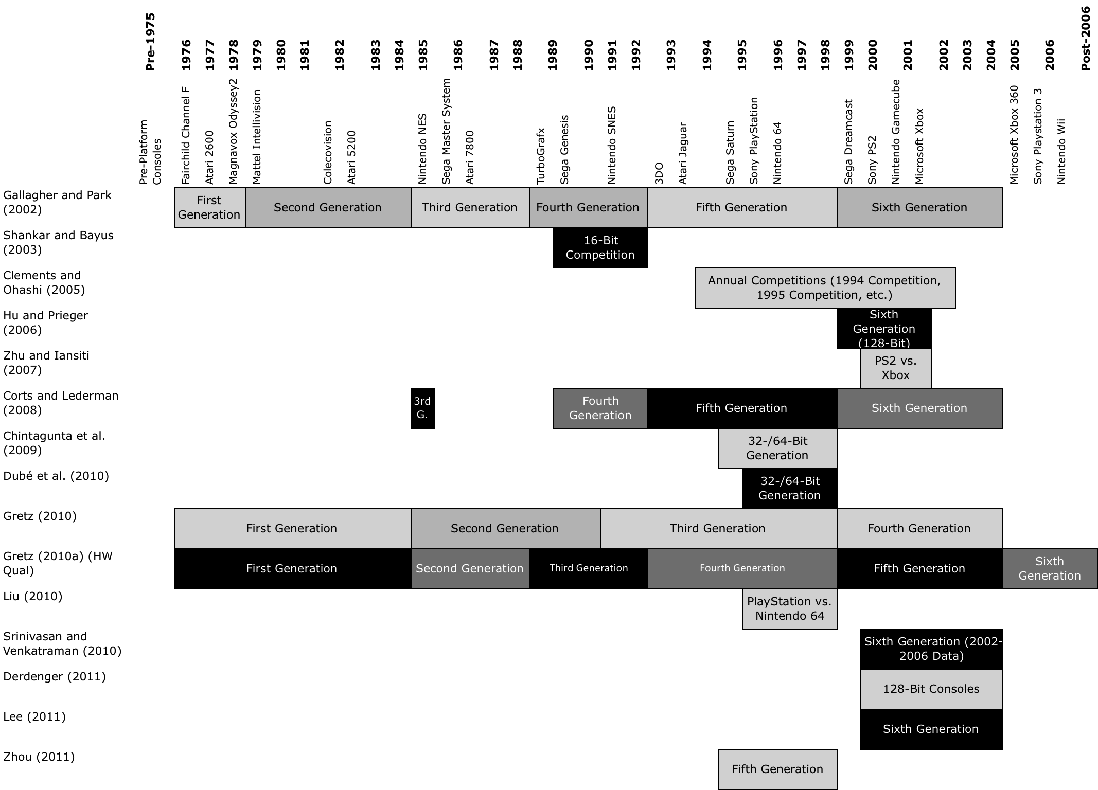
Figure 1. Comparison of Video Game Console Competition Classification Schemes
For example, the TurboGrafx console introduced in 1989 is characterized as “fourth-generation” by Gallagher and Park (2002), is omitted by Corts and Lederman (2008), is considered “second generation” (along with earlier consoles like the 1985 Nintendo NES) according to Gretz (2010), but “third generation” by Gretz (2010a). Similarly, the 1995 Sony Playstation is both Gallagher and Park’s and Corts and Lederman’s “fifth generation”, but is “third generation” and “fourth generation”, respectively, in Gretz (2010) and Gretz (2010a), and “32-/64-bit generation” by both Chintagunta et al. (2009) and Dubé et al. (2010).
However, more problematic than the confusing variety of schemes and labels is the fact that it can be difficult to assess these schemes in terms of the criteria used to establish the boundaries. For example, the earliest of these studies, Gallagher and Park (2002), recounts the historical competitions in the video game console industry. The authors identify six generations, with the onset of a new generation defined by the sole requirement of “a minimum of 100% improvement” in graphics capability (2002, p. 70). This classification scheme raises two significant concerns, however. First, generations are ambiguously defined; it is not clear what is meant by “100% improvement” in graphics capability. Second, there is no argument proposed for why this is necessarily an appropriate single criterion.
More troubling, however, is that the adoption of this approach yields several anomalous results. Prior theory in the evolution of technology markets and the importance of network effects and complementary goods suggests that markets such as the one for console video games will have so-called “winner-take-all” outcomes (Utterback 1994; Arthur 1989; Katz and Shapiro 1985). However, the Gallagher and Park classification yields some anomalous results: their “fourth generation” yields two winners, the Sega Genesis and the Nintendo SNES consoles. Their classification also shows the Sony Playstation and the Nintendo 64 as co-winners of the “fifth generation” (Gallagher and Park, Table VI, p. 78).
One additional concern from these Sony/Nintendo “fifth generation” winners is that Gallagher and Park’s scheme results in Sony also winning the authors’ “sixth generation”. There is considerable research and empirical evidence from Christensen and others that true generational shifts are the result of disruptive technologies, and that winners in one generation are very rarely the winner in the succeeding generation (Christensen 1993, 1997; Henderson and Clark 1990).
In order to address the issue of ambiguity and to possibly rectify the discord between existing classification schemes and theoretical expectations for competitive outcomes, we offer a new classification system (see Figure 2 and Table 1). Our system is based on two key factors, a primary classifier and a secondary one. The primary classifier is processor word length, and, within this, a secondary criterion is the time between world-wide release dates. The logic behind this approach is first that processor word length has been a widely used technical metric to define computing power. Processors with longer word lengths, all else being equal, will have superior performance to shorter word length machines. This has resulted in a monotonic growth path for processor word length. It is also potentially disruptive in that systems software, e.g. operating systems, often requires significant modification in order to take advantage of the new longer word length offered by the hardware. Therefore, this is a natural break point between what we term classes of consoles. Second, we recognize that word length, although useful, may not capture all of the technical advancements that take place in the hardware, particularly in cases where improvements in word size happen more slowly. Therefore, we add a second dimension to the classification criteria of time between world-wide release dates. The passage of time is essentially designed to capture the “residual” of technical improvement that occurs that may not be captured by processor word length.
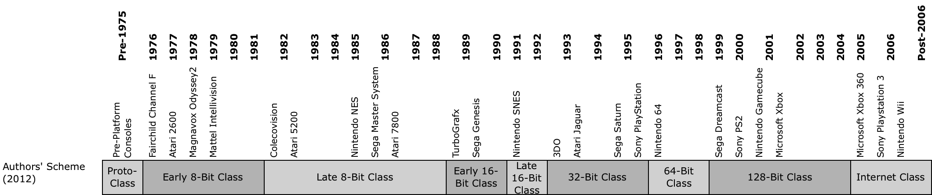
Figure 2. Authors’ Classification Scheme

Specifically, we consider a new class to begin, at a minimum, where a system uses a processor with a longer word length (e.g., 64-bit consoles are considered a different generation from 32-bit consoles), and then additionally where there has been a gap of at least two years in the world-wide release of a major console (where by “major”, we include consoles that sell at least 1 million units). This additional criterion requires the splitting of the long-lived 8- and 16-bit classes into “early” and “late” classes, respectively. Our full classification of consoles and data regarding sales and class dominance can be found in Figure 2 and Table 1. We have adopted the terminology of “class” rather than “generation” to convey the notion of improvement from one group to the next group, and to avoid confusion with prior work by adding one more discordant set of “generations”.
Table 1. Classification of Video Game Console Competitions
Note: Dominant console for each class denoted in bold.
Class | Console | Word Length | Release Date | Sales (M) | % of Class
Early 8-Bit | Fairchild Channel F | 8 Bits | Aug-76 | 0.8 | 2.2%
 | Atari 2600 | 8 Bits | Oct-77 | 30 | 83.8%
 | Magnavox Odyssey2 | 8 Bits | 1978 | 2 | 5.6%
 | Mattel Intellivision | 10 Bits | 1979 | 3 | 8.4%
Late 8-Bit | Colecovision | 8 Bits | Aug-82 | 6 | 7.0%
 | Atari 5200 | 8 Bits | Nov-82 | 1 | 1.2%
 | Nintendo NES | 8 Bits | Oct-85 | 61.9 | 72.2%
 | Sega Master System | 8 Bits | Jun-86 | 13 | 15.2%
 | Atari 7800 | 8 Bits | Jun-86 | 3.8 | 4.4%
Early 16-Bit | NEC TurboGrafx-16 | 16 Bits | Sep-89 | 10 | 20.1%
 | Sega Genesis | 16 Bits | Sep-89 | 39.7 | 79.9%
Late 16-Bit | Nintendo SNES | 16 Bits | Aug-91 | 49.1 | 100.0%
32-Bit | 3D0 | 32 Bits | Oct-93 | 2 | 1.7%
 | Atari Jaguar | 32 Bits | Nov-93 | 0.5 | 0.4%
 | Sega Saturn | 32 Bits | May-95 | 8.8 | 7.6%
 | Sony PlayStation | 32 Bits | Sep-95 | 104.3 | 90.2%
64-Bit | Nintendo 64 | 64 Bits | Sep-96 | 32.9 | 100.0%
128-Bit | Sega Dreamcast | 128 Bits | Sep-99 | 8.2 | 3.9%
 | Sony PlayStation 2 | 128 Bits | Oct-00 | 153.7 | 73.8%
 | Nintendo GameCube | 128 Bits | Nov-01 | 21.7 | 10.4%
 | Microsoft Xbox | 128 Bits | Nov-01 | 24.7 | 11.9%
Internet Class | Microsoft Xbox 360 |  | Nov-05 | 65.8 | 29.2%
 | Sony PlayStation 3 |  | Nov-06 | 63.8 | 28.3%
 | Nintendo Wii |  | Nov-06 | 95.7 | 42.5%

This classification scheme is both consistent and easily replicable. Beyond these desirable measurement characteristics, however, it also generates a different set of dominant consoles (“winners”) than earlier classification systems. In particular, the results of this improved approach are that a single, winner-take-all console emerges in each class, as highlighted by the bold text in Table 1. This is consistent with much prior research on technological market evolution (Utterback 1994; Christensen 1997; Henderson and Clark 1990). However, it also raises a new and potentially interesting research question regarding the failure of a single winner to emerge in the latest class, here termed the “Internet Class”. Is this simply because insufficient time has elapsed for a single winner to emerge, or does this represent a change in digital goods market dynamics (Liu et al. 2013)?

Determining Winners in Video Game Console Markets
In strategic decision-making, winning market share can be seen as a key performance measure. With a consistent guide for determining competitive classes for video game consoles, we can now consider factors that influence the outcomes of these markets, for which we use the lens of the two-sided market framework. A two-sided market is one in which a platform (e.g., the video game console) intermediates between buyers (e.g., video game players) and sellers (e.g., video game producers) (Rochet and Tirole 2003; Caillaud and Jullien 2003; Armstrong 2006). As video game console markets are a clear example of two-sided markets (e.g., Eisenmann et al. 2006, 2011; Rochet and Tirole 2006), this framework seems especially appropriate.
Two-sided markets are further typified by the existence of cross-side externalities (Caillaud and Jullien 2003; Parker and Van Alstyne 2005; Eisenmann et al. 2006), which are generally positive. In other words, the more video game players there are who adopt a given console, the more attractive it becomes for video game manufacturers to produce games for that console. The reverse is also true in the case of video game markets, (more games available makes the platform more attractive for gamers). Same-side externalities also play a significant role (Katz & Shapiro 1985, 1986, 1994; Farrell and Saloner 1985; Arthur 1989). The more gamers who adopt a given console, the more attractive the console becomes to other gamers since they will have more people against whom to play and with whom to trade games. This may also be true for sellers; while additional game producers on a given console increases the competition among sellers, their presence may also encourage enough additional gamers to adopt the platform that their presence becomes a net positive for other game producers (Parker and Van Alstyne 2005). Accordingly, the quality, quantity, and variety of available complements can be expected to significantly influence market share (Shapiro and Varian 1999) as can the strength of network effects.
Pricing is likewise a key component of two-sided markets, where platforms use pricing (and subsidies) to encourage both sides to adopt (Rochet and Tirole 2003; Parker and Van Alstyne 2005). In video game markets, console manufacturers have generally subsidized the cost of their consoles, especially in the time immediately following introduction. Conversely, console manufacturers can use pricing and subsidy to directly influence game producers as well; a less-expensive (or free) software development kit, lower licensing fees, or spending more money to develop an easier-to-use architecture can all be considered forms of subsidy.
Platform owners may also seek to gain advantage over their competitors through differentiation. In the context of video game consoles this differentiation is generally technological (although a unique set of games or a unique set of gamers may also be considered types of differentiation). Such technological differentiation was evident when Nintendo released their Wii console, which included motion-sensing technology initially absent in the other consoles that were available at the time of the Wii’s introduction. When it released the PlayStation 2, Sony differentiated their product by allowing backward compatibility with the original PlayStation, thus making their platform more attractive (Shapiro and Varian 1999).
Where multiple platforms are competing (as in video game console markets), both buyers and sellers have an option to either single-home, where a buyer or seller adopts one platform exclusively, or multi-home, where a buyer or seller adopts two or more platforms (Armstrong 2006; Armstrong and Wright 2007). It is clearly possible for consumers to own both an Xbox 360 and a PlayStation 3 and for a video game producer to release a given game for one or multiple systems. For console makers, single-homing among games (i.e., a game being released exclusively for one console) has been an important means of creating complement-based differentiation. Further, console makers can opt to create their own content, another means of creating exclusive complements (Derdenger 2011).
This homing behavior (and, thus, market outcomes) can be further influenced by interoperability, the ability to use the same content on multiple devices. Where interoperability is possible users can opt to adopt whichever platform is most convenient or offers the most desirable set of features without regard for content availability (Liu et al. 2012). A form of this was seen in the video game console industry with the release of the Colecovision console, which could be made compatible with Atari’s 2600 console through an adapter (Gallagher and Park 2002).
Switching costs can, if high enough, discourage buyers or sellers from multi-homing, thus giving greater advantage to the platform with which they single-home. For example, controllers, downloaded content, and personalized settings and achievements have all been used in the video game console market in order to dissuade users from switching to alternate platforms (Chakravorti 2004). A gamer with a reputable gamer tag on Xbox Live, a Kinect adapter, and a large library of games is less likely to abandon the Xbox for the PlayStation 3 or Wii, since doing so would require significant cost (not least the cost of the console) in order to attain the utility derived from the already-adopted Xbox.
Two-sided market outcomes are also, in part, determined by the homogeneity of buyers and sellers (Caillaud and Julien 2003, 2006). In the video game context, seller goods (the video games themselves) tend to be heterogeneous; while there may be soccer games released by two different manufacturers, even these tend to differ significantly in terms of graphical presentation, control schemes, and game play variety. Homogeneity among buyers, however, may be more influential. For instance, the popularity of the Nintendo Wii at its initial launch was considered in part due to its ability to appeal to a new segment of gamers (Enderle 2007); if not for heterogeneity, there would be no new segment.
The above factors form a foundation for inquiry into the emergence of certain consoles as winners of their respective classes. While some of these topics have been credibly examined in the existing literature, we conducted a thorough review of relevant studies (see Table 2) to discover where gaps may exist and discover which potential drivers of class dominance may yet require research. We generated this table by conducting a comprehensive literature review that included working papers as well as research published in academic journals. In the review we noted which dependent variables were used and how factors influencing these variables were measured or conceptualized. A key finding is that the Table 2 matrix is very sparse; a significant set of potential explanatory variables have not been tested in prior research.
Analysis of these data reveals that factors such as console pricing, game availability, and installed base network effects have been suggested as factors. We find that relatively little empirical work has been done. Further, potentially important factors, such as network strength, seller-side pricing decisions, interoperability, differentiating technology, and consumer homing behavior, have been left largely uninvestigated. These factors may yet prove important drivers in the identification of class winners. As such, future research is directed at these factors.
Conclusion
The video game console industry provides a good exemplar of competitive performance in a digital goods market. As such, and given the successive classes of competitions in the industry, it is a useful laboratory for exploring related issues. Through our analysis we found that prior literature is limited in two ways. First, the separation of consoles into discrete competitions is necessary to identify the winners. However, discrepancies in these classification schemes necessitate the creation of the new, more consistent scheme presented here. This new scheme, in addition to being a superior measurement approach, is in part validated by its illumination of a set of results that are consistent with established theory in this area.
Second, prior research has left significant gaps, as evidenced by the sparseness of the Table 2 matrix. Theory suggests that there are multiple additional factors that may significantly influence the emergence of class winners that require investigation. We discovered some of these factors (e.g., differentiating technology, seller-side pricing and subsidy decisions) by appraising past research through the lens of two-sided markets. Future research is directed at modeling these factors in light of the longitudinal data. Of particular additional interest is an assessment of whether a single dominant platform is likely to emerge in the current Internet Class of consoles, or if a paradigm shift away from a winner-take-all result has occurred.

Table 2. Video Game Console Markets Literature

References
Armstrong, M. 2006. "Competition in two-sided markets". RAND Journal of Economics (37:3), pp. 668-691.
Armstrong, M. and Wright, J. 2007. "Two-sided Markets, Competitive Bottlenecks and Exclusive Contracts". Economic Theory (32:2), pp. 353-380.
Arthur, W. B. 1989. "Competing Technologies, Increasing Returns, and Lock‐In by Historical Events." The Economic Journal (99:394), pp. 116‐131.
Bass, D. and Thaw, J. 2005. "Sony's PlayStation May Lose Sales to Microsoft's Xbox Console". Bloomberg. Retrieved April 30 from http://www.bloomberg.com/apps/news?%20pid=newsarchive &%20sid=aeC3OGwd5BI4.
Caillaud, B. and Jullien, B. 2003. "Chicken & egg: competition among intermediation service providers". RAND Journal of Economics (34:2), pp. 309-328.
Chakravorti, S. 2004. "The new rules for bringing innovations to market". Harvard Business Review (82:3), pp. 59-67.
Chintagunta, P. K., Nair, H. S. and Sukumar, R. 2009. "Measuring marketing-mix effects in the 32/64 bit video-game console market". Journal of Applied Econometrics (24:3), pp. 421-445.
Christensen, C. M. 1993. "The Rigid Disk Drive Industry: A History of Commercial and Technological Turbulence." The Business History Review (67:4), pp. 531-588.
Christensen, C. M. 1997. The Innovator's Dilemma. New York, Harper Collins.
Clements, M. T. and Ohashi, H. 2005. "Indirect Network Effects and the Product Cycle: Video Games in the U.S., 1994-2002". The Journal of Industrial Economics (53:4), pp. 515-542.
Corts, K. S. and Lederman, M. 2009. "Software exclusivity and the scope of indirect network effects in the U.S. home video game market". International Journal of Industrial Organization (27:2), pp. 121-136.
Derdenger, T. 2011. "Technological Tying and the Intensity of Competition: An Empirical Analysis of the Video Game Industry". Working Paper.
DFC Intelligence. 2011. "DFC Intelligence Forecasts Worldwide Video Game Market to Reach $81 Billion by 2016." DFC Intelligence. Retrieved April 28, 2012, from http://www.dfcint.com/wp/?p=312.
Dubé, J. H., Hitsch, G. J. and Chintagunta, P. K. 2010. "Tipping and Concentration in Markets with Indirect Network Effects". Marketing Science (29:2), pp. 216-249.
Eisenmann, T., Parker, G. and Van Alstyne, M. 2006. "Strategies for Two-Sided Markets". Harvard Business Review (84:10).
Eisenmann, T., Parker, G. and Van Alstyne, M. 2011. "Platform envelopment". Strategic Management Journal (32:12), pp. 1270-1285.
Enderle, R. 2007. "Game consoles 2007: It's Nintendo's market to lose". TGDaily. Retrieved April 30 from http://www.tgdaily.com/games/33359-game-consoles-2007-its-nintendos-market-to-lose.
Farrell, J. and Saloner, G. 1985. "Standardization, Compatibility, and Innovation." RAND Journal of Economics (16:1), pp. 70‐83.
Gallagher, S. and Park, S. H. 2002. "Innovation and competition in standard-based industries: a historical analysis of the US home video game market". IEEE Transactions on Engineering Management (49:1), pp. 67-82.
Gretz, R. T. 2010. "Console Price and Software Availability in the Home Video Game Industry". Atlantic Economic Journal (38:1), pp. 81-94.
Gretz, R. T. 2010a. "Hardware quality vs. network size in the home video game industry". Journal of Economic Behavior & Organization (76:2), pp. 168-183.
Henderson, R. M. and Clark, K., 1990. “Architectural Innovation: The Reconfiguration of Existing Product Technologies and the Failure of Established Firms”, Administrative Science Quarterly, (35:1) pp. 9-30. Katz, M. L. and Shapiro, C. 1985. "Network Externalities, Competition, and Compatibility." The American Economic Review (75:3), pp. 424‐440.
Katz, M. L. and Shapiro, C. 1986. "Technology Adoption in the Presence of Network Externalities." The Journal of Political Economy (94:4), pp. 822‐841.
Katz, M. L. and Shapiro, C. 1992. "Product Introduction with Network Externalities." The Journal of Industrial Economics (40:1), pp. 55‐83.
Kohler, C. 2006. "iSupply: PS3 Components Cost $850". Wired. Retrieved April 30 from http://www.wired.com/gamelife/2006/11/isupply_ps3_com/.
Lee, R. S. 2011. "Dynamic Demand Estimation in Platform and Two-Sided Markets: The Welfare Cost of Software Incompatibility". Working Paper.
Liu, C., E. Gal-Or, C. Kemerer, and Smith, M. 2012. "Compatibility and Proprietary Standards: The Impact of Conversion Technologies in IT-Markets with Network Effects”, Information Systems Research, (22: 1), pp. 188-207.
Liu, C., Kemerer, C. F., Slaughter, S. and Smith, M. 2013. "Standards Competition in the Presence of Conversion Technology: An Empirical Analysis of the Flash Memory Card Market". MIS Quarterly.
Liu, H. 2010. "Dynamics of Pricing in the Video Game Console Market: Skimming or Penetration?". Journal of Marketing Research (47:3), pp. 428-443.
Parker, G. and Van Alstyne, M. 2005. "Two-Sided Network Effects: A Theory of Information Product Design". Management Science (51:10), pp. 1494-1504.
Prieger, J. E. and Hu, W. 2006. "An Empirical Analysis of Indirect Network Effects in the Home Video Game Market". Working Paper.
Rochet, J. and Tirole, J. 2003. "Platform Competition in Two-Sided Markets". Journal of the European Economic Association (1) pp. 990-1029.
Rochet, J. and Tirole, J. 2006. "Two-sided markets: a progress report". The RAND Journal of Economics (37:3), pp. 645-667.
Shankar, V. and Bayus, B. L. 2003. "Network effects and competition: an empirical analysis of the home video game industry". Strategic Management Journal (24:4), pp. 375-384.
Shapiro, C. and Varian, H. R. 1999. "The Art of Standards Wars". California Management Review (41:2), pp. 8-32.
Srinivasan, A. and Venkatraman, N. 2010. "Indirect Network Effects and Platform Dominance in the Video Game Industry: A Network Perspective". IEEE Transactions on Engineering Management (57:4), pp. 661-673.
Utterback, J., 1994. Mastering the Dynamics of Innovation. Cambridge, HBS Press.
Venkatraman, N. and Lee, C. 2004. "Preferential Linkage and Network Evolution: A Conceptual Model and Empirical Test in the U.S. Video Game Sector". Academy of Management Journal (47:6), p. 876.
Zhou, Y. 2011. "Bayesian Estimation of a Dynamic Equilibrium Model of Pricing and Entry in two-Sided Markets: Application to Video Games". Working Paper.
Zhu, F. and Iansiti, M. 2007. "Dynamics of Platform Competition: Exploring the Role of Installed Base, Platform Quality and Consumer Expectations". Working Paper.

DFC Intelligence (2011) estimates that the world-wide industry to grow from $66 billion in 2010 to $81 billion by 2016.
Note that some prior research in the area focuses on a discrete set of consoles (e.g. Srinivasan and Venkatraman (2010)) and avoids this potential problem.
Sales figures given are current world-wide unit sales as of April 2012. Sources: Wikipedia (Fairchild Channel F, Magnavox Odyssey2); http://images.businessweek.com/ss/06/10/game_consoles/source/3.htm (Atari 2600) http://www.intellivisiongames.com/history.php (Intellivision) http://www.colecovision.dk/history.htm (Colecovision); http://www.mashpedia.com/Atari_5200 (Atari 5200); http://retro.ign.com/articles/ 965/965032p1.html (Sega Master System) http://www.gamasutra.com/blogs/MattMatthews/ 20090526/1521/Atari_7800_Sales_Figures_1986__1990.php (Atari 7800); http://www.gamepro.com/gamepro/ domestic/games/features/111822.shtml (TurboGrafx-16); http://segatastic.blogspot.com/2009/12/mega-drive-sales-figures-update.html (Sega Genesis); and vgchartz.com (Nintendo NES, Late 16-Bit, 32-Bit, 64-Bit, 128-Bit and Internet classes).
This oddity has been confirmed at the manufacturer’s website: http://www.intellivisionworld.com/English/FAQ/. The choice of including this console with its contemporary peers in the Early 8-bit Class does not materially affect the results.
For example, at launch Sony’s PlayStation 3 sold for $599, but reportedly cost $840 to produce (Kohler 2005).
For example, Nintendo has famously limited popular franchises such as Mario and Zelda to their consoles; in recent competitions, both Microsoft (e.g., Halo) and Sony (e.g., MLB: The Show) have done likewise (Bass and Thaw 2005).

