In testing a new sleeping pill to help with job stress insomnia, subjects are placed into one of four groups, based on Type of pill (new drug or placebo) and Job type (maintenance or secretary), then are measured on how long it takes them to fall asleep at night.
Type of pill
Placebo New Drug

Maintenance ∑X = 263 ∑X = 185 ∑X_{r1} = 448
n = 5 n = 5
Job Type
Secretary ∑X = 289 ∑X = 265 ∑X_{r2} = 554
n = 5 n = 5

∑X_{c1} = 552 ∑X_{c2} = 450

∑X_{T} = 1002
∑X_{T}² = 52,212

Complete a source table for this experiment.
Tell me if you reject or retain the null hypothesis for each F statistic
Describe what these decisions means about your independent variables.
What should you do as a follow up to your conclusion about the interaction?

ANSWERS:

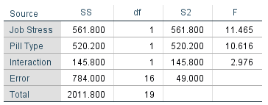

p = .004 (or, 0.4%)
p = .005 (or, 0.5%)
p = .10 (or, 10%)

Job Type, Reject. The maintenance workers and secretaries probably take different amounts of time to fall asleep.

Pill Type, Reject. The placebo and new drug groups probably take different amounts of time to fall asleep.

Interaction, Retain. The effect of job type on falling asleep time probably does not change based on the pill you took.

Power analysis and Type 2 error calculation.

